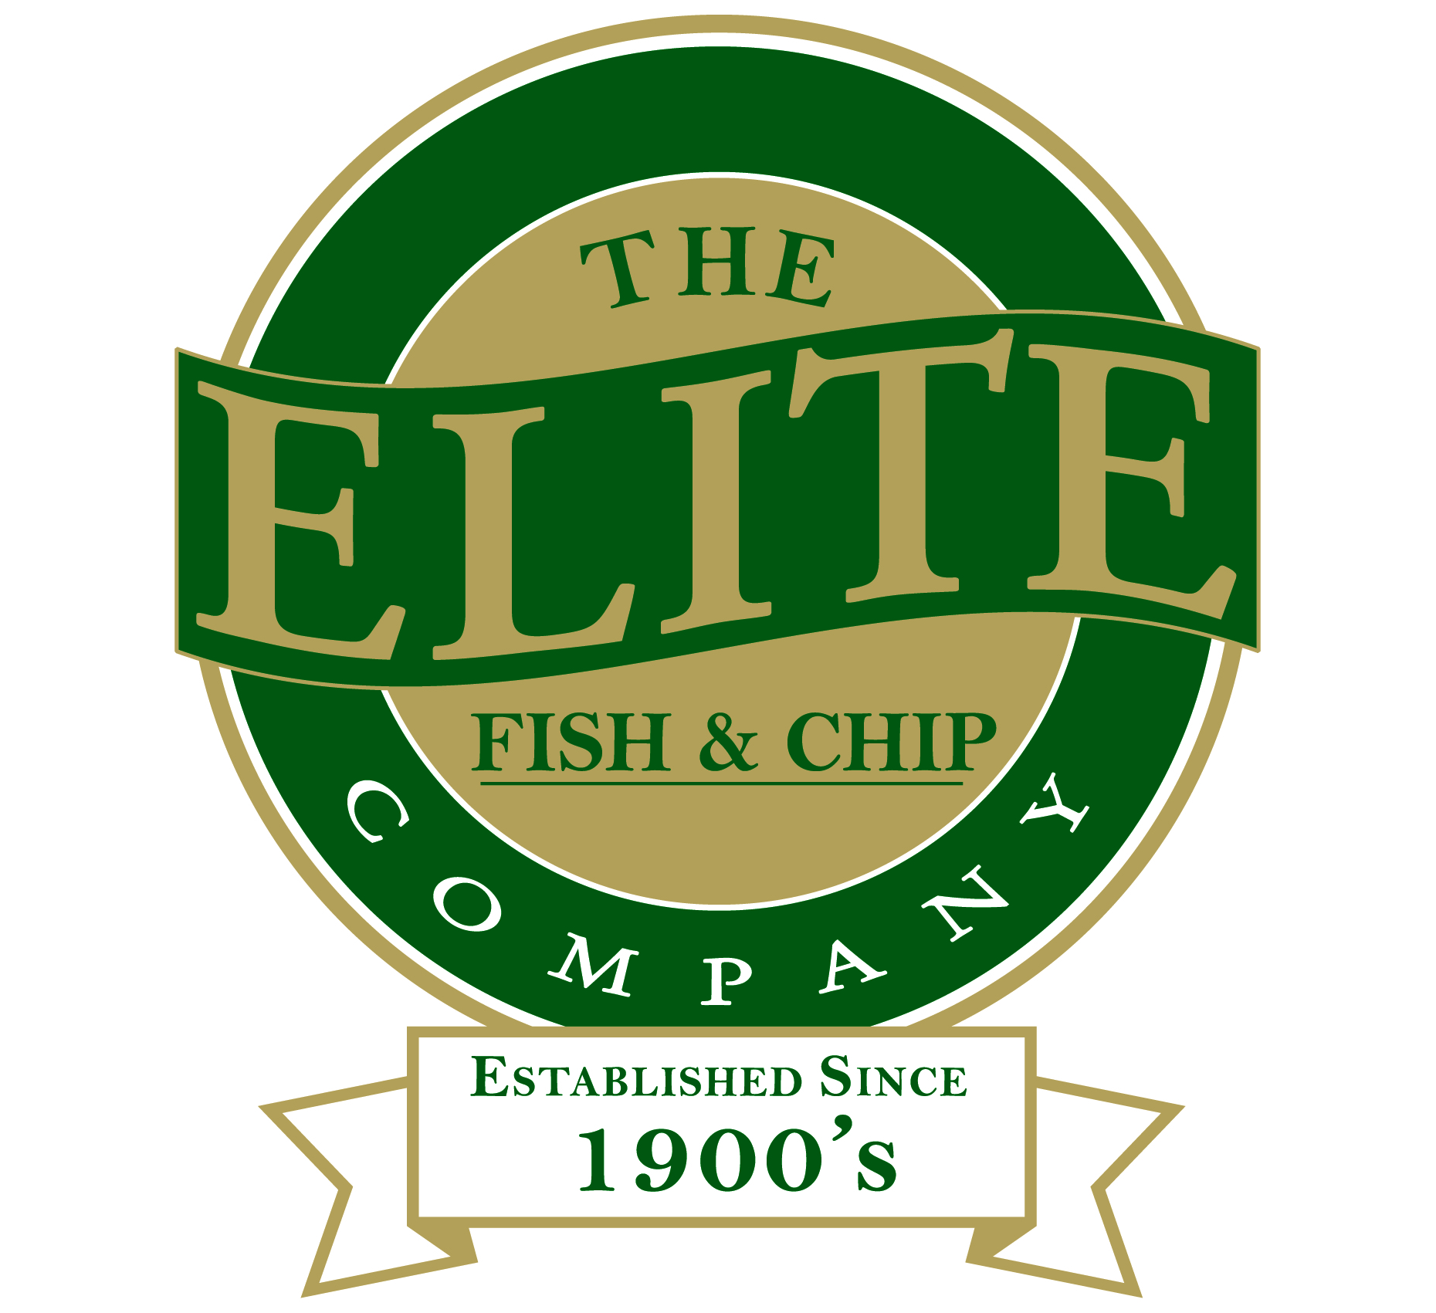

News release

23rd April 2015

Chip Chip Hooray!

The Elite Fish and Chip Company’s Lincoln and Sleaford takeaways are celebrating being named in the UK’s 50 best fish and chip shops.

It’s a hat-trick for the takeaways as they were also in Fry Magazine’s 50 Best Fish and Chip Shops in 2014 and 2013.

Nearly 500 fish and chip shops across the UK entered the competition and each one was visited by a mystery diner from an independent company. The mystery diner assessed 40 aspects of the business, including the quality of fish and chips, staff presentation, front-of-house hygiene and customer service.

Rachel Tweedale, Manager of the Sleaford restaurant and takeaway and Drywite Young Fish Frier of the Year for 2015, said: “This year’s competition was tougher than ever so we are delighted to be in the top 50 for the third year running.”

Tracey Donoghue, Manager at the Lincoln restaurant and takeaway, added: “We are so proud and it has been a great team effort to be named as one of the 50 best for the third year in a row.”

Reece Head, publisher at Frymagazine.com, said: “Our judges marked to a tough set of criteria so being in the 50 best is a real testament to the procedures, practices and staff in place at those outlets.”

Ends

Notes to editors:

- The Elite Fish and Chip Company has three restaurants and takeaways: Lincoln, Sleaford and Ruskington.
- It has been serving fish and chips in Lincolnshire for over 40 years.
- It is a family-owned business in its third generation of friers.
- The Elite Fish and Chip Company won the National Fish and Chip Shop of the Year in 1992.

For media information please contact:
Jonny Hall
Shooting Star PR
01522 528540
jonny@shootingstar-pr.co.uk
[Elite06Best]

