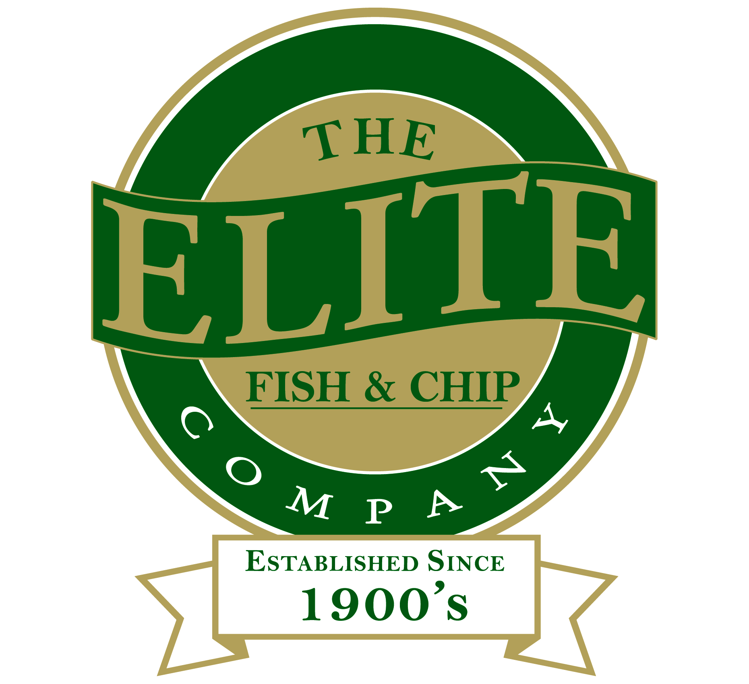

News release

7th May 2015

Arthur’s Wish Set to Come True

A 91-year-old war veteran is set to fly to Norway to visit the grave of his brother who was killed in action in the Second World War.

Arthur Harrison, from Lincoln, is nearing the realisation of a long-held dream to go to the grave of his brother, Edward Harrison, at Trondheim Stavne Cemetery. Arthur will be joined on the trip by his son-in-law Trevor Fox and grandson Robert Crosbie.

Private Edward ‘Ted’ Harrison of the 4th Battalion of the Royal Lincolnshire Regiment died near Steinkjer on 22nd April 1940, aged 21.

The trip to Norway in May has been organised and funded by The Elite Fish and Chip Company. Paul Kiddell, an ex-Territorial Army soldier who served in Norway (Verdal) in 1992 and has lived in Steinkjer since 1994, will guide the family throughout their Norwegian stay.

Arthur’s daughter Susan Fox has been a driving force behind the family’s desire to see Arthur fulfil his wish.

Susan said: “It has always been the family’s ambition to fulfil the dream that Arthur has harboured for so long. Arthur has never made this trip because he insisted that we shouldn’t club together to fund it.”

When the family saw that The Elite Fish and Chip Company was running a Christmas Wish competition giving customers a chance to have their Christmas wish come true, they filled in an entry card at The Elite Fish and Chip Company’s Lincoln restaurant and takeaway.

Adrian Tweedale, owner of The Elite Fish and Chip Company, said: “We received nearly 400 wishes but Arthur’s wish really moved us. Family is important. We had set the prize limit as £250 towards fulfilling a wish, but when we chose Arthur’s wish we wanted to fund whatever it would cost to help Arthur to go to the place where his brother is buried.”

Susan added: “We want to thank The Elite Fish and Chip Company most dearly for choosing us as the winner of their competition.”

Private Edward Harrison was killed in action on 22nd April 1940 at By farm, two kilometres north east of Steinkjer, when the German Luftwaffe bombed and destroyed Steinkjer. Edward was initially buried in a field. He was reburied at the church in the nearby village of Egge on 17th May 1940 (Norway’s National Day). After the war, the Commonwealth War Graves Commission reburied Edward at Trondheim.

Ends

Notes to editors

- The family and The Elite Fish and Chip Company are available for interview on Monday 11th May, Tuesday 12th May and Wednesday 13th May.
- Arthur will lay a Royal British Legion wreath while in Norway, in memory of his brother.
- Arthur and the family members are also set to visit the Steinkjer Memorial and have the option of attending Norway’s National Day in Namsos (the sea port town where Edward Harrison and the Royal Lincolnshire Regiment landed in 1940).
- Arthur served in the Royal Navy in India when the Allies were defending it from Japanese invasion.
- The Elite Fish and Chip Company’s Christmas Wish competition ran from 8th to 31st December 2014. The family discovered in January 2015 that they had won the competition.

The Elite Fish and Chip Company:

- The Elite Fish and Chip Company has three restaurants and takeaways: Lincoln, Sleaford and Ruskington.
- It has been serving fish and chips in Lincolnshire for more than 40 years.
- It is a family-owned business in its third generation of friers.
- The Elite Fish and Chip Company won the National Fish and Chip Shop of the Year in 1992.
- Follow The Elite Fish and Chip Company on Twitter @chippyelite

For media information please contact:
Jonny Hall
Shooting Star PR
01522 528540
jonny@shootingstar-pr.co.uk
[Elite07Wish]

