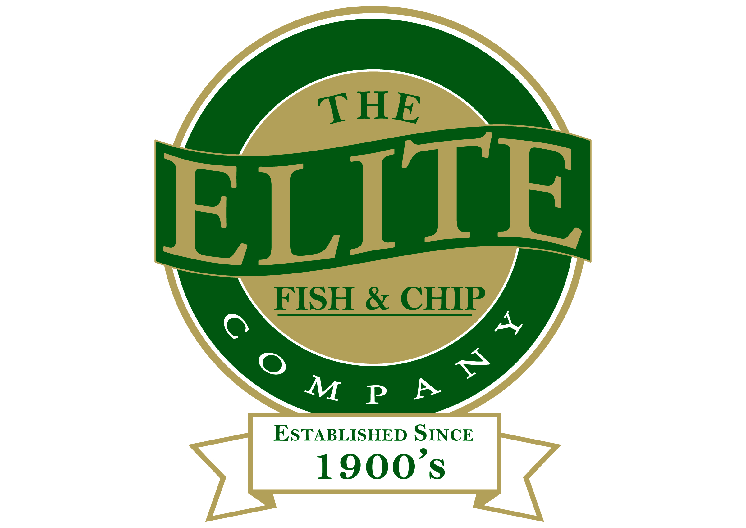
News release

30th March 2016

Elite Cooks up a Treat for Coningsby Luncheon Club

Coningsby Luncheon Club volunteers had a rare week off from cooking for its guests as the club enjoyed a free meal at The Elite Fish and Chip Company.

More than 60 people from Coningsby Luncheon Club tucked into a delicious fish and chip lunch at The Elite’s restaurant in Sleaford on Monday 21st March, after the club won the company’s Christmas Wish competition.

At Christmas, The Elite fulfils the wish of one of its customers who enters the competition. Coningsby Luncheon Club’s Olive Bright filled in a Christmas Wish card expressing how much club members would enjoy a day out to the restaurant.

The club was welcomed to the town by the Mayor of Sleaford Councillor Garry Titmus and Rachel Tweedale, the UK’s 2015 Drywite Young Fish Frier of the Year.

Rachel, Manager of The Elite’s restaurant and takeaway on Grantham Road, said: “We had a great day hosting the Coningsby Luncheon Club. We chose them as the winners of our 2015 Christmas Wish, out of around 250 entries, because we greatly admire how every week the club serves meals to more than 100 older people at Coningsby Community Hall.”

As well as laying on a fantastic spread for the members The Elite also provided a coach to transport them to and from the restaurant.

Coningsby Luncheon Club formed in 1977 as part of The Queen’s Silver Jubilee.

Lorna Curtis, who took on the organisation of the club from 1987 and received a British Empire Medal in 2013 for services to Coningsby, said: “We are very thankful to The Elite Fish and Chip Company for their kind gesture. It was a brilliant meal and atmosphere.

“We’ve invited Rachel to come along to Coningsby Luncheon Club in the near future – and we’ve promised that she won’t have to cook!”

The Mayor of Sleaford, Councillor Garry Titmus added: “I’m always delighted to meet local people and my thanks go to The Elite Fish and Chip Company for a superb event.”

Last year’s winner of The Elite Fish and Chip Company’s Christmas Wish competition was Arthur Harrison, aged 91 from Lincoln. The Elite funded and organised a trip to Norway for war veteran Arthur and members of his family to visit the grave of his brother Edward for the first time. Edward was killed in action during the Second World War, in April 1940.

The Elite Fish and Chip Company is fundraising for its charity of the year, The Royal British Legion’s Poppy Appeal, during 2016. The company is set to host several events to raise money for The Poppy Appeal, including a 1940s vintage event starring Lincolnshire-based professional singer Heather Marie at its Sleaford restaurant on Armed Forces Day, Saturday 25th June.

Ends

Notes to editors:

The Elite Fish and Chip Company
- The Elite Fish and Chip Company has three restaurants and takeaways: Lincoln, Ruskington and Sleaford.
- It has been serving the finest fish and chips for more than 40 years.
- It is a family-owned business in its third generation of friers.
- The Elite Fish and Chip Company won the National Fish and Chip Shop of the Year in 1992.
- Follow The Elite Fish and Chip Company on Twitter @chippyelite

For media information please contact:
Zoe Lamb
Shooting Star
01522 528540
zoe@weareshootingstar.co.uk
[Elite28ConingsbyLuncheonClub]

