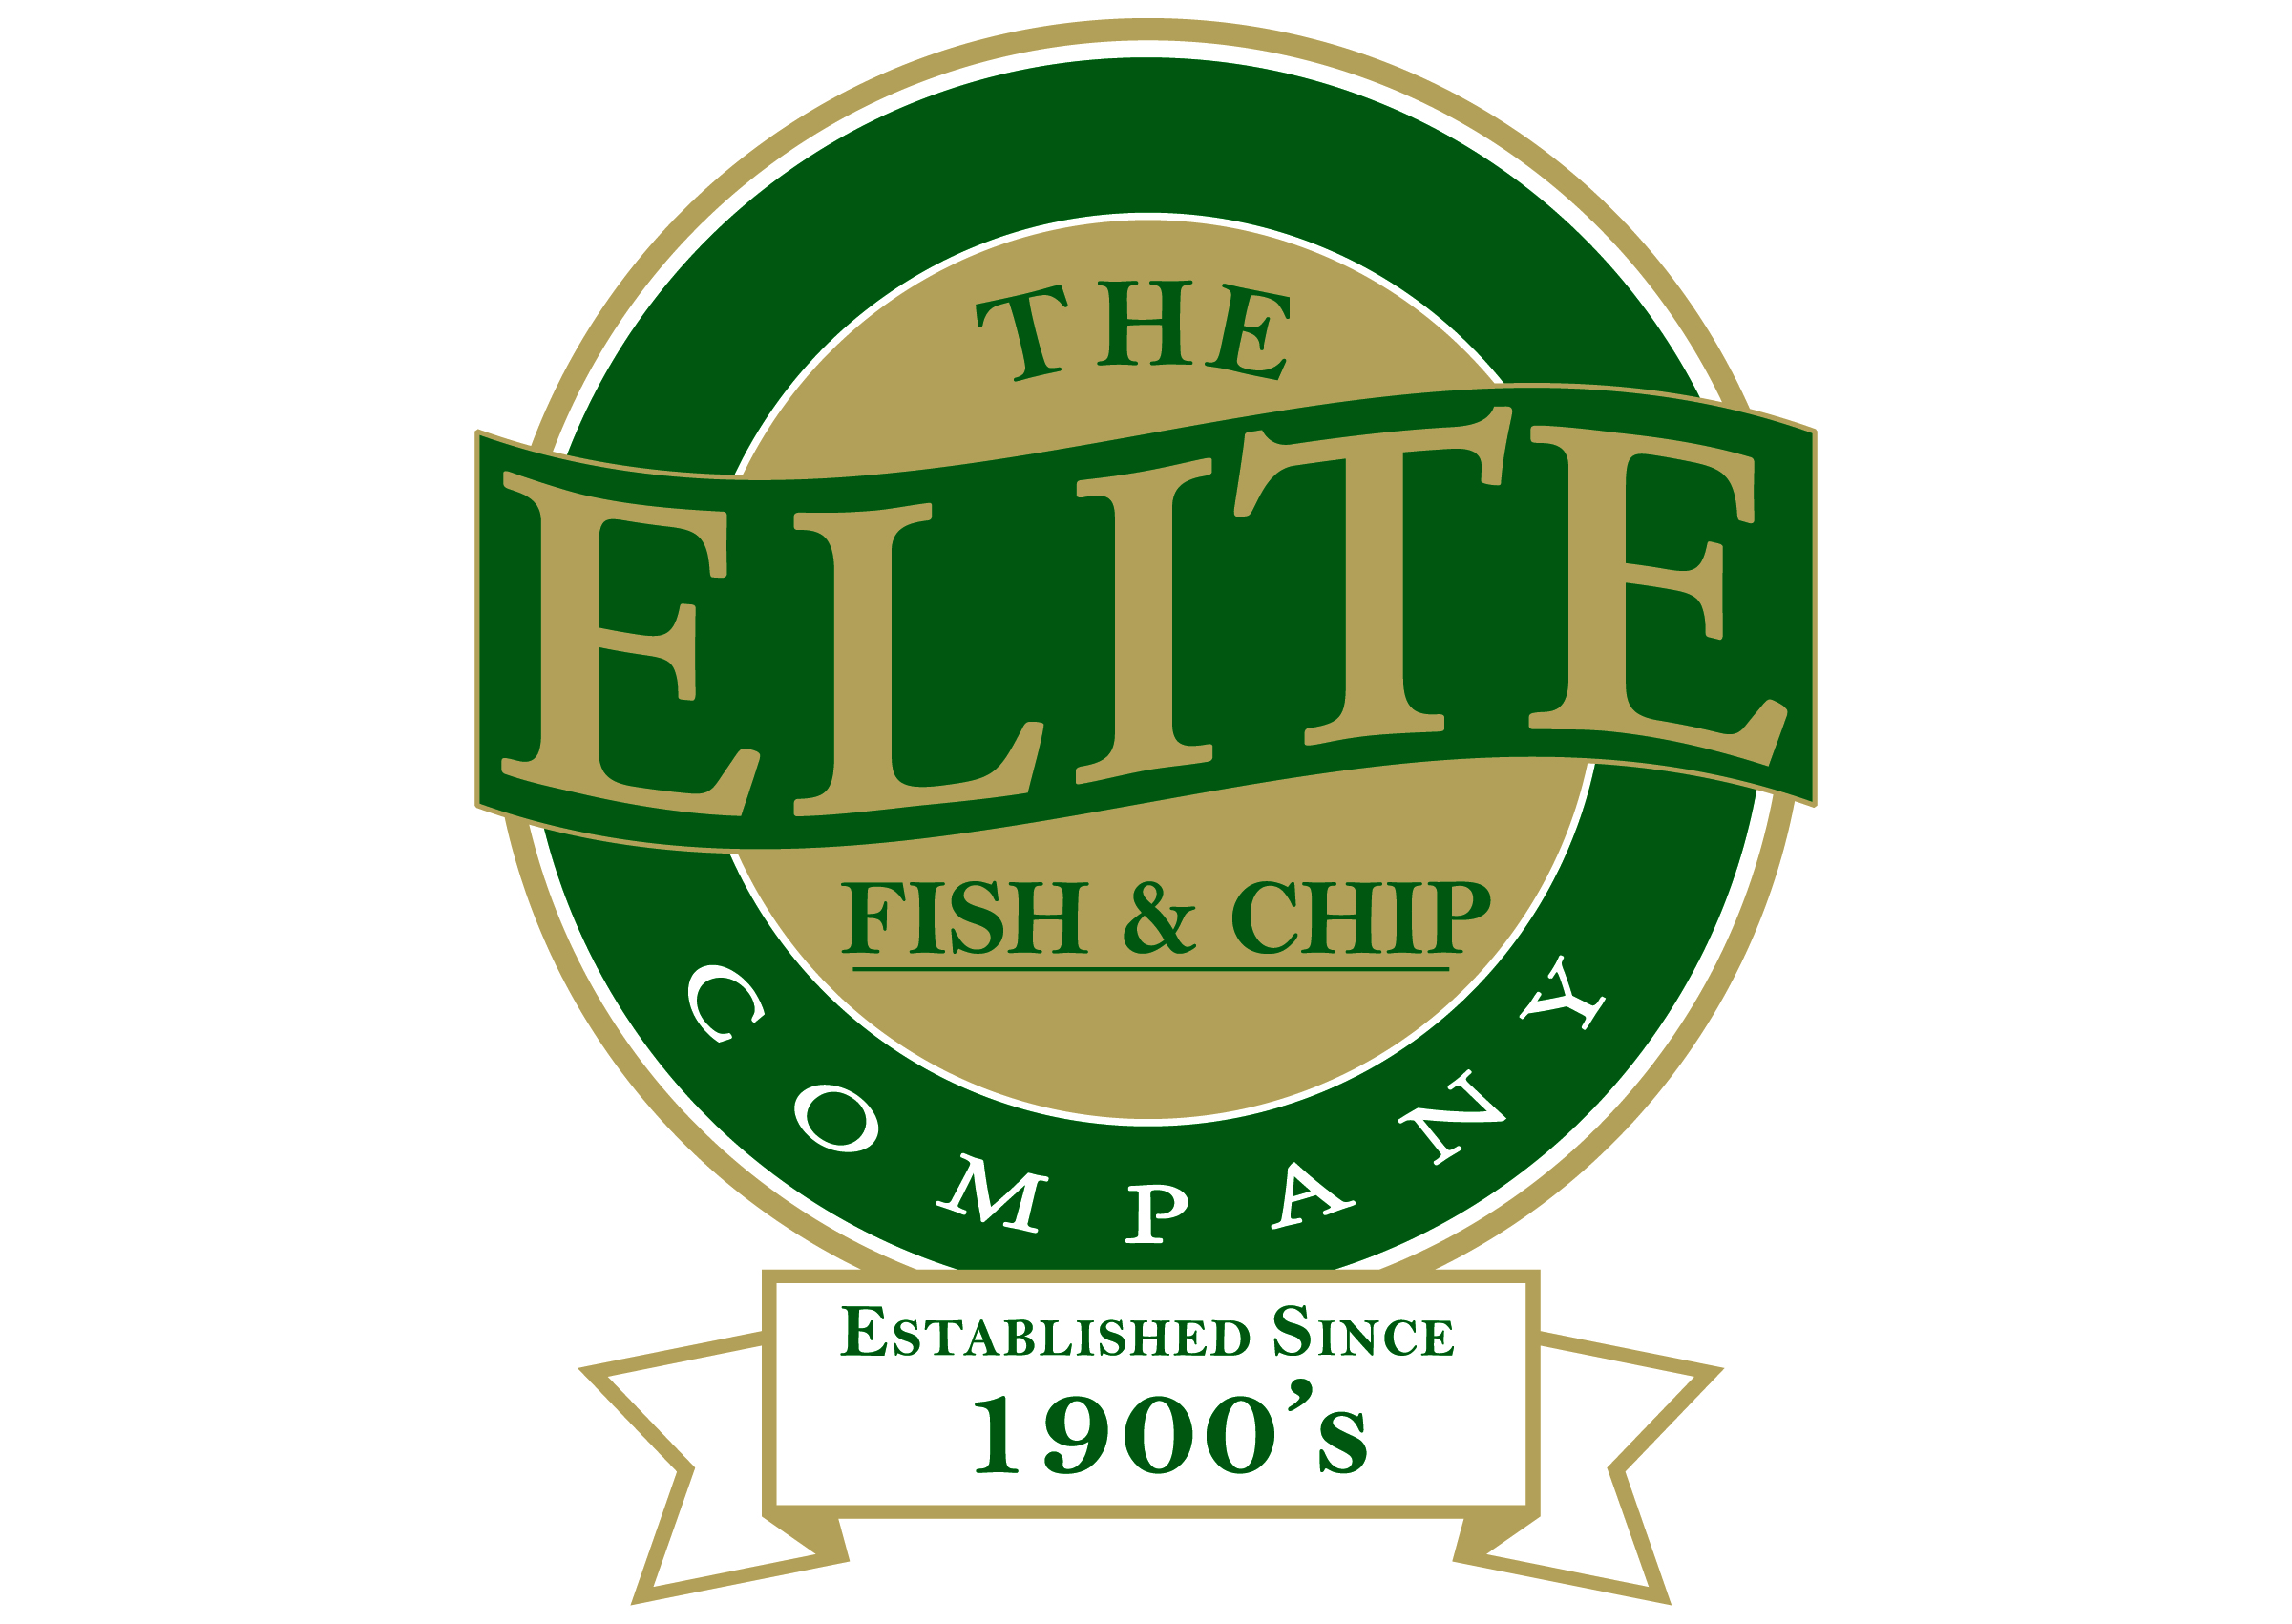
News release

27th April 2016

Wartime Tunes at Elite to Raise Poppy Appeal Cash

Revellers in Sleaford are set to rock to the sounds of the 1940s when Lincolnshire wartime singer Heather Marie comes to The Elite Fish & Chip Company.

Appearing as part of Armed Forces Day on Saturday 25th June, Heather Marie will be performing in the Grantham Road restaurant, with the price of the night’s admission including a portion of delicious fish and chips!

All funds raised will be going to the Royal British Legion’s Poppy Appeal, which is Elite’s charity of the year.

Rachel Tweedale, who runs the Sleaford restaurant and takeaway, said: “We’re so excited to be able to host Heather Marie – she’s a fantastic performer and to be able to celebrate Armed Forces Day on the same night is great!

“We want to welcome as many people as possible and would love it if you dressed up in 1940s dress too! Get into the spirit of things as we raise as much money as we can for the Royal British Legion’s Poppy Appeal!”

Diners will sit down to a meal of fish and chips, accompanied by 1940s music, before Heather Marie performs two sets of nostalgic songs, including hits from the era such as ‘Pennies From Heaven’, ‘Wish Me Luck As You Wave Me Goodbye’ and ‘At Last’ among many more.

Heather Marie added: “This will be a really fun night! I’ve never performed in a fish and chip restaurant before, but it’s the perfect setting – after all, fish and chips was one of the few foods not to be rationed in the two world wars.

“I can’t wait to perform in Sleaford, so come down and celebrate with us!”

Tickets for the event are priced at £17.50, which includes fish and chips and the performance. Doors open at 7pm, with food served at 7.30pm.

For more information, call the Sleaford restaurant on 01529 414534 or follow The Elite Fish & Chip Company on Twitter and Facebook.

Ends

Notes to editors:

- The Elite Fish & Chip Company has three restaurants and takeaways: Lincoln, Ruskington and Sleaford.
- It has been serving the finest fish and chips for more than 40 years.
- It is a family-owned business in its third generation of friers.
- The Elite Fish and Chip Company won the National Fish and Chip Shop of the Year in 1992.
- Follow The Elite Fish and Chip Company on Twitter @chippyelite

For media information please contact:
Mike Shields
Shooting Star
01522 528540
mike@weareshootingstar.co.uk
[Elite30HeatherMarie]

