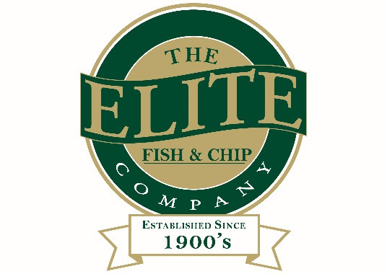
News release

23rd June 2016

Lincoln Chippy Staff Train to be Elite By Name and By Nature

Members of staff at The Elite Fish and Chip Company on Tritton Road in Lincoln are feeling chipper after recently completing some extra vocational training.

As part of its commitment to customer satisfaction and business development, employees at the popular restaurant and takeaway have spent the last year working towards various professional qualifications, which combined on-the-job training with a series of written tests.

Server Amy Grace and friers Mark Wilkinson and Adam Ward have all been awarded a nationally recognised BTEC Level 2 Apprenticeship in Customer Services.

Martin Ward is celebrating after completing his apprenticeship in Food Production and Cooking and an NVQ in Kitchen Services.

Meanwhile, one of Elite’s longest serving employees, Tracey Donoghue, has achieved an NVQ Diploma in Hospitality, Supervision and Leadership which equates to a BTEC Level 3 qualification.

Tracey has worked at The Elite Fish and Chip Company, which has three restaurant and takeaway outlets in Lincolnshire, for over 20 years. She said: “We’re all so happy to have received our certificates after such hard work. Our new qualifications increase our enthusiasm for the job and further motivate us to deliver the best possible service.”
Donna Tweedale, Manager of the Lincoln branch of the Elite restaurant and takeaway chain, added: “I’m delighted to see our staff awarded for all of their continued hard work, and I’m so proud of them and their dedication to the business.”

The Elite prides itself on its bespoke training programme which encourages members of staff to progress within the company.

The Elite Fish & Chip Company owner Adrian Tweedale said: “Our team members are one of the main reasons why we’re known as a friendly, approachable restaurant chain, suitable for all the family, and we’re committed to their development.

“Employing and training polite, helpful individuals who maintain the high standards we set is part of our mission.

“We hold reviews on a regular basis and track feedback from customers both in store and online through social media and review websites. To see our staff members pass these tough qualifications is very rewarding.”

Ends

Notes to editors:

- The Elite Fish and Chip Company has three restaurants and takeaways: Lincoln, Ruskington and Sleaford.
- It has been serving the finest fish and chips for more than 40 years.
- It is a family-owned business in its third generation of friers.
- The Elite Fish and Chip Company won the National Fish and Chip Shop of the Year in 1992.
- Follow The Elite Fish and Chip Company on Twitter @chippyelite

For media information please contact:
Mike Shields
Shooting Star
01522 528540
mike@weareshootingstar.co.uk
[Elite32Certificates]

