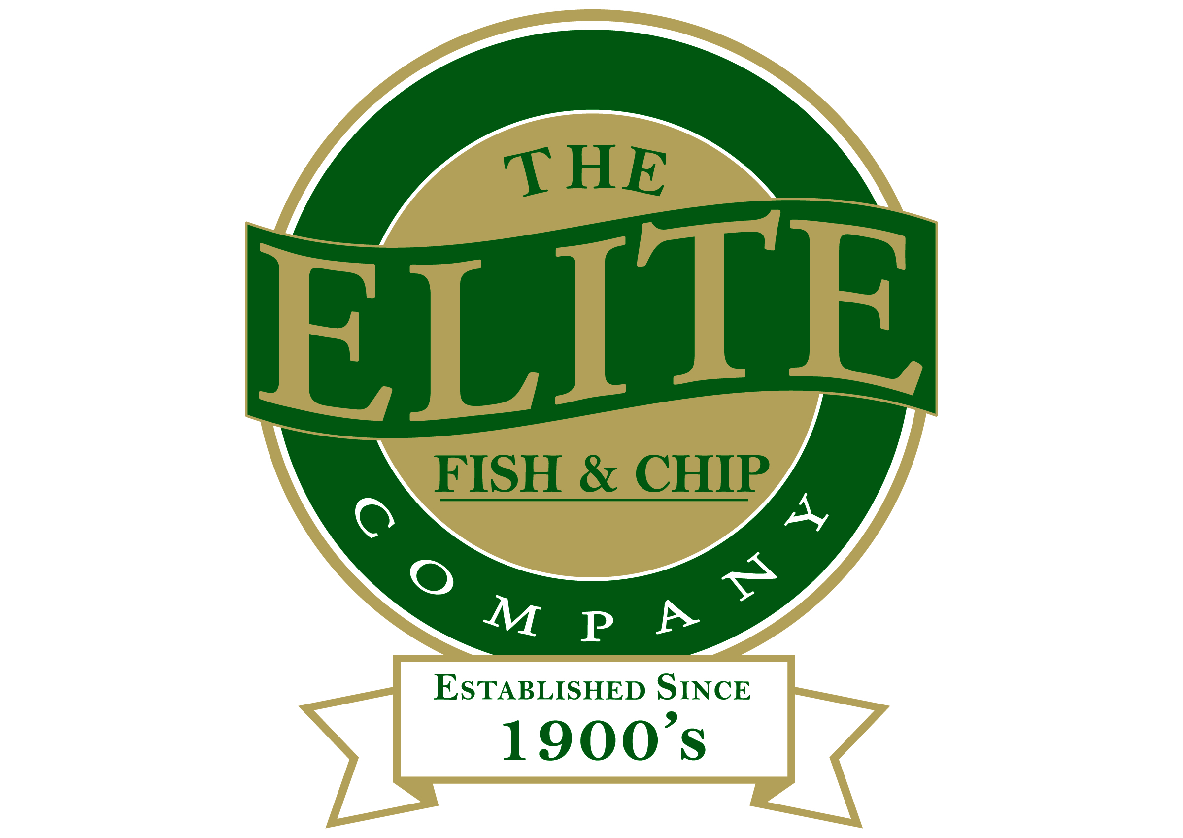
News release

29th June 2016

Elite Flies the Flag for Armed Forces Day

It was a night of delicious fish and chips and wartime tunes for revellers at the Sleaford branch of The Elite Fish & Chip Company at the weekend.

As part of Armed Forces Day on Saturday 25th June, Lincolnshire 1940s singer and entertainer Heather Marie performed at the Grantham Road restaurant, where guests raised an amazing £1,686.60 for the Elite’s charity of the year, the Royal British Legion Poppy Appeal.

Rachel Tweedale, who runs the Sleaford restaurant and takeaway, said: “We had an incredible sell-out evening and people really took to the theme!

“We’re so pleased to have raised this amount of money for our charity of the year. Thanks must go to our generous customers, who dug deep and kept donating all night. This will be the first of many nights at our Sleaford branch, so keep your eye out for more!”

After a delicious fish and chip supper, diners enjoyed two rousing sets of wartime tunes from Heather Marie, who sang hits such as ‘Somewhere Over The Rainbow’, ‘Pennies From Heaven’ and ‘We're Going To Hang Out The Washing On The Siegfried Line’.

As well as donating every penny from tickets sales and the proceeds from the bar on the night, the Elite’s staff also did their bit, donating their time for free for the evening.

“Our staff are brilliant here,” added Rachel. “I’m very proud of them all for their dedication and hard work on the evening. We couldn’t have done it without them.”

Heather Marie said “This was a really fun night! I’ve never performed in a fish and chip restaurant before, but it turned out to be the perfect setting. People were singing along and waving their flags all night and I’m so pleased to hear how much we managed to raise!”

For more information, call the Sleaford restaurant on 01529 414534 or follow The Elite Fish & Chip Company on Twitter and Facebook.

Ends

Notes to editors:

- The Elite Fish & Chip Company has three restaurants and takeaways: Lincoln, Ruskington and Sleaford.
- It has been serving the finest fish and chips for more than 40 years.
- It is a family-owned business in its third generation of friers.
- The Elite Fish and Chip Company won the National Fish and Chip Shop of the Year in 1992.
- Follow The Elite Fish and Chip Company on Twitter @chippyelite

For media information please contact:
Mike Shields
Shooting Star
01522 528540
mike@weareshootingstar.co.uk
[Elite34WartimeNight]

