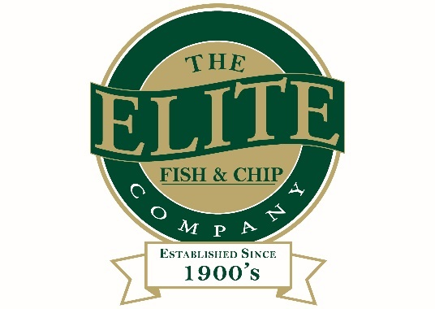

News release

2nd August 2016

Ruskington Recognition Completes Elite’s Quality Trio

A Lincolnshire restaurant and takeaway chain is continuing to fry high after renewing its National Federation of Fish Friers Fish & Chip Quality Award status at all three outlets.

The Elite Fish & Chip Company in Ruskington is the latest to have retained the award, which identifies fish and chip outlets that serve the highest quality fish and chips and deliver the best level of service.

Each Fish and Chip Quality Award is valid for two years and retention is dependent on standards being maintained. These are awarded by assessors from the National Federation of Fish Friers (NFFF), the trade body that represents the nation’s fish and chip shops.

Shops are scored on presentation, hygiene and cleanliness, staff training, equipment, frying and sales skills and, most importantly, the quality of the cooked product.

Owner Adrian Tweedale said: “After a period of thorough inspection and assessment, we are delighted to say that the Elite has once again come out on top.

“All our locations have their own unique charm, but now they can be formally recognised for their consistency in the highest levels of quality and service.”

The NFFF runs the Quality Award scheme as a way of raising standards within the fish and chip trade and enhancing the profile of the industry.
It serves to reward and promote shops that provide good quality products and exceptional standards of hygiene, as well as friers who show a high level of competence.

There are currently around 250 fish and chip outlets across the country that have been recognised with the NFFF Fish & Chip Quality Award.

Welbourne’s Fish & Chips in Ruskington, which is also owned by Adrian, has been recognised alongside the Elite Fish & Chip Company.

NFFF President Gregg Howard explained: "The NFFF Fish & Chip Quality Award assessment is extremely comprehensive. It sets the new benchmark for quality within the industry.

“We examine everything from food safety to other key aspects of business, from preparation and cooking equipment to the management of paperwork and the traceability of fish.

"Adrian and the staff at all of his restaurants and takeaways clearly take pride in where they source their fish and potatoes from. This provides the reassurance to customers that they are being served food made with high-quality ingredients.”

For more information about The Elite Fish & Chip Company, visit: www.elitefishandchips.com.

Ends

Notes to editors:

- The Elite Fish & Chip Company has three restaurants and takeaways: Lincoln, Ruskington and Sleaford.
- It has been serving the finest fish and chips for more than 40 years.
- It is a family-owned business in its third generation of friers.
- The Elite Fish and Chip Company won the National Fish and Chip Shop of the Year in 1992.
- Follow The Elite Fish and Chip Company on Twitter @chippyelite
- For more information, visit: www.elitefishandchips.com

For media information please contact:
Zoe Lamb
Shooting Star
01522 528540
zoe@weareshootingstar.co.uk
[Elite36QualityAward]

