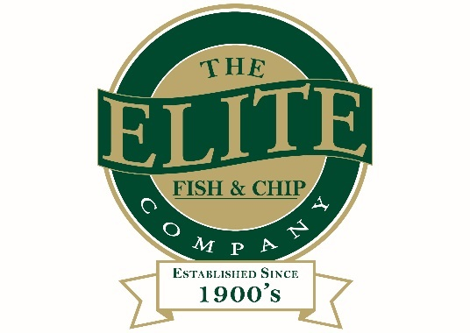

News release

8th August 2016

Elite Underlines Family Values as Lauren Returns

It’s always been a family affair at The Elite Fish & Chip Company and now another member of the Tweedale family has joined the ranks.

Lauren Tweedale, 23, has joined the fish and chip chain at the Sleaford branch after relocating from Sheffield. Having worked in retail for the past two years, Lauren has made the move to be closer to family and to work in what she says is a trade that is in her blood.

Lauren, who is the younger sister of Sleaford manager Rachel, said: “It’s great being back and working alongside my family, and in particular my sister. There’s a lot to learn but I feel like I’ve come back at the right time. I’ve worked out what it is I want to do with my career and to be part of the family firm is brilliant.

“What I like is that there are so many options for me to progress within the company. As there are three very different restaurants and four takeaways, I’m spoilt for choice. With work also available at our Welbourne’s bakeries in Navenby and Ruskington, I’m going to be able to meet all my fellow staff, get to know our customers and learn so many new skills.”

So far Lauren has been working at the company’s Sleaford branch, shadowing her sister and reminding herself of the fast-paced takeaways and restaurant environment.

“I’ve worked at the takeaway in the past, but there’s so much more to it behind the scenes. I’m hoping my retail experience will come into use and I can be a valuable member of the team here at Elite.”

Elite owner Adrian Tweedale said: “To have my daughter Lauren working alongside her sister Rachel is brilliant. Lauren is a practical thinker and is always full of ideas on how we can improve. She’ll have some real insight into the younger market and her work in consumer retail will no doubt come in useful.”

Lauren is now a third-generation fish frier, with her grandfather David having founded the company, father and mother Adrian Tweedale and Jayne Wright still working within the company and with younger sisters who also work as waitresses.

Adrian added: “We’re a proud, family-run company. It’s great that Rachel has won another award for her services to the industry and another one of our daughters is making a commitment like this to the business. We welcome Lauren back to Lincolnshire and wish her lots of luck!”

For more information about The Elite Fish & Chip Company, visit: www.elitefishandchips.com.

Ends

Notes to editors:

- The Elite Fish & Chip Company has three restaurants and four takeaways in Lincoln, Ruskington and Sleaford.
- The Elite also owns Welbourne’s Bakery, which has shops in Navenby and Ruskington.
- It has been serving the finest fish and chips for more than 40 years.
- It is a family-owned business in its third generation of friers.
- The Elite Fish and Chip Company won the National Fish and Chip Shop of the Year in 1992.
- Rachel Tweedale was the Drywite Young Fish Frier of the Year 2015 and has recently won a recognition for her services to the industry at the Family Business Place Red Ribbon Awards.
- Follow The Elite Fish and Chip Company on Twitter @chippyelite
- For more information, visit: www.elitefishandchips.com

For media information please contact:
Mike Shields
Shooting Star
01522 528540
mike@weareshootingstar.co.uk
[Elite38LaurenTweedale]

