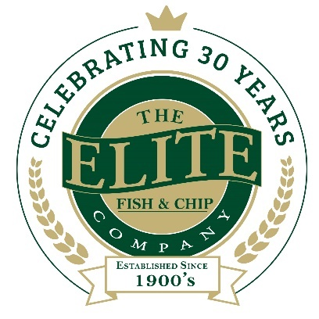
News release

14th February 2018

Elite Gets Behind the Imps with VIP Charity Draw

The Elite Fish & Chip Company is offering a lucky pair of Lincoln City FC fans the chance to go to Wembley for just £2 in an exclusive charity prize draw.

Customers dining at the family-run fish and chip chain’s three restaurants and takeaways in Lincoln, Ruskington and Sleaford will be able to purchase a ticket for £2. This enters them into a prize draw to win a pair of Diamond Package tickets to the Checkatrade Trophy final at Wembley Stadium.

The Imps recently beat Chelsea’s U21 squad on penalties at Sincil Bank to make the trip to the iconic national stadium for the first time in the club’s 133-year history. They will now face either Shrewsbury Town or Yeovil Town in the final on 8th April.

Director at The Elite Fish & Chip Company Adrian Tweedale said: “After finding out that Matt Green, one of Lincoln’s star players, comes to eat fish and chips with us before games, we wanted to show our support now the Imps have made it to Wembley, which is a fantastic achievement.

“All the money raised from the draw will go towards our three charities of the year. We’re aiming to raise £30,000 this year for the RAF Association, the RNLI and Sleaford Dementia Support. This is to celebrate 30 years in the county since our first restaurant opened in 1988 in Ruskington.”

The Diamond Package includes:
- Reserved premium tickets on Level 2 in blocks either side of the Royal Box
- Access to the Atrium from turnstile opening
- Three-course buffet pre-match
- Inclusive beer, wine and soft drinks pre-match
- Beer, wine, soft drink, tea or coffee at half time
- Inclusive beer, wine and soft drinks for one hour post-match
- Match programme

Prize draw tickets cost £2 each and can only be purchased by customers dining at the restaurants and takeaways. Tickets cannot be resold. The winner must provide their own transport and be available for PR photographs.

To find out more about the Elite’s fundraising throughout the year, keep up with their Facebook, Twitter and Instagram feeds or visit www.elitefishandchips.com

Ends

Notes to editors:
- The Elite Fish & Chip Company has three restaurants and takeaways: Lincoln, Ruskington and Sleaford.
- It has been serving the finest fish and chips for more than 40 years.
- It is a family-owned business in its third generation of friers.
- The Elite Fish and Chip Company won the National Fish and Chip Shop of the Year in 1992.
- The company will be fundraising for, the RAF Wings Appeal, the RNLI and the Sleaford Dementia Group throughout 2018.
- Follow The Elite Fish & Chip Company on Twitter @chippyelite

For media information please contact:
Mike Shields
Shooting Star
01522 528540
mike@weareshootingstar.co.uk
[Elite67Wembley]

