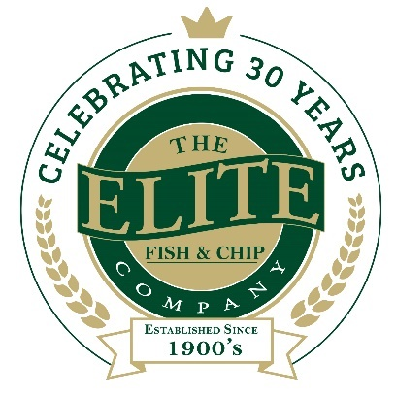
News release

5th September 2018

Lincolnshire Chip Shop Celebrates 30 Years
The Elite Fish & Chip Company, which has outlets in Lincoln, Sleaford and Ruskington, is celebrating 30 years in business in Lincolnshire this weekend – and you’re invited!
This Saturday 8th September the award-winning fish and chip chain, which is owned and managed by the Tweedale family, is celebrating 30 years since the opening of its first restaurant and takeaway in Ruskington, near Sleaford.
Co-founders David and Freda Tweedale opened the first Elite in the village of Ruskington in September 1988, after moving to Lincolnshire from Huddersfield.
In honour of the company’s 30th anniversary, the Tweedale family have pledged to raise £30,000 to be divided equally across three charities including: the RAF Association, the RNLI and Sleaford Dementia Support. To mark three decades in business in the county, the Elite Fish & Chip Company is holding celebrations at all three of its locations and is encouraging everyone to come along.

Adrian Tweedale, Director at The Elite Fish & Chip Company, said: “It’s 30 years since we set up our first Elite in Ruskington and we are thanking all of our loyal customers with celebrations across all three of our shops. Customers can expect a day of fun and will have the chance to win free fish and chips!”
The company is also giving customers the chance to win £88 worth of Amazon vouchers on its Facebook page, in honour of the first Elite opening in 1988.
“We’re running a competition on our Facebook page where customers have to guess the number of balloons inside the car. We’ve had lots of interest already, but there’s still time for people to enter as we’ll be announcing the winner on Friday 7th September,” said Adrian.
Rachel Tweedale, Director at The Elite Fish & Chip Company, said: “We’ve all been counting down to this month since the start of the year!
“Thirty years is traditionally known as the pearl anniversary and we’ve incorporated pearl-themed ideas and events into our celebrations. We’ll be open as normal at all three shops, but with the added buzz of our 30th birthday and a few extra surprises in store, it’ll be far from any ordinary Saturday.”
To find out more about The Elite Fish & Chip Company’s fundraising efforts throughout the year, follow its Facebook, Twitter and Instagram feeds or visit: www.elitefishandchips.com.
Ends
Notes to editors:
- The Elite Fish & Chip Company has three restaurants and takeaways: Lincoln, Ruskington and Sleaford.
- Awards recently won include: ‘Heart of the Community’ at the Lincolnshire Media Business Awards, ‘Big Heart’ at the National Family Business Awards and ‘Regional Family Business of the Year’ at the East Midlands FSB Awards.
- It has been serving the finest fish and chips in Lincolnshire for 30 years.
- It is a family-owned business in its third generation of friers.
- The company will be fundraising for, the RAF Wings Appeal, the RNLI and the Sleaford Dementia Group throughout 2018.
- Follow The Elite Fish & Chip Company on Twitter @chippyelite

For media information please contact:
Nikhita Keshwara
Account Executive
Shooting Star
01522 528540
nikhita@weareshootingstar.co.uk
[Elite72PearlAnniversary]

