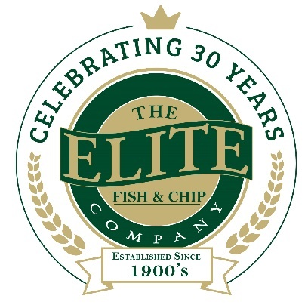
News release

5th October 2018

Lincolnshire Chip Shop Named in UK Top 20 Restaurants
The Elite Fish & Chip Company is celebrating once again after its Sleaford restaurant has been named as one of the UK’s top 20 for fish and chips!
Following the news of the shortlist, the Lincolnshire-based chain, which has outlets in Lincoln, Sleaford and Ruskington, will now compete for a place in the final at the 2019 National Fish & Chip Awards as semi-finalists in The Best Fish & Chip Restaurant category.
Rachel Tweedale, Manager at the Elite’s Sleaford restaurant, said: “We’re absolutely bowled over to be named as one of the best places in the UK for fish and chips, and the only one in Lincolnshire too! We’re still on a high from celebrating our 30th anniversary last month, so this news has come at an exciting time!
“To reach this stage of the competition our restaurant was carefully assessed against a range of judging criteria, which considered everything from menu development to staff training, marketing and promotional activity.
“For us, there would be no better way to end our 30th anniversary year than with the title of the UK’s best fish and chip restaurant. Fingers crossed we can make it through the next stage of judging.”
The UK’s Fish and Chip Restaurant of the Year will be announced at The National Fish & Chip Awards’ 31st anniversary, at a ceremony in London on 24th January 2019.
To find out more about the awards visit: http://www.fishandchipawards.com/about-the-awards.
In honour of the company’s 30th anniversary this year, The Elite Fish & Chip Company has pledged to raise £30,000 to be divided equally across three charities including: The RAF Association, the RNLI and Sleaford Dementia Support.
To find out more about The Elite Fish & Chip Company’s fundraising efforts, follow its Facebook, Twitter and Instagram feeds or visit: http://www.elitefishandchips.com/.
Ends
Notes to editors:
- The Elite Fish & Chip Company has three restaurants and takeaways: Lincoln, Ruskington and Sleaford.
- Awards recently won include: ‘Heart of the Community’ at the Lincolnshire Media Business Awards, ‘Big Heart’ at the National Family Business Awards and ‘Regional Family Business of the Year’ at the East Midlands FSB Awards.
- It has been serving the finest fish and chips in Lincolnshire for 30 years.
- It is a family-owned business in its third generation of friers.
- The company will be fundraising for, the RAF Wings Appeal, the RNLI and the Sleaford Dementia Group throughout 2018.
- Follow The Elite Fish & Chip Company on Twitter @chippyelite

For media information please contact:
Nikhita Keshwara
Account Executive
Shooting Star
01522 528540
nikhita@weareshootingstar.co.uk
[Elite73UKTop20]

