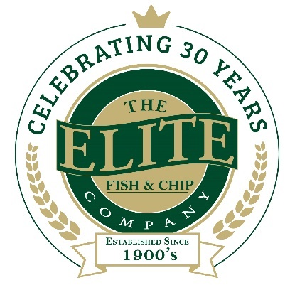
News release

20th December 2018

Lincolnshire Chip Shop Featured in The Book of Amazing People
Following a successful 30th anniversary year, the Elite Fish & Chip Company is ending 2018 on a high after being the only business to be featured in The Book of Amazing People.

The Lincolnshire-based family-run business made the final cut and has its own dedicated chapter in the prestigious book – a ground-breaking project showcasing individual achievement and featuring inspiring real-life stories.

The chapter tells the story behind the success of the Elite brand, which was brought to life by the Tweedale family in 1988. Readers can get an insight into what life was like for the family in Huddersfield before they uprooted and left for a new start in rural Lincolnshire.

Adrian Tweedale, Director at the Elite Fish & Chip Company, said: “To have our story told in The Book of Amazing People is just fantastic and we're absolutely over the moon with the news!

“It was quite emotional putting our chapter in the book together as it meant that we, as a family, were able to reflect and retrace the steps that helped us to get to where we are today. In our 30-year history we’ve been lucky enough to experience many highs, but our success hasn’t come without challenges.

“Ultimately the road to success began with my parents David and Freda all those years ago. We’re so honoured to be able to share their legacy with the world – and we hope everyone enjoys reading it!”

The Book of Amazing People highlights individual successes and each chapter delivers inspiring and motivating real-life stories of ordinary people that make their lives truly extraordinary. Many contributors have transformed their lives, physically and emotionally, overcoming loss, serious illness and heartbreak to achieve success against all odds. The Elite Fish & Chip Company is the only business to feature in the book.

The Book of Amazing People has already featured in My Entrepreneur Magazine as December’s book of the month.

Rachel Tweedale, co-director at the Elite Fish & Chip Company, said: “2018 has been a momentous year for my family – in September we reached a huge milestone as we officially celebrated 30 years in business in Lincolnshire, and as part of the celebrations we embarked on a year-long £30,000 fundraising campaign. Now to have our own chapter in The Book of Amazing People is the icing on the cake and a fantastic way for us to end the year!

“The chapter tells the story from the very beginning to the present day and gives an insight into all the hard work, commitment and dedication that goes into running a successful business. I can’t wait to get my hands on a copy – a perfect stocking filler! I hope it will be treasured and enjoyed by generations to come.”

To find out more about The Book of Amazing People or to purchase a copy, visit: http://voilasuccess.com/index.php/products-page/inspirational/the-book-of-amazing-people-2/.

In honour of the company’s 30th anniversary this year, The Elite Fish & Chip Company has pledged to raise £30,000 to be divided equally across three charities including The RAF Association, the RNLI and Sleaford Dementia Support.

To find out more about The Elite Fish & Chip Company’s fundraising efforts, follow its Facebook, Twitter and Instagram feeds or visit: http://www.elitefishandchips.com/.

Ends
Notes to editors:
- The Elite Fish & Chip Company has three restaurants and takeaways: Lincoln, Ruskington and Sleaford.
- Awards recently won include: ‘Heart of the Community’ at the Lincolnshire Media Business Awards, ‘Big Heart’ at the National Family Business Awards and ‘Regional Family Business of the Year’ at the East Midlands FSB Awards.
- It has been serving the finest fish and chips in Lincolnshire for 30 years.
- It is a family-owned business in its third generation of friers.
- The company will be fundraising for, the RAF Association, the RNLI and the Sleaford Dementia Group throughout 2018.
- Follow The Elite Fish & Chip Company on Twitter @chippyelite

For media information please contact:
Nikhita Keshwara
Account Executive
Shooting Star
01522 528540
nikhita@weareshootingstar.co.uk
[Elite74BookofAmazingPeople]

