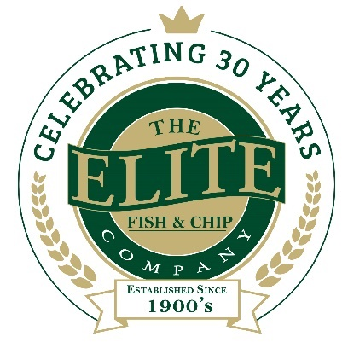
News release

20th March 2019

Double Regional Award Win for Lincolnshire Chip Shop!

The Elite Fish & Chip Company is celebrating once again after clinching two regional awards at the East Midlands Federation of Small Businesses (FSB) Celebrating Small Business Awards 2019.

The Lincolnshire-based chain which has outlets in Ruskington, Lincoln and Sleaford, scooped the Family Business of the Year award for the second year running as well as the Community Business of the Year award (area only).

Rachel Tweedale, Co-Director at The Elite Fish & Chip Company, said: “We’re absolutely thrilled to have been named East Midlands Family Business of the Year for a second year in a row!

“Last year we celebrated our 30th anniversary year and as part of the celebrations we committed to a £30,000 fundraising campaign to be split equally between three charities which all have a close connection to the Elite. To have our fundraising efforts recognised with the Community Business of the Year Award is the icing on the cake for us!

“We wouldn’t have won these awards without the hardwork and dedication of all our loyal staff - and it goes without saying that we wouldn’t have been able to reach our ambitious £30,000 fundraising target without the generosity of our loyal customers, who always show us their full support for worthy causes.”

As regional winners of the Family Business of the Year, members of staff at the Elite Fish & Chip Company will be heading to the glittering UK final on Thursday 23rd May at Battersea Evolution, where the UK category winners and FSB Business of the Year 2019 will be announced.

This double award win follows a recent spate of success for the family-run chain, which earlier this year featured in The Book of Amazing People.

In honour of its 30th anniversary, The Elite Fish & Chip Company has committed to a year-long £30,000 fundraising campaign to be divided equally between The RAF Association, the RNLI and Sleaford Dementia Support. The family-run business will be raising money for the three charities until March 2019.

To find out more about The Elite Fish & Chip Company’s fundraising efforts, follow its Facebook, Twitter and Instagram feeds or visit: www.elitefishandchips.com.

Ends
Notes to editors:
- The Elite Fish & Chip Company has three restaurants and takeaways: Lincoln, Ruskington and Sleaford.
- Awards recently won include: ‘Heart of the Community’ at the Lincolnshire Media Business Awards, ‘Big Heart’ at the National Family Business Awards and ‘Regional Family Business of the Year’ at the East Midlands FSB Awards.
- It has been serving the finest fish and chips in Lincolnshire for 30 years.
- It is a family-owned business in its third generation of friers.
- The company will be fundraising for, the RAF Association, the RNLI and the Sleaford Dementia Group until March 2019.
- Follow The Elite Fish & Chip Company on Twitter @chippyelite

For media information please contact:
Nikhita Keshwara
Account Executive
Shooting Star
01522 528540
nikhita@weareshootingstar.co.uk
[Elite76FSBAwards]

