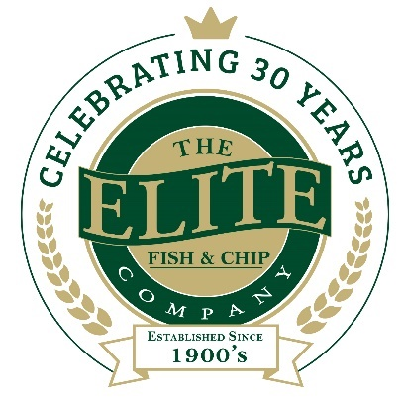
News release

13th June 2019

Gluten-Free Glory for Elite Fish & Chip Company

The Elite Fish & Chip Company is launching a new gluten-free menu at its Sleaford restaurant and takeaway this Friday (14th June).

The company, which has been serving Lincolnshire’s finest fish and chips for the last 30 years, is now expanding its Sleaford menu to include gluten-free options every Friday and Saturday between 12 noon and 8pm.

The menu includes starters, mains, desserts and sides and is available on both restaurant and takeaway orders. As well as traditional fish and chips, the menu offers smoked haddock and mozzarella fishcakes, mini filled potato skins and chocolate brownies. Gluten-free alcoholic drinks are also available.

The menu is only available in Elite’s Sleaford location as it is the only outlet with the space to accommodate the stand-alone fryer needed to safely prepare gluten-free food.

The Sleaford restaurant and takeaway has been busy preparing for the launch of the gluten-free menu; brand new equipment is now in place and Elite’s Sleaford staff have also undertaken the Coeliac UK online training course ahead of the opening.

Rachel Tweedale, Co-Director at The Elite Fish & Chip Company, manages the Sleaford restaurant and takeaway.

She commented: “We’re very excited to introduce the new menu so now more customers can enjoy our award-winning fish and chips. Many of our customers request gluten-free options and we are delighted to now offer a menu with a range of choices.

“Our customer experience is so important to us and we recognise that eating habits and dietary requirements are important now more than ever. At Elite, our fish is sustainably sourced, our suppliers are local where possible and we have expanded our menu to include healthy alternatives and seasonal produce.

“Offering a gluten-free menu at our Sleaford restaurant and takeaway is the next step for us to develop as a company – we are looking forward to welcoming new customers through the doors!”

Earlier this year, Elite’s Sleaford branch was one of only two restaurants in Lincolnshire to be awarded with the Healthier Options award by Lincolnshire County Council. The award recognises businesses that make healthier changes to their food menu and preparation, thereby helping customers to make healthier food choices.

To find out more about The Elite Fish & Chip Company, follow its Facebook, Twitter and Instagram feeds or visit www.elitefishandchips.com.

Ends

Notes to editors:
- The Elite Fish & Chip Company has three restaurants and takeaways: Lincoln, Ruskington and Sleaford.
- Awards recently won include: ‘Family Business of the Year’ for the second year running and the ‘Community Business of the Year’ award (area only) at the East Midlands FSB Awards, ‘Heart of the Community’ at the Lincolnshire Media Business Awards, and ‘Big Heart’ at the National Family Business Awards.
- It has been serving the finest fish and chips in Lincolnshire for 30 years.
- It is a family-owned business in its third generation of friers.
- The company raised £32,128.92 for the RAF Association, the RNLI and the Sleaford Dementia Group in honour of its 30th anniversary in business.
- To find out more about The Elite Fish & Chip Company, follow the company on Facebook, Twitter and Instagram feeds or visit: www.elitefishandchips.com.

For media information please contact:
Nikhita Keshwara
Account Executive
Shooting Star
01522 528540
nikhita@weareshootingstar.co.uk
[Elite80GlutenFreeMenu]

