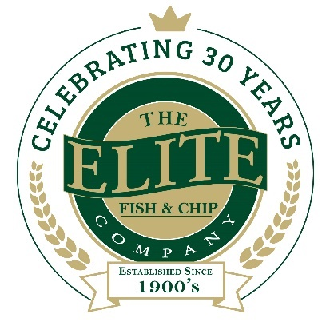
News release

22nd July 2019

The Elite Meets Green Goal to Help Tackle Climate Change

The Elite Fish & Chip Company, which has three restaurants and takeaways in Lincolnshire, is facing the challenge of climate change head on by becoming ‘zero waste to landfill’.

All the waste produced at the company’s three sites in Lincoln, Sleaford and Ruskington is now either reused, recycled, composted, or converted into energy.

Working in partnership with Veolia, the Elite has started segregating its rubbish into different bins including, more recently, one for food waste.

This is collected from the Elite’s three restaurants and takeaways once a week and taken to Hemswell Biogas where it gets converted into methane gas. The gas either goes into the National Grid or gets converted into electricity to power local homes and businesses.

Currently around three percent of the UK’s total greenhouse gas emissions comes just from the methane arising from the decomposition of biodegradable waste at landfill sites.

Angela O’Connor from Veolia explained: “Diverting food waste away from landfill is crucial to help combat climate change.

“Veolia can help the Elite and other businesses turn food waste into a valuable resource, by using anaerobic digestion to create green energy. A standard 240 litre waste bin, for example, can produce enough methane gas to fully charge three electric cars, a mobile phone for approximately 19,000 hours, and boil a kettle for 45 hours.
“The Elite is setting a great example which we hope others in the hospitality sector will follow. We’d like to congratulate them on implementing this change and their commitment to becoming a more responsible and sustainable business.”
Operations Manager Nigel Tindall said: “As a business we’re always looking for ways to improve sustainability and reduce our carbon footprint.

“We initially trialled the new bins at our Sleaford restaurant and, although separating all our rubbish takes a bit more work, the rewards are worth all the effort.

“Not only have we been able to increase recycling and lower our CO2 emissions, but we’ve also saved money. However, we couldn’t have achieved this goal without the cooperation of our staff, and I’d like to personally thank them for doing their bit.”

As part of its ongoing commitment to the environment, the Elite ensure that it serves sustainably-sourced fish from North East Atlantic fishing grounds and is MSC certified – helping to safeguard the future of our oceans.

To find out more about The Elite Fish & Chip Company, follow its Facebook, Twitter and Instagram feeds or visit: www.elitefishandchips.com.

Ends
Notes to editors:
- The Elite Fish & Chip Company has three restaurants and takeaways: Lincoln, Ruskington and Sleaford.
- Awards recently won include: ‘Heart of the Community’ at the Lincolnshire Media Business Awards, ‘Big Heart’ at the National Family Business Awards and ‘Regional Family Business of the Year’ at the East Midlands FSB Awards.
- It has been serving the finest fish and chips in Lincolnshire for 30 years.
- It is a family-owned business in its third generation of friers.
- The company raised £32,128.92 for the RAF Association, the RNLI and the Sleaford Dementia Group in honour of its 30th anniversary in business.
- To find out more about The Elite Fish & Chip Company, follow the company on Facebook, Twitter and Instagram feeds or visit: www.elitefishandchips.com.

About Veolia:
- Veolia group is the global leader in optimized resource management. With nearly 169,00 employees worldwide, the Group designs and provides water, waste and energy management solutions that contribute to the sustainable development of communities and industries. Through its three complementary business activities, Veolia helps to develop access to resources, preserve available resources, and to replenish them.
- In 2017, the Veolia group supplied 96 million people with drinking water and 62 million people with wastewater service, produced nearly 55 million megawatt hours of energy and converted 47 million metric tons of waste into new materials and energy. Veolia Environnement (listed on Paris Euronext: VIE) recorded consolidated revenue of €25.12 billion in 2017 (USD 30.1 billion). To find out more about Veolia, visit the website.

For media information please contact:
Nikhita Keshwara
Account Executive
Shooting Star
01522 528540
nikhita@weareshootingstar.co.uk
[Elite81ZeroWaste]

