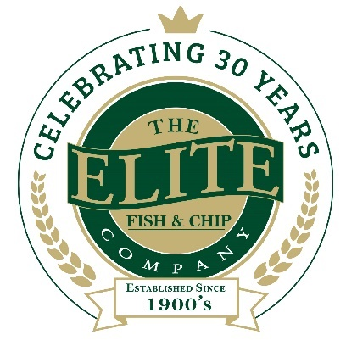
News release

15th July 2019

Lincolnshire Chip Shop Crowned National Champions!

The Elite Fish & Chip Company is celebrating after being named as national champions in the food and drink category at this year’s National Family Business Awards.

Staff from the family-run business, which has outlets in Ruskington, Lincoln and Sleaford, enjoyed a night of glitz and glamour on Saturday (13th July) to celebrate this year’s National Family Business Awards at the iconic Wembley Stadium.

Adrian Tweedale, Director at the Elite Fish & Chip Company, said: “We’re absolutely delighted to have won the national title for the food and drink Family Business of the Year! This award win is the highest accolade for a family business – and we’re thrilled to be adding more silverware to our trophy cabinet.

“We wouldn’t be where we are without our hardworking and dedicated staff, as well as our amazing customers who have shown loyalty to us over the last 30 years. This award tops off what has been a hugely successful time for our business after we raised more than £32,000 for three wonderful charities to mark our 30th anniversary.”

The award win comes after a busy and successful period for the Elite Fish & Chip Company; earlier this year the family-run firm celebrated a double award win at the East Midlands Federation of Small Businesses (FSB) Celebrating Small Business Awards 2019. In March, the Elite also announced that it would be opening a fourth restaurant and takeaway in Lincoln’s historic Bailgate which is due to open later this year.

The National Family Business Awards recognise the very best in family-owned businesses across the UK and Ireland. This year’s awards marked a decade of showcasing the very best in family-owned businesses and have become the highest and most sought-after accolade a family-owned business can take home.

To find out more about The National Family Business Awards, visit: http://thenationalfamilybusinessawards.com/

To find out more about The Elite Fish & Chip Company, follow its Facebook, Twitter and Instagram feeds or visit: www.elitefishandchips.com.

Ends
Notes to editors:
- The Elite Fish & Chip Company has three restaurants and takeaways: Lincoln, Ruskington and Sleaford.
- Awards recently won include: ‘Family Business of the Year’ for the second year running and the ‘Community Business of the Year’ award (area only) at the East Midlands FSB Awards, ‘Heart of the Community’ at the Lincolnshire Media Business Awards and ‘Big Heart’ at the National Family Business Awards.
- It has been serving the finest fish and chips in Lincolnshire for 30 years.
- It is a family-owned business in its third generation of friers.
- The company raised £32, 128.92 for the RAF Association, the RNLI and the Sleaford Dementia Group in honour of its 30th anniversary in business.
- To find out more about The Elite Fish & Chip Company, follow its Facebook, Twitter and Instagram feeds or visit: www.elitefishandchips.com.

For media information please contact:
Nikhita Keshwara
Account Executive
Shooting Star
01522 528540
nikhita@weareshootingstar.co.uk
[Elite82NFBAWin]

