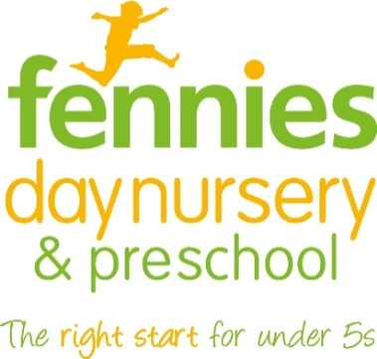
News release

20th October 2015

Fennies Kids Dress Up To Help Hospital Hero Aoife
Photo opportunity

Children and staff at Fennies day nursery and preschool in Croydon are set to dress as caped crusaders, superheroes and comic book stars on October 30th to help super parent Aoife Bennett raise money for a sick and premature baby charity.
Aoife (37) recently ran the Royal Parks Half Marathon in Hyde Park to raise cash for First Touch, the sick and premature baby charity that helps patients and parents at St George’s Hospital, Tooting.
Fennies on St Augustine’s Avenue in Croydon is set to add to the money raised so far, which already stands at over £1,300.
Aoife’s baby son Eoghan (one), a regular at the nursery, was born at St George's at 36 weeks weighing just 1.8kg in August last year.
He was resuscitated, had part of his bowel removed and was intensive care for six days and a high dependency unit for three weeks.
Aoife said: “It was a very frightening time for us but we were incredibly lucky to be in such a wonderful hospital with incredible facilities. Everyone from the nurses, doctors, to the cleaners were amazing.
“We wanted a way to say thank you to First Touch as it supports the sick and premature babies cared for in the neonatal unit. The charity raises funds for vital medical equipment and patient welfare. It’s amazing to see how many babies benefit from this incredible charity. We are very grateful for everything.”

Aoife added: “The run went really well considering I didn't get to train as much as I wanted due to an injury. The day itself was perfect, a beautiful autumn day in a stunning location. I ran it in two hours, seven minutes. Thanks to everyone who has donated so far!”
The Manager at Fennies St Augustine’s in Croydon, Dayna Smith, said: “On 30th October we are having a Heroes Day. We are aiming to raise as much money as possible, so please join us and dress your children up in their best hero outfits!”
The nursery will also be holding a cake stall around 4pm, but is also inviting parents for sausage baps and muffins in the morning from 8.30am till 10am.

All funds raised on the Heroes Day at Fennies at St Augustine’s will go to the charity, but anyone who wants to donate can do so at Aoife’s Just Giving page.

Photo opportunity – photographers and press are invited to the nursery on St Augustine’s Avenue in South Croydon, CR2 6BA between 8am and 9am and after 4pm to take photos of the children in fancy dress. If you would like to attend please email jez@weareshootingstar.co.uk or call 01522 528540.

Notes to editors:
- Fennies runs eight childcare settings in Croydon, Horley, Bromley, Purley, Sanderstead, Epsom and Beckenham.
- The company has opened three new nurseries in Bromley, Epsom and Horley since September 2014.
- Fennies has over 20 years’ experience in the childcare sector.
- Fennies won the Medium Apprenticeship Employer of the Year category at the National Apprenticeship Awards 2012 and the Mayor’s Fund for London Award for Apprentice Employer of the Year 2015.
- First Touch is a neonatal charity that deals with premature and sick babies at St George’s Hospital in Tooting, South West London.

For media information contact:
Jez Ashberry
Shooting Star
01522 528540
jez@weareshootingstar.co.uk
@jezashberry
[fennies05heroesdaycroydon]

