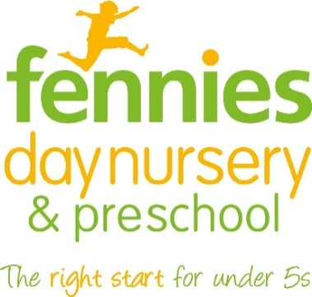
News release

21st March 2016

Day of Excellence for Fennies Nursery Staff

Around 220 employees from Fennies Day Nursery and Preschool will get together for a Day of Excellence at the home of Crystal Palace FC on Thursday (24th March).

Staff from Fennies’ eight nurseries located across south London and Surrey will spend a day celebrating the company’s achievements and hearing from expert and inspirational speakers.

The event will take place on Thursday 24th March and will feature talks by Dr Jools Page from the University of Sheffield and food writer Annabel Karmel MBE.

Dr Page carried out a study with Fennies into what she has dubbed ‘professional love’ and will talk about the importance of encouraging early years professionals to express affectionate and caring behaviours towards the children in their care.

Annabel Karmel is currently working on a new menu for Fennies and will be inviting the company’s staff to try some dishes from the new menu as well as giving a talk on how she started her career and the importance of never giving up.

She will also be passing on some tips on healthy snacks and talking about the new Fennies menu.

The day will conclude with the presentation of the Fennies Awards of Excellence, including the Apprentice of the Year award.

“In the past 18 months Fennies has taken great strides, opening three new nurseries in Bromley, Epsom and Horley, and we are continuing to expand and grow,” said John Warren, Director of Childcare Services at Fennies.

“We regard our employees as part of the Fennies family and we are always looking for ways to encourage them to work together even though they may be based in nurseries in different parts of London and the south-east.

“Our Day of Excellence will be an opportunity to bring our staff together, to inspire them and to encourage learning and the sharing of great ideas. We’re really looking forward to the day!”

Fennies has nurseries in Croydon, South Croydon, Purley, Bromley, Epsom, Horley, Sanderstead and Beckenham.

The Day of Excellence runs from 9.15am until 5pm on Thursday 24th March at Selhurst Park, home of Crystal Palace FC, London SE25 6PU.

Reporters and photographers are welcome to attend. Please advise of your attendance before the day by emailing jez@weareshootingstar.couk or calling 07780 735071.

Notes to editors:
- Fennies is a fast-growing nursery group which runs eight childcare settings in Croydon, Horley, Bromley, Purley, Sanderstead, Epsom and Beckenham.
- The company has opened three new nurseries in Bromley, Epsom and Horley since September 2014.
- Fennies has over 20 years’ experience in the childcare sector.
- Fennies won the Medium Apprenticeship Employer of the Year category at the National Apprenticeship Awards 2012, the Mayor’s Fund for London Award for Apprentice Employer of the Year 2015 and the Best Recruitment Initiative at the NMT Nursery Awards 2015.
- Visit www.fennies.com for more information.
- To find out more about Dr Jools Page and her research on ‘professional love’ visit http://professionallove.group.shef.ac.uk/
- To find out more about Annabel Karmel MBE visit http://www.annabelkarmel.com

For media information contact:
Jez Ashberry
Shooting Star
01522 528540
jez@weareshootingstar.co.uk
@jezashberry
[fennies08excellenceday]

