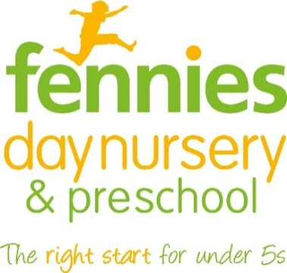
News release

29th March 2016

Inspiring Day of Excellence for Fennies Staff

Two hundred childcare practitioners from nursery chain Fennies enjoyed an inspiring and informative Day of Excellence on Thursday (24th March).

The event was the first of its kind staged by Fennies, which runs eight nurseries in south London and Surrey. It took place at Selhurst Park, home of Premier League club Crystal Palace FC, and featured workshops, seminars and expert talks.

The two key speakers were Dr Jools Page from the University of Sheffield, who spoke about her research into ‘professional love’, and children’s food writer Annabel Karmel MBE.

Dr Page carried out a study with Fennies into what she has dubbed ‘professional love’ and spoke to staff about the importance of encouraging early years professionals to express affectionate and caring behaviours towards the children in their care.

Annabel Karmel is currently working on a new menu for Fennies and staff got to try out some meals created from her menus at lunchtime.

“It was fantastic to be a part of Fennies’ Day of Excellence,” said Annabel. “The whole event was a great success and I loved meeting the hard-working team, especially the talented chefs who were busy preparing my recipes for lunch!”

The day ended with the presentation of Fennies annual awards as follows:

- Apprentice of the Year – Brooke Kelly (Blyth Road, Bromley)
- Personality of the Year – Kirstie Davis (Hook Road, Epsom)
- Inspirational Nursery of the Year – Christchurch Road, Purley
- Employee of the year –
  - King's Hall Road, Beckenham - Mandy Favell
  - St Augustine's, South Croydon - Charlotte Bailey
  - Addiscombe Road, Croydon - Charmaine Reid
  - Christchurch Road, Purley - Bonnie Matlock
  - Blyth Road, Bromley - Sophie Smith
  - Hook Road, Epsom - Maria Townsend
  - Beech House, Sanderstead - Veronica Coppard
  - Albert Road, Horley - Rachel Bound

“We feel it’s really important to develop all our employees and make them feel part of one big family,” said John Warren, Director of Childcare Services at Fennies, who organised the day.

“Our Day of Excellence was a great opportunity to bring our staff together, to inspire them and to encourage learning and the sharing of great ideas. It was a tremendous success and we look forward to staging similar inspirational events in the future.”

Notes to editors:
- Fennies is a fast-growing nursery group which runs eight childcare settings in Croydon, Horley, Bromley, Purley, Sanderstead, Epsom and Beckenham.
- The company has opened three new nurseries in Bromley, Epsom and Horley since September 2014.
- Fennies has over 20 years’ experience in the childcare sector.
- Fennies won the Medium Apprenticeship Employer of the Year category at the National Apprenticeship Awards 2012, the Mayor’s Fund for London Award for Apprentice Employer of the Year 2015 and the Best Recruitment Initiative at the NMT Nursery Awards 2015.
- Visit www.fennies.com for more information.
- To find out more about Dr Jools Page and her research on ‘professional love’ visit http://professionallove.group.shef.ac.uk/
- To find out more about Annabel Karmel MBE visit http://www.annabelkarmel.com

For media information contact:
Jez Ashberry
Shooting Star
01522 528540
jez@weareshootingstar.co.uk
@jezashberry
[fennies09excellenceday]

