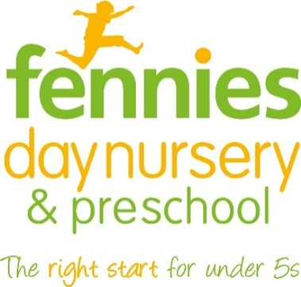
News release

8th August 2016

Nursery Raises Hundreds for Children with Brain Injuries

Fennies’ Hook Road, Epsom nursey has raised a total of £400 for The Children’s Trust in Tadworth.

On Saturday 30th July, the nursery opened its doors to the public for its annual summer fete.

For the 50 parents and children in attendance, there was plenty to see and do. Activities included an ice-cream van, face painting, hook-a-duck and a craft store.

Nursery Manager, Laura Lunn explained: “We had a terrific fun-filled day and we would like to thank everyone who came along and helped us raise a really good amount for the charity. A fire engine also came to visit us, which the children particularly enjoyed, and it was very exciting when it had to leave to answer an emergency call.”

Businesses including Nandos, Quest, Zig Zag and Ron Glazier Personal Training donated gifts to the raffle.

“I’d also like to thank all of the local companies which donated gifts to our raffle,” added Laura. “We really appreciated their generosity and support as The Children’s Trust, which provides expert rehabilitation, education, therapy and care for children with brain injuries and support for their families, is such a worthwhile cause.”

Ends

Notes to editors:
About Fennies
- Fennies runs eight childcare settings in Croydon, Horley, Bromley, Purley, Sanderstead, Epsom and Beckenham.
- The company has opened three new nurseries in Bromley, Epsom and Horley since September 2014.
- Fennies has over 20 years’ experience in the childcare sector.
- Fennies won the Medium Apprenticeship Employer of the Year category at the National Apprenticeship Awards 2012 and the Mayor’s Fund for London Award for Apprentice Employer of the Year 2015.
- Visit www.fennies.com for more information.

For media information, please contact:
Jez Ashberry
Shooting Star
01522 528540
jez@weareshootingstar.co.uk
@jezashberry
[Fennies14summerfete]

