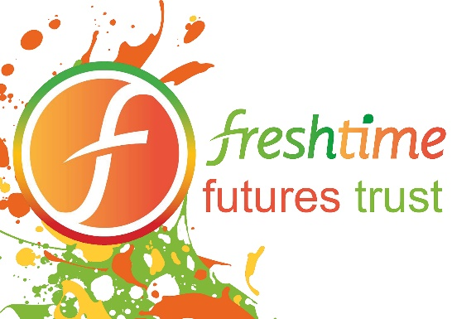

News release

23rd March 2017

Beyoncé and Bublé Tributes to Star at Freshtime Charity Gala

Freshtime Futures Trust is set to host a star-studded annual gala to raise awareness and funds to support young people in Lincolnshire.

The Night with the Stars Gala will take place on Saturday 28th October 2017 at Springfields Event Centre in Spalding, Lincolnshire and promises to be a night to remember.

Headline acts Aaron Carty as Beyoncé and Jamie Flanagan as Michael Bublé will join the Bootleg Bee Gees and The Look to entertain guests while professional impressionist Darren Altman, who rose to fame on Britain’s Got Talent, will MC the event.

The gala is one of a handful of events planned for the year to help the Freshtime Futures Trust raise funds to support local young people in achieving their ambitions.

Mark Newton, Managing Director of Freshtime and Trustee of the Freshtime Futures Trust, said: “We received such positive feedback from everyone who attended our first gala that when people started to ask what our plans were for 2017 we wondered how we would ever top it.

“Having raised £40,000 during the gala in 2016 we knew that we would have to pull out all the stops this year to deliver even more to our guests, and we hope the choice of entertainment reflects that.”

The trust recently announced its first beneficiaries as pupils of The Pilgrim School, a Community Special School (Hospital School) which supports 120 children aged four to 16 across its sites in Lincoln, Sleaford, Louth and Boston.

Another round of beneficiaries will be announced soon after the next trustees’ meeting.

In the meantime, applications for funding are sought from young people aged 11 to 25 living in the Lincolnshire area who need financial support to help them achieve their goals. Application forms can be downloaded from http://freshtimefuturestrust.org

Funding can be used to pay for anything from specialist sports equipment to travel costs to attend school, further education or an apprenticeship. Applicants who enjoy a specialist sport or art should also get in touch if they need equipment or access to expert training.

To buy tickets for the Night with the Stars Gala Dinner, which cost £50 each, contact the team on 07769 930 124 or email info@freshtimefuturestrust.org

Further announcements will be shared on the Freshtime Futures Trust Facebook www.facebook.com/freshtimefuturestrust and Twitter www.twitter.com/futurestrust pages.

If you would like some more information on how to apply or to donate to the trust please visit the website http://freshtimefuturestrust.org
ENDS
Notes to editors:

- The Freshtime Futures Trust is a registered charity and is the brainchild of leading Lincolnshire food producer Freshtime UK
- The trust is supported by seven trustees from various backgrounds. These are: Chris Luck, the former Air Commandant from RAF College Cranwell; Peter McDermott, Managing Director of Food Network Ltd; Graham Shooter, Director of A E Lenton Group; Neil Rhodes, former Chief Constable of Lincolnshire Police; and Freshtime’s Head of Procurement John Stokes, Chairman Mark Swanwick and Managing Director Mark Newton.
- Freshtime Futures Trust aims to help individuals aged 11 to 25 realise their full potential by providing financial support to allow recipients to access specialist training, apprenticeship schemes or to support additional academic or sporting pursuits.
- For more information visit: freshtimefuturestrust.org

For media information contact:
Kerri Saxby
Shooting Star
01522 528540
kerri@weareshootingstar.co.uk
[freshtime70NWTSGala]

