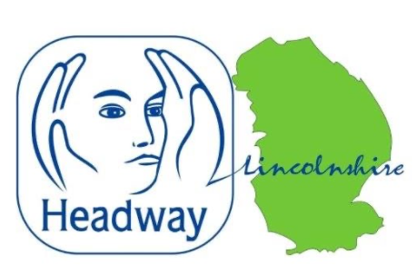
News release
7th October 2022
Brain Injury on the Agenda at Charity Conference
The One Punch Campaign, relationships after brain injury and real life brain injury survivor stories are just some of the topics visitors can hear about at Lincolnshire’s only brain injury conference of the year.
Headway Lincolnshire is hosting the event at the Lincolnshire Showground on Tuesday 18th October to raise awareness of acquired brain injury and the support survivors and their families can receive.

This year’s theme is ‘Making the Invisible, Visible’, which refers to the hidden disabilities that brain injury survivors may face long after their initial trauma.

Approximately 200 people are expected to attend the event, which is sponsored by Ringrose Law, Roythornes Solicitors, PremEx Services and MediLaw.

The conference will review brain injury, its diverse range of causes and its effects on the wider community. Delegates will hear perspectives from specialists across a variety of sectors to understand the unique ways in which brain injury survivors can benefit from tailored rehabilitation, from diagnosis through to therapy.

Topics and expert presentations on the day will cover concussion in sport, brain injury and the criminal justice system, the One Punch campaign, and more.

Keynote speakers include:
- Marc Jones, Police and Crime Commissioner for Lincolnshire and Chair of the Association of Police and Crime Commissioners
- Sean Morton, Senior Lecturer at the University of Lincoln’s School of Health and Social Care
- Dr Gemma Elliott, Consultant Clinical Neuropsychologist
- Dr Lauren Roche, Clinical Neuropsychologist
- Dr Daniel O ’Hara, Consultant Neuropsychologist
- Professor Huw Williams, Professor of Neuropsychology at the University of Exeter
- Nicola Hunt, Specialist Neurological and Vestibular Physiotherapist
- Sophie Garner, Vocal Coach and Wellbeing Music Specialist
- John Knight, Director and Solicitor at Ringrose Law
- Elizabeth Young, Partner at Roythornes Solicitors

There will also be an opportunity to attend health and care exhibitor stands and hear from brain injury survivors who have been directly supported by Headway Lincolnshire.

Ann-Marie Smith, Coordinator and Development Officer at Headway Lincolnshire, said: “We are delighted to be hosting this year’s brain injury conference, ‘Making the Invisible, Visible’.
“Our aim is to raise awareness of the non-visible, though life-changing, impact of sustaining an acquired brain injury. Living with hidden disabilities can make everyday life more demanding.
“Without visible evidence of the disability, it is often the case that others, including professionals, fail to acknowledge the challenges faced and there can be a lack of understanding and sympathy for those experiencing hidden disabilities.”

To find out more, contact Ann-Marie at info@headwaylincolnshire.org.uk.

Recent statistics from Headway UK have revealed that between 2019 to 2020, there were approximately 977 hospital admissions per day in the UK for acquired brain injuries (ABI), which equates to roughly one every 90 seconds.

In the same year, Lincolnshire’s hospitals received a total of 4,262 admissions.

The need for ABI provision and support in Lincolnshire is growing, and Headway Lincolnshire continually works to support and aid those living with an ABI and their families.
If you or someone you know may be suffering from a head injury, click here to get in contact with the Headway Lincolnshire team.

Notes to Editors:

About Headway Lincolnshire:
- Headway Lincolnshire is affiliated with Headway, the brain injury association.
- Registered charity number: 1151708.
- The charity does not receive any statutory or government funding.
- Based in Boston, Headway Lincolnshire works in partnership with specialist health teams, including neuropsychology, neurological outreach teams, rehabilitation consultants, and Ashby Ward at Lincoln County Hospital.
- If you have a brain injury, or care for someone who does, and would like more information or help to find the most appropriate support available, visit the Headway Lincolnshire website or connect on Twitter, Facebook, LinkedIn, and Instagram.

For media information please contact:

Molly Hare
Senior Account Executive
Shooting Star
Molly@weareshootingstar.co.uk
01522 528540
[HeadwayLincolnshire04Conference]

