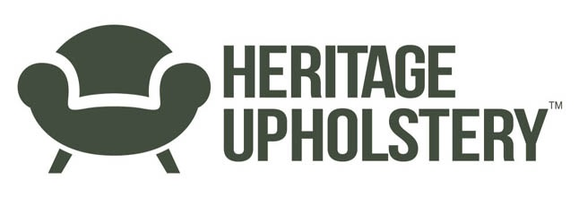
News release

6th February 2017

3D Printing Gives Heritage Upholstery Fresh Legs

Heritage Upholstery, which specialises in furniture components and upholstery supplies, is launching a new 3D prototyping service in partnership with Designblok at the University of Lincoln.

The firm, which was first established in 2011, provides legs and castors for tables, chairs, cabinets and sofas to the furniture industry as well as members of the public from its base on Cedar Parc near Lincoln.

Director Martin Fahy said although the company has thousands of products in stock, some clients require bespoke items or a variation of an existing castor, for example.

“Previously if someone wanted a bespoke product we had to create a CAD file and then get a sample made to send to the customer which could take several weeks,” he explained.

“However, we can now create a sample using the university’s 3D printers and send it to the customer within a matter of days which significantly speeds up the whole design and manufacture process.”

Senior Technician at the University of Lincoln Kevin Hallsworth said Heritage Upholstery is one of several local businesses they’re working with though the new Designblok service.

“Designblok is part of the College of Arts and brings together a range of in-house design expertise and fabrication technologies to champion the value of design as a tool for innovation and business growth.

“We’re keen to engage with local businesses like Heritage Upholstery and introduce them to new technologies like 3D printing, CNC machining or CAD and computer modelling to test, simulate and validate new product ideas.

“We’ve already worked with Martin and the team on a prototype for a new slipper cup to go on the end of a furniture leg and now we’re helping him to make alterations to an existing product.”

Martin added: “By working in partnership with the university, we can respond quickly to our customers’ needs and offer a faster more cost effective service.”

Ends

Notes to Editors:
- Heritage Upholstery specialises in the design and manufacture of furniture legs and furniture castors and supply these, alongside quality upholstery supplies, exclusively through its ecommerce website to both retail and trade customers.
- The company also stocks thousands of preconfigured furniture components ready for immediate dispatch worldwide.
- To find out more about Heritage Upholstery please visit www.heritageupholsterysupplies.co.uk

For more information, contact:
Kate Strawson
kate@shootingstar.co.uk
Shooting Star
weareshootingstar.co.uk
01522 528540
07733 230293

