News release

24th November 2015

Santa Paws is Coming to Town
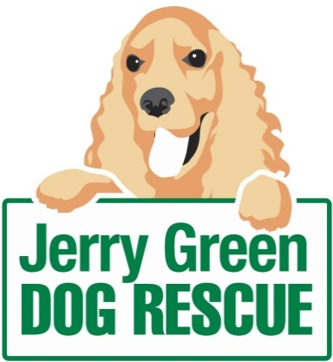
Not all dogs are lucky enough to be part of a loving home this winter, so as the festive period approaches the team at Jerry Green Dog Rescue have launched an appeal to ensure waggy tails all round this Christmas.

The charity, which has cared for and found forever homes for around 1,000 dogs in the last 12 months, is calling upon its supporters to fulfil a rescue dog’s Christmas wish by donating doggie toys and treats through its annual shoe box appeal.

“We work hard throughout the year to ensure all of our dogs are well loved and looked after, and of course we like to make their stay with us extra special at Christmas time,” said Jenny Harris, Fundraiser at Jerry Green Dog Rescue.

“Any donations from supporters are very gratefully received. In the past our dogs have enjoyed everything from kongs, rope toys and tennis balls to bones, squeaky toys, gravy bones, blankets and dog coats - even hot dogs and squeezy cheese!

The teams at each of the five Jerry Green Dog Rescue centres across the region will be doing all they can to make sure the dogs spending Christmas with them enjoy the festivities. But a shoe box packed with treats and toys would add to the fun.

Jenny continued: “It would mean so much to our dogs who are without a forever home if people were able to help put a smile on their faces during the festive period.”

Supporters who are unable to visit one of the centres but would still like to make a donation are welcome to send a cheque made payable to Jerry Green Dog Rescue marked ‘Christmas Appeal’ to the charity.

Alternatively, tech-savvy dog lovers can text JGDR15 £ followed by the amount they would like to donate to 70070, for example to donate £5 text JGDR15 £5 to 70070

Donations are welcome from now and into the New Year at any of the following Jerry Green Dog Rescue centres:

Nottinghamshire
Warsop Lane, Blidworth, Nottinghamshire, NG21 0PG
Lincolnshire
Broughton, North Lincolnshire, DN20 0BJ
Algarkirk near Boston, Lincolnshire, Marsh Lane, PE20 2BB
Yorkshire
Bennetland Lane, Gilberdyke, East Yorkshire, HU15 2TN
Catton, Thirsk, North Yorkshire, YO7 4SG

ENDS
Notes to editors:
- Jerry Green Dog Rescue was founded in 1961 in Broughton, Lincolnshire and is now one of the UK’s largest dog rescue charities.
- Jerry Green Dog Rescue has a caring ethos which puts the dogs in its care at the centre of everything it does. It also operates a policy whereby prospective adopters are introduced to dogs in a neutral environment away from the kennel, resulting in less stress for the dog and increasing the chances of permanent homes being found.
- The adoption process at Jerry Green Dog Rescue involves a number of introductory visits and the rehoming team provide pre and post adoption support to ensure the move to the dog’s new home is as smooth as possible.
- The charity receives no Government or National Lottery funding. This means it is dependent on the generosity of public and corporate donors/sponsors.

For media information please contact:
Kerri Saxby
Shooting Star
01522 528540
kerri@weareshootingstar.co.uk
[jerrygreen104ShoeboxAppeal]

