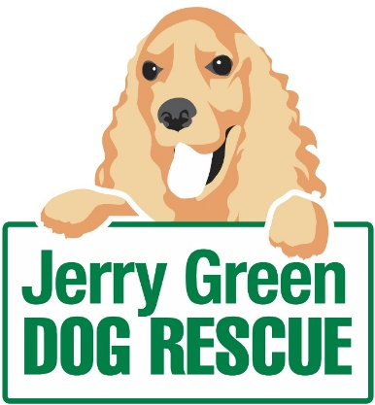
News release
6th January 2016

Warning to Dog Owners Ahead of New Law

Jerry Green Dog Rescue is encouraging dog owners to get their pets microchipped ahead of a change in the law which will make it compulsory.

From April 2016 new legislation in England will state that all dogs aged eight weeks and over must be microchipped and registered on an authorised microchip database.

Microchipping is a quick, simple and painless procedure which implants a chip the size of a grain of rice into the neck of a dog. The unique 15-digit microchip code is then assigned to the dog for life, with the owner's contact details saved on an authorised database.

“We welcome the introduction of the new law on microchipping,” said Jacqui Bell, CEO at Jerry Green Dog Rescue. “Not only will it help reunite lost dogs and owners, it will also provide an element of closure for owners whose dogs have been fatally injured.

“If you’ve recently moved house, taken ownership of a puppy or you’re yet to get your dog microchipped, January is the perfect time to update your details or book your family pet in for the simple procedure.

“As a dog owner myself I can imagine how dreadful it is to have your dog slip its collar and run off. But if the worst happens, I’d like to think someone would take my dog to the nearest vet to be scanned.”

As well as offering advice on all manner of dog-related issues, the teams at Jerry Green Dog Rescue offer a microchipping service in return for a donation to the charity. It offers peace of mind and helps fund the general running costs of the centres.

The charity has five centres Thirsk in North Yorkshire, Blidworth in Nottinghamshire, Gilberdyke in East Yorkshire, Broughton in North Lincolnshire and Algarkirk in Lincolnshire.

To book your dog in for microchipping contact your local centre for an appointment. Contact details can be found via the website: www.jerrygreendogs.org.uk/RescueCentres

All the dogs being cared for at Jerry Green Dog Rescue centres are microchipped as part of the preparation for finding forever homes.

For more information about microchipping contact Jerry Green Dog Rescue via fundraising@jerrygreendogs.org.uk or call 01652 650886.

ENDS

Notes to editors:

- Jerry Green Dog Rescue was founded in 1961 in Broughton, Lincolnshire and is now one of the UK’s largest dog rescue charities.
- Jerry Green Dog Rescue has a caring ethos which puts the dogs in its care at the centre of everything it does. It also operates a policy whereby prospective adopters are introduced to dogs in a neutral environment away from the kennel, resulting in less stress for the dog and increasing the chances of permanent homes being found.
- The adoption process at Jerry Green Dog Rescue involves a number of introductory visits and the rehoming team provide pre and post adoption support to ensure the move to the dog’s new home is as smooth as possible.
- The charity receives no Government or National Lottery funding. This means it is dependent on the generosity of public and corporate donors/sponsors.

For media information please contact:
Kerri Saxby
Shooting Star
01522 528540
kerri@weareshootingstar.co.uk
[jerrygreen105Microchipping]

