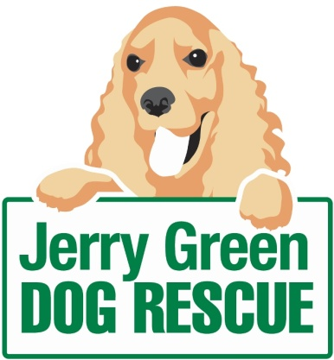
News release
15th January 2016

Volunteers Sought to Put the Fun into Fundraising

Are you a dog lover with a few hours a week to spare? Then a leading dog rescue charity wants to hear from you!

Jerry Green Dog Rescue is calling on dynamic supporters to get involved in the charity’s activities by giving up some of their spare time to become fundraising volunteers.

With operating costs of £1.5 million and almost 1,000 dogs rehomed last year, the dedicated support of staff and volunteers is vital to ensuring the charity is able to continue to address the needs of the dogs in its care.

Jenny Harris, Fundraiser at Jerry Green Dog Rescue, said: “Volunteering at Jerry Green provides an opportunity for people to make new friends and gain additional skills as well as the satisfaction of knowing they’re making a difference to the lives of dogs in need.

“We rely heavily on the outstanding contribution of our volunteers throughout the year, especially when we’re out and about fundraising. It’s for this reason we’re hoping to attract new volunteers, who share our passion for dog welfare.

“If you have some spare time and enjoy talking to new people come along and take up a role as one of our fundraising volunteers. You’ll make such a difference to our team and the lives of the dogs we support."

In exchange for their time, volunteers are provided with a full induction and ongoing training and support within their chosen role.

Fundraising activities will include attending events to raise awareness of the charity, collecting donations and engaging with supporters, sponsors and members of the public.

Casey Wray (24) from Scunthorpe has been volunteering at the North Lincolnshire centre near Brigg for the last five months.

Casey said: “I started volunteering at Jerry Green to gain valuable experience towards my degree in Events Management. Working with the fundraising team has been amazing; I have learnt to understand the processes, creativity and passion behind fundraising for a charity like Jerry Green.

"Volunteering in this environment has further boosted my desire to work in the events industry. As well as giving me real-life experience I have made some great friends and love giving up my time to care for all the beautiful dogs at the centre.”

The charity has five centres across the region, including Thirsk in North Yorkshire, Blidworth in Nottinghamshire, Gilberdyke in East Yorkshire, Broughton in North Lincolnshire and Algarkirk in Lincolnshire.

For more information about volunteering contact your local Jerry Green Dog Rescue centre. Details can be found on the website: www.jerrygreendogs.org.uk/RescueCentres

Ends
Notes to editors:

- Jerry Green Dog Rescue was founded in 1961 in Broughton, Lincolnshire and is now one of the UK’s largest dog rescue charities.
- Jerry Green Dog Rescue has a caring ethos which puts the dogs in its care at the centre of everything it does. It also operates a policy whereby prospective adopters are introduced to dogs in a neutral environment away from the kennel, resulting in less stress for the dog and increasing the chances of permanent homes being found.
- The adoption process at Jerry Green Dog Rescue involves a number of introductory visits and the rehoming team provide pre and post adoption support to ensure the move to the dog’s new home is as smooth as possible.
- The charity receives no Government or National Lottery funding. This means it is dependent on the generosity of public and corporate donors/sponsors.

For media information please contact:
Kerri Saxby
Shooting Star
01522 528540
kerri@weareshootingstar.co.uk
[jerrygreen108FundraisingVolunteers]

