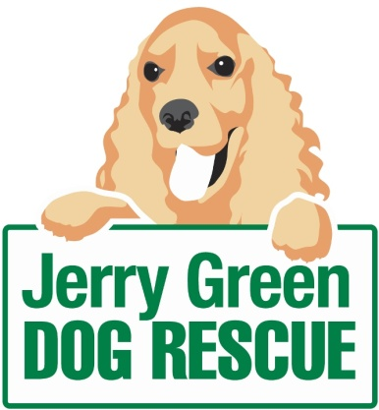
News release
16th February 2016

Donate Pounds to Hounds by Pampering Your Pooch

Treat your pooch to a pawfect pampering session at Jerry Green Dog Rescue, which has recently launched a new dog grooming service at its centre in Gilberdyke.

The grooming room at Jerry Green’s East Yorkshire centre is now open for business and dogs of all sizes can be catered for by the professional team.

Dog owners can feel just as good as their made-over mutts as all donations from the grooming service will go direct to the charity, which cares for rescue dogs until they find a forever home.

“We’re passionate about animal welfare and are pleased to be able to bring this level of care to our dog grooming service,” said Lucy Pottage, Centre Support Officer.

“As well as adding another string to our bow, we’re delighted that the donations from this service will be invested back into our work, allowing our customers to see the benefits of supporting this venture.

“Our fantastic groomer Rachel Sykes, who previously worked at Jerry Green Dog Rescue for 15 years as a kennel welfare assistant, holds a Level 3 City and Guilds qualification in dog grooming.”

Rachel said: “I’ve been offering the grooming service at Jerry Green alongside my own dog grooming business for a couple of months now, and have managed to build a small client base through word of mouth alone.

“It’s great to be back at the centre, and a lot of dog grooming customers know and recognise me from my work here before.

“So far, I’ve had some fantastic feedback with many clients booking in for repeat treatments. It would be great to build on this throughout the rest of the year.”

Rachel currently offers sessions each Wednesday at the site in Gilberdyke, East Yorkshire and booking is essential.

Prices are based on the size / breed of dog and range from £15 for a bath and brush for a small dog (Yorkshire Terriers, Shih Tzus, Jack Russell Terriers), to £30 for a full groom for a larger dog such as a Greyhound or Golden Retriever.

Other services include nail clipping and sanitary trims for just £5, as well as microchipping – which is due to become a legal requirement in April – for £10.

Lucy added: “Listed prices are a suggested donation, as we wouldn’t people to spend more than they can afford.

“I’m at the centre most days and, as a qualified dog groomer myself, I’ve got a good understanding of how long each session should last based on the needs of each dog. I’d be happy to answer any questions or queries people might have.”

To find out more or to book your dog in for a treatment, please contact the centre on 01430 449112 or visit the Dog Grooming - Jerry Green Dog Rescue Facebook page.

For more information about Jerry Green Dog Rescue in Gilberdyke please visit: www.jerrygreendogs.org.uk/RescueCentres/Show/Gilberdyke

Ends
Notes to editors:
- Jerry Green Dog Rescue was founded in 1961 in Broughton, Lincolnshire and is now one of the UK’s largest dog rescue charities.
- Jerry Green Dog Rescue has a caring ethos which puts the dogs in its care at the centre of everything it does. It also operates a policy whereby prospective adopters are introduced to dogs in a neutral environment away from the kennel, resulting in less stress for the dog and increasing the chances of permanent homes being found.
- The adoption process at Jerry Green Dog Rescue involves a number of introductory visits and the rehoming team provide pre and post adoption support to ensure the move to the dog’s new home is as smooth as possible.
- The charity receives no Government or National Lottery funding. This means it is dependent on the generosity of public and corporate donors/sponsors.

For media information please contact:
Zoe Lamb
Shooting Star
01522 528540
zoe@weareshootingstar.co.uk
[jerrygreen109DogGrooming]

