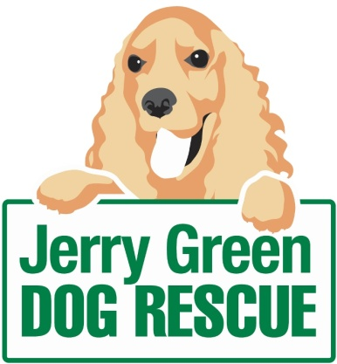
News release

** March 2016

Foster Families Needed for Four-Legged Friends

Could you provide a temporary home for a dog in need? Then Jerry Green Dog Rescue wants to hear from you!

Throughout the year Jerry Green works with a band of dedicated foster families to provide temporary support to rescue dogs who find the kennel situation stressful or are in need of a little extra care.

Animal welfare is the top priority for the charity and when the team spots a dog struggling they put the call out to the foster carers on their books.

But now, the charity is looking for more families to get involved in the fostering scheme, to help spread the load at busy times of the year.

Jenny Harris, Fundraiser at Jerry Green Dog Rescue, said: “Older dogs coming into the centre from a stable home environment owing to a change in circumstances can find the move incredibly stressful.

“Surrounded by unfamiliar dogs and people, they can find kennel space unsettling, which can contribute to a sharp decline in their health.”

Fortunately, the dog welfare team carefully monitors new arrivals and won’t hesitate to contact foster families if they need to.

Jerry Green works closely with all of its foster families to provide guidance and to arrange meet and match dates with potential adopters, so the search for a forever home can continue while the dog is in a home environment.

Jenny added: “Fostering also provides an opportunity for people who are unsure if their lifestyle is suited to having a dog full time to test-drive caring for a dog for a short period of time.

“We have had instances in the past where fosterers have fallen in love with the dogs they’re taking care of, and when the time comes to hand them back, they decide to permanently adopt instead.”

If you would like to sign up to help the charity as a fosterer please contact your nearest centre, the details for which can be found here: http://www.jerrygreendogs.org.uk/RescueCentres

For more information about Jerry Green Dog Rescue or the dogs currently looking for a forever home please visit the website: www.jerrygreendogs.org.uk

Ends
Notes to editors:

- Jerry Green Dog Rescue was founded in 1961 in Broughton, Lincolnshire and is now one of the UK’s largest dog rescue charities.
- Jerry Green Dog Rescue has a caring ethos which puts the dogs in its care at the centre of everything it does. It also operates a policy whereby prospective adopters are introduced to dogs in a neutral environment away from the kennel, resulting in less stress for the dog and increasing the chances of permanent homes being found.
- The adoption process at Jerry Green Dog Rescue involves a number of introductory visits and the rehoming team provide pre and post adoption support to ensure the move to the dog’s new home is as smooth as possible.
- The charity receives no Government or National Lottery funding. This means it is dependent on the generosity of public and corporate donors/sponsors.

For media information please contact:
Kerri Saxby
Shooting Star
01522 528540
kerri@weareshootingstar.co.uk
[jerrygreen111Foster]

