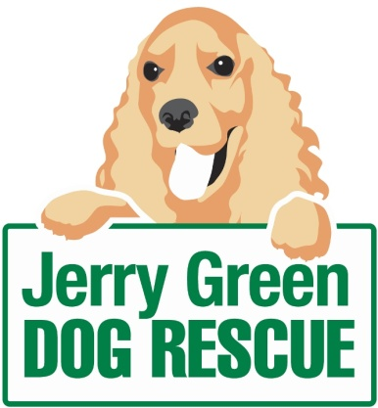
News release
19th February 2016

Staff and Pooches Praying for Win in Petplan Awards

Leading dog rescue charity Jerry Green Dog Rescue is celebrating a series of nominations for this year’s Petplan and Association of Dogs and Cats Homes (ADCH) Animal Charity Awards.

The charity, which cares for rescue dogs until they find a forever home, is a contender in all three categories for the awards: Animal Charity Volunteer of the Year, Animal Charity Employee of the Year and Animal Charity Team of the Year.

The annual Petplan and ADCH Animal Charity Awards are a chance to celebrate outstanding animal charities and not-for-profit organisations across the UK who go above and beyond to help rescue and rehome animals in need.

Simone Dewis (26) is nominated in the Animal Charity Employee of the Year category for her work as kennel welfare assistant at the Jerry Green Dog Rescue centre in Blidworth, Nottinghamshire.

In the summer of 2015, Simone took part in the Macmillan Brave the Shave campaign – having never previously cut her hair – and split her fundraising total between the cancer charity and Jerry Green.

Simone has been working for Jerry Green for the last five years. She said: “I am delighted to have been shortlisted in this year’s Petplan and ADCH Awards. I get to do something I love for a living, and to be recognised for this is an added bonus.”

Also shortlisted, in the Animal Charity Volunteer of the Year Award category, is Ralph with his furry Newfoundland friend Rafferty, who have together raised a total of £12,000 for Jerry Green Dog Rescue.

The charity has a dedicated team of volunteers at each of its five centres but Ralph, who helps out with fundraising for the charity’s site in Broughton, North Lincolnshire, has been recognised for his special efforts.

“Rafferty and I have become somewhat of a double act in the local area, and it is an absolute pleasure to have raised so much cash for such a worthy cause. But we won’t stop there!” said Ralph.

Jenny Harris, Fundraiser at Jerry Green Dog Rescue, said: “It is so great that Jerry Green Dog Rescue has been nominated in all three categories in the Petplan and ADCH Awards.

“There is so much hard work that goes on behind the scenes to provide the best level of care for all dogs we come in to contact with, and we rely solely on the fantastic support of people just like Simone and Ralph.

“These awards are a great way to recognise such support, and we are extremely grateful to everyone who nominated Jerry Green Dog Rescue.

“Whether we’re lucky enough to be winners in any of the three categories or not, we’re already proud to have come this far and are very much looking forward to celebrating on the night with our fellow nominees,” said Jenny.

Winners will be announced at the awards ceremony on 20th April 2016, and on the Petplan website the following day.

For more information about the awards, please visit www.petplan.co.uk/charityawards

If you would like to find out more about Jerry Green Dog Rescue or the dogs currently looking for a forever home, please visit the website: www.jerrygreendogs.org.uk

Ends
Notes to editors:
- Jerry Green Dog Rescue was founded in 1961 in Broughton, Lincolnshire and is now one of the UK’s largest dog rescue charities.
- Jerry Green Dog Rescue has a caring ethos which puts the dogs in its care at the centre of everything it does. It also operates a policy whereby prospective adopters are introduced to dogs in a neutral environment away from the kennel, resulting in less stress for the dog and increasing the chances of permanent homes being found.
- The adoption process at Jerry Green Dog Rescue involves a number of introductory visits and the rehoming team provide pre and post adoption support to ensure the move to the dog’s new home is as smooth as possible.
- The charity receives no Government or National Lottery funding. This means it is dependent on the generosity of public and corporate donors/sponsors.
- More information about the Petplan and ADCH Animal Charity Awards can be found on their website: www.petplan.co.uk/charityawards/

For media information please contact:
Kerri Saxby
Shooting Star
01522 528540
kerri@weareshootingstar.co.uk
[jerrygreen112PetplanAwards]

