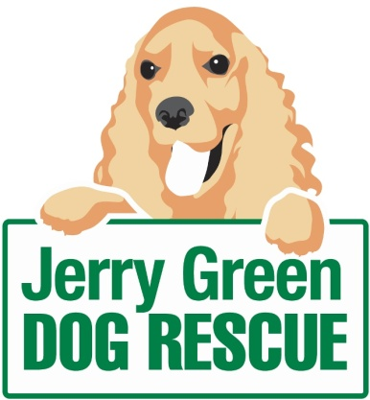

News release

14th April 2016

Jerry Green Finds New Way to Raise Pounds for Pooches

With annual running costs of £1.5 million, Jerry Green Dog Rescue is inviting dog owners to hire out its facilities as part of a series of new enterprising initiatives to raise funds.

Animal welfare is the top priority for the charity in Algarkirk, which cares for rescue dogs until they find a forever home and relies heavily on donations from the public.

As part of a series of new fundraising activities, dog owners are being invited to hire out the centre’s secure, grassed outdoor space and specialist bathroom amenities.

The cost to hire the facilities is a recommended £5 donation per half-hour with all monies going towards the running of the charity’s five centres across Lincolnshire, Yorkshire and Nottinghamshire.

Jenny Harris, Fundraiser at Jerry Green, said: “We’ve launched this initiative for all dog owners, but hiring out our paddock spaces will be particularly beneficial for those with more than one dog as they provide a large open space, away from traffic and the general public.

“If you have a new pup which you want to train or your dog has a nervous temperament, it’s a great opportunity to get them on their own to relax, without the worry that anything might happen unexpectedly.”

The centre is also offering the use of its specialist dog bathroom facilities which are available to dog owners who may not have the space or who want to limit the mess washing a dog can make in their own home.

Jenny added: “We’re delighted to be able to offer these facilities to dog lovers across the region. Not only will it offer an opportunity for owners to exercise and pamper their pets, but the donations will help boost our fundraising efforts and enable us to continue our work.”

If you are interested in hiring the facilities, please contact the centre on 01205 260546.

For more information about Jerry Green Dog Rescue, the work they do and those dogs currently looking for a forever home, please visit the website: www.jerrygreendogs.org.uk

Stay up to date with the Jerry Green staff and dogs by following their activity on Facebook.

Ends

Notes to editors:
- Jerry Green Dog Rescue was founded in 1961 in Broughton, Lincolnshire and is now one of the UK’s largest dog rescue charities.
- Jerry Green Dog Rescue has a caring ethos which puts the dogs in its care at the centre of everything it does. It also operates a policy whereby prospective adopters are introduced to dogs in a neutral environment away from the kennel, resulting in less stress for the dog and increasing the chances of permanent homes being found.
- The adoption process at Jerry Green Dog Rescue involves a number of introductory visits and the rehoming team provide pre and post adoption support to ensure the move to the dog’s new home is as smooth as possible.
- The charity receives no Government or National Lottery funding. This means it is dependent on the generosity of public and corporate donors/sponsors.

For media information please contact:
Zoe Lamb
Shooting Star
01522 528540
zoe@weareshootingstar.co.uk
[jerrygreen115EnterprisingSLincs]

