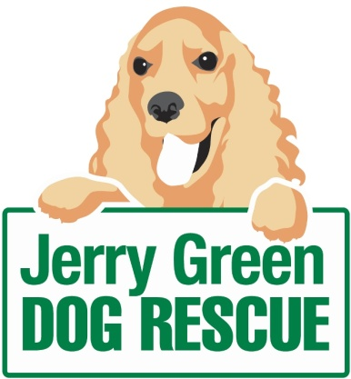
News release

31st May 2016

Spring into Volunteering with Jerry Green

Are you an animal lover looking for a volunteering opportunity that will make a difference? Then a leading dog rescue charity wants to hear from you!

With summer in the air Jerry Green Dog Rescue is calling on supporters to get involved in the charity’s activities by giving some of their spare time to become event volunteers.

Last year, teams from the five centres across the region collectively hosted and attended more than 50 events and called upon their event volunteers to support the running of the charity’s stall and talk to members of the public.

One of the volunteers urging others to get involved is Casey Wray (24) who got in touch with the team at Jerry Green Dog Rescue in Broughton to gain valuable experience towards her degree in Event Management.

She said: “Working with the fundraising team for the last seven months has been amazing, I have learnt about the processes, creativity and passion behind fundraising for a charity such as this one and this experience has further boosted my desire to work in the events industry.

“I have recently been involved in the planning and organisation for our centre’s summer show and the Moggies for the Doggies event in nearby Castlethorpe. I cannot wait to see the end result and volunteer my skills during these and other events this year.

Volunteering with Jerry Green provides an opportunity for people to gain additional skills as well as the satisfaction of knowing they’re making a difference to the lives of dogs in need.
“As well as giving me the experience I needed for my course,” added Casey. “I have made some great friends and loved volunteering some of my time to care for all the beautiful dogs at the centre.
“Even if I only have an hour to spare, it's nice to pop up to the centre and brainstorm with the fundraising team or take the dogs out for a walk in the woods. I would 100% recommend volunteering to anyone!"
In exchange for their time, all volunteers are provided with a full induction and ongoing training and support within their chosen role.

Jenny Harris, Communications and Fundraiser Co-ordinator at Jerry Green Dog Rescue, said: “We’re indebted to our volunteers, who go above and beyond to promote the work taking place here.

“Our event volunteers have a brilliant track-record of explaining what we do to members of the public, especially those who are hearing our name for the first time.

“As well as promoting the support of our charity, through donations or getting involved in our campaigns, event fundraisers also explain more about our innovative rehoming ‘Meet & Match’ service and provide information to those looking to adopt a rescue dog.”

With operating costs of £1.5 million each year and almost 1,000 dogs rehomed in 2015, the dedicated support of staff and volunteers is vital to ensuring the charity is able to continue to address the needs of the dogs in its care.

The charity has five centres across the region, including Thirsk in North Yorkshire, Blidworth in Nottinghamshire, Gilberdyke in East Yorkshire, Broughton in North Lincolnshire and Algarkirk in Lincolnshire.

For more information about volunteering contact your local Jerry Green Dog Rescue centre. Details can be found on the website: www.jerrygreendogs.org.uk/RescueCentres

Ends
Notes to editors:

- Jerry Green Dog Rescue was founded in 1961 in Broughton, Lincolnshire and is now one of the UK’s largest dog rescue charities.
- Jerry Green Dog Rescue has a caring ethos which puts the dogs in its care at the centre of everything it does. It also operates a policy whereby prospective adopters are introduced to dogs in a neutral environment away from the kennel, resulting in less stress for the dog and increasing the chances of permanent homes being found.
- The adoption process at Jerry Green Dog Rescue involves a number of introductory visits and the rehoming team provide pre and post adoption support to ensure the move to the dog’s new home is as smooth as possible.
- The charity receives no Government or National Lottery funding. This means it is dependent on the generosity of public and corporate donors/sponsors.

For media information please contact:
Kerri Saxby
Shooting Star
01522 528540
kerri@weareshootingstar.co.uk
[jerrygreen117EventVolunteers]

