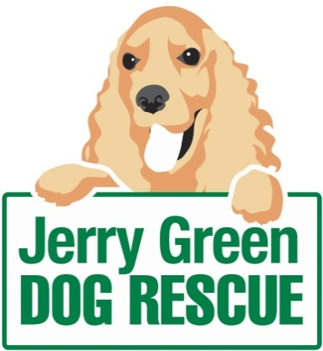
News release

27th May 2016

Rescue Dog Milo Helps Seal a Match Made in Heaven

It goes without saying that you’d want your best friend to be a part of your wedding, but one young couple from Scunthorpe went a step further and welcomed him on their honeymoon.

A former rescue dog who was cared for by Jerry Green Dog Rescue donned his best bib and tucker to appear as a special guest at his owners’ wedding reception at Rookery Wolds in North Lincolnshire on 8th April and even accompanied them on their honeymoon in the Forest of Dean.

After moving in together in Scunthorpe, Catherine Gibbons and her partner Scott decided that it was time to make their house feel more like a home with the addition of a four-legged friend.

The couple adopted Milo, a Jack Russell Pug crossbreed, from Jerry Green Dog Rescue’s North Lincolnshire centre through the charity’s Meet and Match scheme in February 2015.

Milo first arrived at the centre early last year when he was just eight months old, after his previous owners were unable to spend sufficient time with him owing to work commitments.

However, it was only a matter of weeks before Catherine and Scott arrived at the centre, where they were welcomed by staff who took the time to get to know them and find out what their perfect pet would be.

Catherine said: “After explaining the sort of dog we were looking for – fairly small and young, so that we would be able to enjoy him or her for years to come – we were offered a few profiles to browse.

“But before we had chance to meet any of them in person, we were told that Milo’s original adopted family had had to pull out, but that he seemed to be everything we had been searching for.

“Milo was the only dog we met that day – we were completely smitten and are still convinced it was meant to be.

“It was only right that he was a special guest at our wedding and he had the best time during our honeymoon, going on long walks in the forest during the day and falling asleep in front of the fire in the evening."

Catherine added: “Scott and I would definitely recommend the Meet and Match service at Jerry Green Dog Rescue to anyone looking to rehome a dog. The staff were extremely friendly and professional and are obviously very passionate about the work they do.”

As part of the Meet and Match process, potential owners and their families experience a mock home environment, during which they and the Jerry Green staff can see how well they’re able to handle and interact with the dog.

Paige Chappill, Centre Support Officer at Jerry Green Dog Rescue in Broughton, said: “We can not only see how the relationship between a dog and its potential owner forms, but also provide the opportunity to see how well he or she gets along with any other dogs already in the household.

“We feel that our Meet and Match service, available at each of our five centres, is the best way to ensure that all of our dogs will continue to receive the highest level of care within a secure and loving forever home.

“It’s a great process to be a part of and I’m delighted to see Catherine, Scott and Milo so happy together as a family.”

If you’re interested in finding out more about the dogs at Jerry Green Dog Rescue still looking for a home, or would like to know more about the Meet and Match process, please visit: www.jerrygreendogs.org.uk

Ends
Notes to editors:
- Jerry Green Dog Rescue was founded in 1961 in Broughton, Lincolnshire and is now one of the UK’s largest dog rescue charities.
- Jerry Green Dog Rescue has a caring ethos which puts the dogs in its care at the centre of everything it does. It also operates a policy whereby prospective adopters are introduced to dogs in a neutral environment away from the kennel, resulting in less stress for the dog and increasing the chances of permanent homes being found.
- The adoption process at Jerry Green Dog Rescue involves a number of introductory visits and the rehoming team provide pre and post adoption support to ensure the move to the dog’s new home is as smooth as possible.
- The charity receives no Government or National Lottery funding. This means it is dependent on the generosity of public and corporate donors/sponsors.

For media information please contact:
Zoe Lamb
Shooting Star
01522 528540
zoe@weareshootingstar.co.uk
[jerrygreen122MiloWedding]

