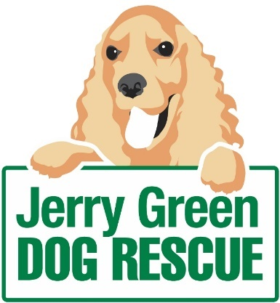

News Release

24th June 2016

Canine Charity’s Summer Festival Coming Soon
Save the date! Families and dogs alike are invited to a summer show that promises to be bigger and better than ever, to raise funds for Jerry Green Dog Rescue.
Members of the public and their four-legged friends are invited to take part in a fun dog show, interactive dog agility and a silent auction during the Jerry Green Dog Rescue summer show on Sunday 10th July from 11:30am until 4:30pm.
Following a successful summer show last year, during which Jerry Green staff welcomed more than 2000 people to its centre in Broughton, the charity is hosting this year’s event at their North Lincolnshire Centre, DN20 0BJ.
Rosettes will be on offer for the winners from first through to sixth place and anyone can enter. Owners can register their dogs from 11:30am for £1 per dog, per class, ready to begin at 12noon. Best in show will be announced after 3:30pm.
Paige Chappill, Centre Support Officer at Jerry Green Dog Rescue in Broughton, said: “We are really excited about this year’s show and hope to attract even more people to help raise awareness and money for our charity.”
“There’s lots to do for all the family including a children’s fun fair, live music, assorted stalls, fun dog show, a raffle and the chance to win an amazing 4x4 Land Rover experience worth £300!”
As well as joining in with fundraising activities for Jerry Green Dog Rescue, which cares for and helps to find homes for unwanted and abandoned dogs, visitors can find out more about the charity’s work and browse a variety of independent stalls.
A team of dog trainers from Field of Dreams will be hosting demonstrations and interactive workshops in agility and heelwork to music. Food and refreshments will be available throughout the day as well as a mobile bar and live music – including a performance from local band Koostix.
Paige added “We’ve planned to make the day as fun-filled as possible and would love to see people of all ages – with or without their dogs – join us for a day out with a difference.”
Jenny Harris, Fundraiser at Jerry Green, said: “These events are hosted by staff and volunteers at all of our five centres during the summer season and support our work with local communities.
“They are an exciting way to generate some extra money and all proceeds help towards the costs of running the centre, thus enabling us to continue to protect dogs in need.”
The summer show entry fee is £2 per adult and £1 per child with a special family offer of £5 for two adults and two children. There is also free parking available on-site.
For further information about this event, please contact Paige Chappill at the centre by calling: 01652 653 343 or emailing paige.chappill@jerrygreendogs.org.uk
ENDS
Notes to editors:
- Jerry Green Dog Rescue was founded in 1961 in Broughton, Lincolnshire and is now one of the UK’s largest dog rescue charities.
- Jerry Green Dog Rescue has a caring ethos which puts the dogs in its care at the centre of everything it does. It also operates a policy whereby prospective adopters are introduced to dogs in a neutral environment away from the kennel, resulting in less stress for the dog and increasing the chances of permanent homes being found.
- The adoption process at Jerry Green Dog Rescue involves a number of introductory visits and the rehoming team provide pre and post adoption support to ensure the move to the dog’s new home is as smooth as possible.
- The charity receives no Government or National Lottery funding. This means it is dependent on the generosity of public and corporate donors/sponsors.

For media information please contact:
Jenny Harris
Fundraiser
Jerry Green Dog Rescue
01652 650886
Jenny.Harris@JerryGreenDogs.org.uk

