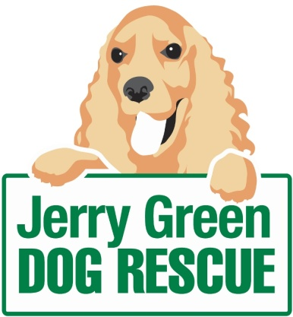
News release
21st November 2014

Meet Santa Paws at Charity Christmas Event
Families and dog lovers in North Lincolnshire won’t want to miss Jerry Green Dog Rescue’s Christmas event on Sunday 30th November.
The Furry Tail of Christmas event in Brigg will feature stalls selling crafts, gifts and dog treats, while children will have the chance to meet Santa Paws in his grotto and dog owners can bring their dogs to the event for a blessing.

Catherine Foster, Head of Fundraising for Jerry Green Dog Rescue, said it’s the perfect event to get people in the mood for Christmas while helping to support a worthwhile cause.

“Our Furry Tail of Christmas event has something for everyone, whether you’re looking for Christmas gifts, dog treats or a fun day out with the kids. As well as the craft and trade stalls there will be a Christmas auction at 1.30pm, live music during the day from The Koostix and Kuban Kaos and a selection of festive food and drink.

“People are welcome to bring their dogs to the event and we’re always delighted to see how past residents are getting on with their new owners.”

The event will take place from 11am to 3pm at The Mount Tearooms, Castlethorpe, Brigg, DN20 9LG.

“Thank you to Zara Grey from The Mount Tearooms who has kindly offered to host the event for a second year,” Catherine added. “Not all dogs are lucky enough to have a home this winter so all the proceeds will help make Christmas more special for them.”

ENDS

Follow us on Twitter @jerrygreendogs
Find us on Facebook: facebook.com/pages/Jerry-Green-Dog-Rescue/
Visit: www.jerrygreendogs.org.uk

Notes to editors:

Jerry Green Dog Rescue was founded in 1961 in Broughton, Lincolnshire and is now one of the UK’s largest dog rescue charities. It has rescue centres in five locations:

- Gilberdyke, East Yorkshire
- Blidworth near Mansfield, Nottinghamshire
- Broughton near Brigg, North Lincolnshire
- Algarkirk near Boston, Lincolnshire
- Thirsk, North Yorkshire

Jerry Green Dog Rescue has a caring ethos which puts the dogs in its care at the centre of everything it does. It also operates a policy whereby prospective adopters are introduced to dogs in a neutral environment away from the kennel, resulting in less stress for the dog and increasing the chances of permanent homes being found.

The adoption process at Jerry Green Dog Rescue involves a number of introductory visits and the rehoming team provide pre and post adoption support to ensure the move to the dog’s new home is as smooth as possible.

The charity receives no Government or National Lottery funding. This means it is dependent on the generosity of public and corporate donors/sponsors.

For media information please contact:
Sarah Howells
Shooting Star PR
01522 528540
sarah@shootingstar-pr.co.uk
@shootingstarpr
@sarahhowellspr
[jerrygreen64_FurryTailsXmas]

