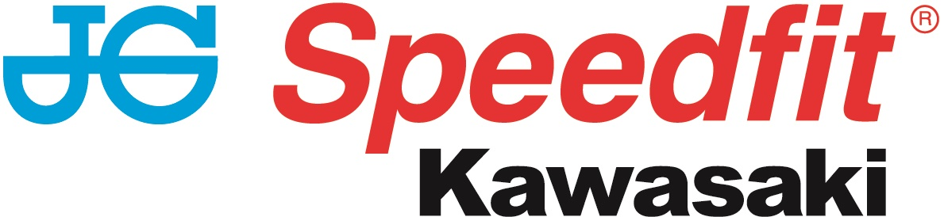

NEWS RELEASE

18th June 2017

Haslam Out in Practice But Mossey Takes Lead

The JG Speedfit Kawasaki team had a challenging round four of the MCE British Superbike Championship, held at Knockhill in Scotland this weekend, but they put behind them the disappointment of losing Leon Haslam in practice to injury with Luke Mossey taking second and fourth in the two races to move into the Championship lead.

The weekend started in the worst possible fashion for the team when Haslam crashed heavily in Friday’s practice session and the Derbyshire rider was ruled out for the rest of the meeting with concussion and cracked vertebrae. That left Mossey to fly the flag in the Superbike class and he responded perfectly, with pole position in qualifying signalling his intentions.

Sunday’s opening race saw Luke slot into third place on the first lap but a lap later he was up to second and sitting behind fellow Kawasaki rider Jake Dixon. The latter was in imperious form and duly took his maiden BSB victory but an excellent second saw Luke gain more podium credits and take over the Championship lead.

Opting for the softer tyre for race two, the 24-year-old occupied second behind Dixon in the early stages, but he hit the front on lap eight and promptly opened up a near one-second lead. However, on lap 19, he had a major moment through the chicane which allowed James Ellison to grab the lead, and as he tried to make up the time lost he lost his rhythm slightly and had to settle for fourth, although the day’s results saw him leave with a healthy 30-point advantage in the table.

It was a busy weekend for the sidecar teams too, as reigning British champions Ricky Stevens and Ryan Charlwood qualified in fifth place for the first of three races, although a first lap collision and damaged wheel arch led to a black flag. They regrouped though for the remaining two races and third and fifth sees them occupy third overall in the Championship - albeit 63 points behind the pace-setting Tim and Tristan Reeves.

Meanwhile, the all-female crew of Maria Costello and Kirsty Hauxwell qualified in 26th and, continually getting faster throughout the weekend, they recorded 20th, 22nd and 23rd in the three races.

Luke Mossey commented: "It has been a bit of a strange weekend to be honest. I felt really
good all weekend and I knew I had good pace throughout the weekend. We decided because of the track temperature for race one to run the harder compound tyre. It wasn't the right decision and I really struggled, so I had to push for a podium and more podium credits.

“We went back to the soft tyre for race two and it made a huge difference. We were dicing for positions at the start of the race but I managed to get to the front and I felt really comfortable and my times were good. I was managing to bridge a gap between myself and the riders behind me, but then I had a huge moment and it was more luck than anything that I stayed on.

“After that I was trying too hard to get back to the front and I just kept making mistakes and running wide, which allowed Shakey to pass me.

“I've a 30 point lead in the Championship now and Leon is still second, which is great for the JG Speedfit Kawasaki team. We've two weeks until Snetterton and I can't wait to get back out there again.

“Thanks to my sponsors and all their team for their hard work this weekend!”

Ryan Charlwood said: “It was a tough weekend for us. We didn’t really get anywhere in qualifying and we finished fifth, which is out of form for us. Saturday was a complete drama - somebody dropped a lot of oil and we span on that oil along with two other bikes at the same time. At the restart unfortunately we got tangled up with some of the slower riders, which meant our wheel arch came off and led to our retirement from the race.

“In race two we had to start at the back but we managed to salvage third place, which was a good result.

“Today we had a problem with our rear grip and finished fifth, which we were disappointed with because we knew we could have made much better progress than that. So it was a tough weekend for us.”

In contrast Maria Costello said: “It’s been really brilliant. To come to a circuit that we’ve never been to and have three races, three finishes and make some time improvements – I’m really happy.

“Now we’ve got the chance to ride together and gain a bit more confidence. Kirsty is a brilliant passenger and she makes my job so much easier. That’s a tough circuit to learn!

“That was our first BSB and we should both be proud of how we performed.”

Team Manager Jack Valentine said: "It was a difficult weekend to start off with when Leon crashed on Friday morning and he was declared medically unfit to ride for the rest of
the weekend. He has been sent home now and will have further tests but we
are confident he will be back out with us at Snetterton.

“Luke has ridden extremely well all weekend; he has been consistently fast
and set some good times. We decided to go with the harder front compound
tyre for the opening race and we managed to secure a podium place and some
more podium credits which is important.

“We went back to the softer tyre for race two which Luke was happier on. He
managed to gain just over a second lead from his nearest rival when he had a
huge slide. This totally disrupted his rhythm and he was unable to regain
the time and positions he'd lost.

“We are only at the end of round four and we are still first and second in
the Championship, which is fantastic. But we are under no illusions and will
continue to be working hard and pushing forwards for the rest of the season.

“It was brilliant to see Jake Dixon take his first and second BSB win and
great for the Championship to see another young rider winning races at BSB.

“We move onto Snetterton now where I'm sure Luke and Leon will be out in
force for the JG Speedfit Kawasaki team."

MCE British Superbike Championship Positions (after four rounds)
1 Luke Mossey 141
2 Leon Haslam 111
3 Shane Byrne 90
4 Christian Iddon 86
5 Jason O’Halloran 83
6 Josh Brookes 78

Hyundai heavy Industries British Sidecar Championship Positions (after three rounds)
1 Reeves/Reeves 150pts
2 Kershaw/Clark 108
3 Stevens/Charlwood 87
4 Walker/Hawes 68
5 Holland/Ramsey 56
6 Bell/Belsey 54

Ends

Notes to Editors

- The line-up for JG Speedfit Kawasaki consists of British Superbike riders Leon Haslam and Luke Mossey, road racing specialist James Hillier and sidecar champions Ricky Stevens and Ryan Charlwood.
- The team is owned by Bournemouth Kawasaki Racing. Title sponsor for 2017 is British plumbing and heating engineering firm JG Speedfit which is a world leader in push-in fittings, as well as plastic plumbing systems and underfloor heating.
- Derbyshire-based Leon Haslam finished runner-up in the 2016 British Superbike Championship while Cambridgeshire-based Luke Mossey secured his highest ever British Superbike Championship season finish last year in sixth place.
- The team’s 2017 International Road racing events at the North West 200 and Isle of Man TT will be contested by James Hillier. Last season, Hillier secured three podiums earning him fourth overall in the 2016 TT riders’ championship.
- 2016 British F1 Sidecar Champions Ricky Stevens and Ryan Charlwood are being retained by Bournemouth Kawasaki Racing for a second year and will be going for their third championship win in a row this year.

For further information about this news release please contact:
Kate Strawson
Director, Shooting Star
kate@weareshootingstar.co.uk
01522 528540
07733 230293
@KateStrawson

