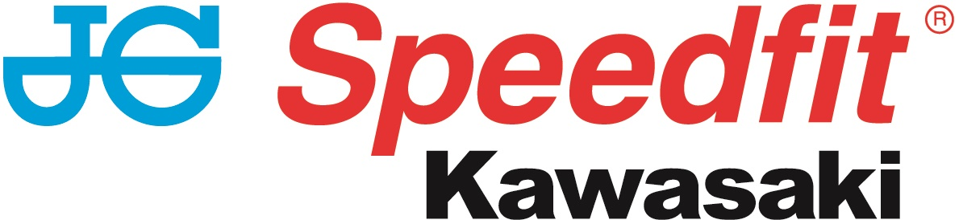

PRESS RELEASE

30th September 2018

Assen Double Victory for Haslam and JG Speedfit

Leon Haslam and the JG Speedfit Kawasaki team tightened their grip on the 2018 Bennetts British Superbike Championship with an emphatic double victory at Assen this weekend (28th to 30th September).

Haslam’s 13th and 14th wins of the season resulted in a 61-point lead over Jake Dixon when the Kawasaki rider was forced to retire with a mechanical issue in the second race around the Dutch circuit.

Practice and qualifying had initially gone well for both Haslam and team-mate Luke Mossey but while Haslam took third place in the latter for a front row start for Sunday’s opening race, a technical issue meant Mossey was unable to post a competitive time in Q2 and had to start from 17th and the sixth row.

Subsequently, the duo had vastly different opening races and whilst Mossey eventually took 14th place after finding himself part of a four-rider battle for 11th, Haslam pushed for the race win from the start although he had to battle his way through the pack after dropping back to fourth place in the early stages.

This he duly did and having moved ahead of Peter Hickman on lap five to take third, he did the same to main championship rival Dixon five laps later.

There was never more than a second between the leading quartet so the Derbyshire rider had to work hard throughout the 18 laps. Then, having taken the lead from Tarran Mackenzie on lap 16, he held off the close attentions of Dixon on the final lap to take his 13th win of the season by 0.086s.

Starting race two from the front row once more, this time in second place, he slipped back to sixth on the opening lap but was then lucky to stay on board at the end of lap two when Dan Linfoot hit him exiting the chicane, the Honda rider crashing out. A safety car period saw the field bunch up once more and when racing resumed on lap five, Haslam set about moving forward.

He quickly did just that and his championship aspirations took a turn for the better on lap ten when Dixon was forced out. Keen to capitalise on Dixon’s demise and extend his lead as much as possible, Haslam grabbed the lead from Josh Brookes on lap 16 and never looked back, sweeping through for his 14th win from the 23 races held so far this season.

Mossey, meanwhile, lined up in the middle of the fifth row in 14th place and made a good start to slot into tenth place but when the safety car pulled in, Tarran Mackenzie crashed coming onto the start and finish leaving a number of riders, including Mossey, to take evasive action.

Forced onto the grass, he lost a lot of time and dropped all the way back to 20th although he fought his way back to 15th at the chequered flag for a hard-earned championship point.

The Holland meeting also hosted the penultimate round of the Hyundai Construction Equipment British Sidecar Championship with Ricky Stevens and Ryan Charlwood claiming second and seventh in the two races to maintain fourth place in the overall championship standings with one round remaining.

Leon Haslam said: “I’m over the moon with the wins in both races. It was two really good battles. We planned a lot over the weekend with the tyres and set-up. I can’t thank the JG Speedfit team enough for all the effort and hard work they have put in all year.

“To have 14 race wins this season has been great and I will be riding hard at Brands to try and wrap up the championship as soon as I can.

“It’s been a really good season so far, I’ve never won at Brands and that is something I would like to achieve before leaving the series next year. I am looking forward to getting there and seeing what happens!”

Luke Mossey said: “I just don’t know where to start; this year just hasn’t gone my way at all. I had a problem with the bike in qualifying so I had to start from 17th, I struggled to make a pass on people despite reasonable lap times.

“I got a better start in the second race but the opening laps were just full of accidents and drama, I had to take to the grass to avoid Taz and when I re-joined I was right at the back. I just hope we can end the season on a high note at Brands.”

Ricky Stevens said: “We were really happy with the first race, where we secured a second-place finish. The bike performed really well and we were hopeful for the rest of the weekend.

“Sadly, in race two we were taken out by another outfit and had to fight our way back from last place to seventh.

“We’re feeling slightly despondent at this weekend’s result, but with double points available at Brands Hatch we’re hoping to finish the championship on a high.”

Team Manager Jack Valentine added: “It’s been the perfect weekend and everything has gone to plan. We came to Assen hoping to extend the championship lead but with the temperatures being down we had to work hard on Leon and Luke’s bikes on the soft and hard compound tyre to ensure the bikes would run race distance on both and we got them working well. That paid off as the weather was cooler on race day and Leon had a really good feel on the SC1.

“We wanted to leave Assen with 50 points advantage and we are leaving with a 61-point lead. We are not chancing anything this year and making sure everything is 100% and giving him the best bike we possibly can. Leon rode two exceptional races, he didn’t have to win the second race but he’s a racer and he’ll always want to win, he delivered again and it was brilliant.

“It’s been a tough weekend for Luke, he had a small problem in qualifying so had to start further back on the grid and he struggled to make up the places in the race. In the second race he had to avoid an accident which dropped him to the back of the pack, there was nothing he could do.

“It would be great to win the championship on the Saturday at Brands and then enjoy and relax a little bit on Sunday, but you never know what will happen in racing. I’d also like to see Luke end the season on a high note, he’s good at Brands and it would be a good end to the season for him.”

Bennetts British Superbike Championship standings (after 11 rounds)

1 Leon Haslam (JG Speedfit Kawasaki) 654pts
2 Jake Dixon (Kawasaki) 593
3 Josh Brookes (Yamaha) 557
4 Glenn Irwin (Ducati) 554
5 Peter Hickman (BMW) 549
6 Bradley Ray (Suzuki) 533
16 Luke Mossey (JG Speedfit Kawasaki) 90

To keep up to date with the latest news from JG Speedfit Kawasaki you can follow the team on Facebook @JGSpeedfitBournemouthKawasaki and on Twitter @JGSpeedfitKawa or visit the website www.jgspeedfitkawasaki.co.uk

Ends

Notes to Editors

- The line-up for JG Speedfit Kawasaki consists of British Superbike riders Leon Haslam and Luke Mossey, road racing specialist James Hillier and 2015 and 2016 sidecar champions Ricky Stevens and Ryan Charlwood.
- The team is owned by Bournemouth Kawasaki Racing.
- Derbyshire-based Leon Haslam finished third overall in the 2017 British Superbike Championship while Cambridgeshire-based Luke Mossey secured ninth place overall.
- The team’s 2018 international road racing events at the North West 200 and Isle of Man TT will be contested by James Hillier. Last season, Hillier secured three podiums earning him fourth overall in the 2017 TT riders’ championship.
- 2015 and 2016 British F1 Sidecar Champions Ricky Stevens and Ryan Charlwood are being retained by Bournemouth Kawasaki under the Quattro Plant JG Speedfit Kawasaki team. They will be aiming to reclaim the championship title after finishing third in 2017.

For further information about this news release please contact:

Kerri Saxby
Account Manager, Shooting Star
kerri@weareshootingstar.co.uk
01522 528540
[JGS32R11AssenPost]

