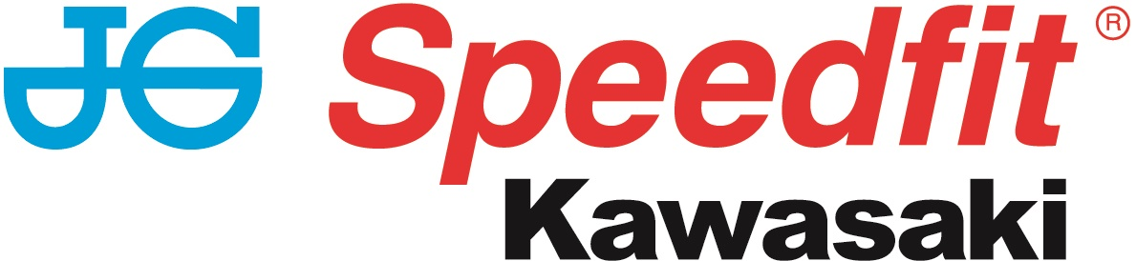

PRESS RELEASE

8th October 2018

Haslam Heads to Brands in the Battle for Championship Glory

Leon Haslam and the JG Speedfit Kawasaki team’s fight for championship glory will get under way at Brands Hatch this weekend (12th to 14th October) in the final round of the Bennetts British Superbike Championship.

The Derbyshire ace has been pushing hard in each round and has secured 14 first-place wins out of a possible 23 so far this season. After finishing second in the BSB three times (2006, 2008 and 2016), Haslam was on course to win the championship last year before a crash in the final race of the season resulted in a broken wrist and ankle and the end of his title dreams. Now his patience and tenacity might finally pay off at this weekend’s showdown grand finale.

Haslam’s 61-point lead stands him in good stead for the title and with one hand on the trophy he’s showing no signs of easing off for the triple header. Having sat at the top of the leaderboard for much for the season, Haslam knows better than to become complacent in the final round.

With a first, fourth and three third-place finishes under his belt at the circuit earlier in the season, Haslam will be using what he’s learnt to ensure he plays to his strengths and rides the Kawasaki ZX10-RR to victory this time.

Meanwhile, teammate Luke Mossey is still hoping to claim a podium to finish the season on a high after suffering a range of challenges and difficult results.

Currently in 16th place in the championship, the Royston rider has overcome a spate of DNF results at Oulton Park and Snetterton in the earlier rounds. His seven top-10 finishes have led to him amassing 90 championship points and he’s consistently remained within the top 15 in the races he’s completed.

Flying the flag for Quattro Plant JG Speedfit Kawasaki in the final round of the Hyundai Construction Equipment British Sidecar Championship this weekend are Ricky Stevens and Ryan Charlwood.

The pair, currently in fourth place in the main championship with 235 points and second in the F600 Cup with 334 points, hope to build on their second-place finish at Assen recently with another couple of solid performances to round off the season.

Leon Haslam said: “I’m looking forward to Brands. Honestly, I can’t wait; I feel like I need to just wrap it up now.

“Obviously, we’re in a really good position with a 61-point lead but I’ve still got a lot of objectives for Brands. The main objective is to win this championship, but also to win at Brands Hatch on a Kawasaki. I have won on quite a few other manufacturers around there but not on the GP circuit with the Kawasaki.

“I’d also like to get a podium place in all three races and ideally win all three. I’m really looking forward to it and to celebrating my first British superbike title!”

Luke Mossey said: “I’m looking forward to the weekend. It’s the last round of the season – which I can’t believe – and we want to finish it on a high. I really like Brands Hatch and we’ve had great results there in the past.

“It’s no secret that we’ve not had the best season, but I’ve never lost focus despite all the setbacks. We’re going into the weekend with the aim of getting a rostrum. I want to come home with a trophy and shake a few things up in the Showdown – with it being a triple header we’ve got a few chances.”

Ricky Stevens said: “We’re both really looking forward to finishing the championship with two good solid results.

“It's been a very up and down season, but a positive one. We feel like we're in a good place and are already looking forward to mounting an assault on the 2019 title.

“We want to say a huge thank you to all our sponsors, fans, friends and family without whom we couldn't aim for or achieve our goals.”

Team Manager Jack Valentine added: “It’s hard to believe the final round of the 2018 BSB Championship is already upon us. The whole team has worked so hard this season and we are in a very strong position with Leon holding a 61-point lead going into the last three races at Brands Hatch.

“Leon is certainly on great form and we just need to carry that on for one more weekend to be crowned 2018 Bennetts BSB champions. We all know too well it’s not over yet, but for sure it’s pretty close this year.

“Luke will be trying to finish on a high in a season that has not been kind to him, with bad luck hampering his efforts on a few occasions.

“We would like to thank all our current sponsors and fans for their support this season and hope to see them all again in 2019.”

To keep up to date with the latest news from JG Speedfit Kawasaki you can follow the team on Facebook @JGSpeedfitBournemouthKawasaki and on Twitter @JGSpeedfitKawa or visit the website www.jgspeedfitkawasaki.co.uk

Ends

Notes to Editors

- The line-up for JG Speedfit Kawasaki consists of British Superbike riders Leon Haslam and Luke Mossey, road racing specialist James Hillier and 2015 and 2016 sidecar champions Ricky Stevens and Ryan Charlwood.
- The team is owned by Bournemouth Kawasaki Racing.
- Derbyshire-based Leon Haslam finished third overall in the 2017 British Superbike Championship while Cambridgeshire-based Luke Mossey secured ninth place overall.
- The team’s 2018 international road racing events at the North West 200 and Isle of Man TT will be contested by James Hillier. Last season, Hillier secured three podiums earning him fourth overall in the 2017 TT riders’ championship.
- 2015 and 2016 British F1 Sidecar Champions Ricky Stevens and Ryan Charlwood are being retained by Bournemouth Kawasaki under the Quattro Plant JG Speedfit Kawasaki team. They will be aiming to reclaim the championship title after finishing third in 2017.

For further information about this news release please contact:

Kerri Saxby
Account Manager, Shooting Star
kerri@weareshootingstar.co.uk
01522 528540
[JGS33R12BrandsHatchPre]

