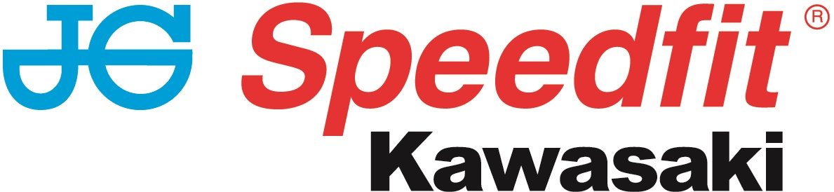

NEWS RELEASE

18th April 2017

Luke Mossey Celebrates First Ever Double Race Victory

JG Speedfit Kawasaki celebrated another double win in the 2017 MCE BSB Championship this weekend after Luke Mossey clinched not only his first ever win but his first ever double race victory!

Mossey, from Royston in Cambridgeshire, gave a hint of things to come on the Kawasaki ZX-10R after setting an unofficial fastest ever lap time at Brands Hatch in the opening qualifier which was then astonishingly surpassed in the final qualifier by James Ellison.

He started second on the grid behind Ellison with team mate Leon Haslam in third. Haslam, from Smalley in Derbyshire, led the pack on the opening lap but two laps later Ellison had regained the lead as Haslam ran wide at Druids.

Ellison crashed out on the 12th lap leaving Mossey out in front ahead of Haslam and Iddon. With the scrap for second place intensifying Haslam and Iddon traded blows before Iddon made a move at Paddock Hill Bend that kept Haslam in third. Mossey went on to claim the victory 3.529s ahead of Haslam in second.

In race two Ellison headed out onto the grid in pole, but retired after the warm up lap. Haslam took the lead from the off but Mossey pushed hard to pass Haslam and the pair continued to rival for first place until Mossey managed to get ahead on lap six.

Christian Iddon managed to overtake Haslam on lap nine moving into second. Shakey moved up into fourth on lap 16 and despite managing to overtake Haslam on lap 24, he crashed out for the second time this season.

Haslam had to take evasive action which slowed him down but two podium finishes means he retains his position at the top of the championship table.

At the front Iddon closed the gap between him and Mossey on lap 17, however, the 24-year-old managed to hang on to the lead to seal his second-ever victory with Leon in third.

In the Hyundai Heavy Industries British Sidecar Championship last year’s title winners Ricky Stevens and Ryan Charlwood took two excellent second place finishes behind the Carl Cox Motorsport duo of Tim and Tristan Reeves in both races.

Tim Reeves and partner Tristan grabbed the pole position by 0.825 of a second from Stevens and Charlwood. In race one Reeves and Reeves grabbed the holeshot from pole ahead of Kershaw and Clark in second. Recovering from a bad start Stevens and Charlwood made their way into third place before crossing the finish line in second.

With the top ten places being reversed for the start of the second race, it was Phil Bell and Tony Belsey who grabbed the holeshot but Ricky and Ryan climbed from ninth on the grid to secure another well-deserved second.

Mossey said: “Race one was a really tough and I was pushing hard to keep a consistent pace. I was surprised to win by 3.529s as I didn’t think we had that much pace. To win my first race like that at my local circuit is a great feeling but to win the double is a dream come true.

“The JG Speedfit Kawasaki team have done a great job and I can’t thank them enough for this. We really did our homework this weekend and I hope now that we can build on this. I’ve never had such a strong start to a season.”

Haslam said: ““I knew Shakey was catching me in race one, and I was struggling to pass. I was on the back of Luke mid-race but he was riding consistent laps and I was unable to stay with him. It’s hard to pass here at the Brands Hatch Indy circuit but my aim was to be second and I made the pass stick on the last lap. I wanted to be in the mix and I made a few mistakes early on but overall I was happy with my performance.

“In the second race, we made a few changes but I don’t think we went the right way. I was happy I got on the podium again but just frustrated we didn’t resolve the issues from earlier on. However, I’ve come out of Brands Indy with two podiums and we’ve got to move on and keep progressing.”

Charlwood said: “Our season has started off well at Brands Hatch with two solid points hauls on our new bike. We are going testing and will be stronger for Oulton. We worked really hard all weekend and have thankfully been consistent. We will be pushing hard for wins for the rest of the season and would like to thank everyone for their support over the weekend.”

Team Manager Jack Valentine added: “It’s been another fantastic weekend for both riders. Luke especially as he has worked so hard to win a race and then he did the double! I am so pleased for the team and we are still one – two in the championship standings.
“I would like to say huge congratulations to Luke’s side of the garage, for working so hard to get to this point and I’m glad they were rewarded so well this weekend.

“Leon worked through issues during the qualifying session and he pushed hard all weekend to secure second and third in the two races. I am very happy with how everyone is working together and the results that we are getting on the track are incredible. I’m pretty speechless at the minute but delighted at where we are and what we have achieved.

“I hope we are able to carry this form through to Oulton Park and the remainder of the season. I must also thank JG Speedfit and all our sponsors for their continued help and support for the team.”

MCE Insurance British Superbike Championship standings after Brands Hatch:
Leon Haslam (JG Speedfit Kawasaki) 86
Luke Mossey (JG Speedfit Kawasaki) 81
Christian Iddon (Tyco BMW) 65
Josh Brookes (Anvil Hire TAG Yamaha) 48
Peter Hickman (Smiths Racing BMW) 37
Glenn Irwin (Be Wiser Ducati) 36

To keep up to date with the latest news from JG Speedfit Kawasaki you can follow the team on Facebook @JGSpeedfitBournemouthKawasaki on Twitter @JGSpeedfitKawa or visit the website www.jgspeedfitkawasaki.co.uk

Ends

Notes to Editors

- The line-up for JG Speedfit Kawasaki consists of British Superbike riders Leon Haslam and Luke Mossey, road racing specialist James Hillier and sidecar champions Ricky Stevens and Ryan Charlwood.
- The team is owned by Bournemouth Kawasaki Racing. Title sponsor for 2017 is British plumbing and heating engineering firm JG Speedfit which is a world leader in push-in fittings, as well as plastic plumbing systems and underfloor heating.
- Derbyshire-based Leon Haslam finished runner-up in the 2016 British Superbike Championship while Cambridgeshire-based Luke Mossey secured his highest ever British Superbike Championship season finish last year in sixth place.
- The team’s 2017 International Road racing events at the North West 200 and Isle of Man TT will be contested by James Hillier. Last season, Hillier secured three podiums earning him fourth overall in the 2016 TT riders’ championship.
- 2016 British F1 Sidecar Champions Ricky Stevens and Ryan Charlwood are being retained by Bournemouth Kawasaki Racing for a second year and will be going for their third championship win in a row this year.

For further information about this news release please contact:
Kate Strawson
Director, Shooting Star
kate@weareshootingstar.co.uk
01522 528540
07733 230293
@KateStrawson

