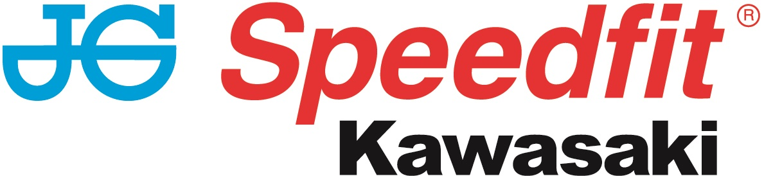

NEWS RELEASE

4th June 2017

Hillier Fourth but Frustrated In Superbike TT

JG Speedfit Kawasaki’s James Hillier put in a superb ride in Sunday afternoon’s superbike race to get his 2017 Isle of Man TT races campaign underway in fine style. However, after leading in the early stages, problems with a faulty fuel filler at his first pit stop saw him lose 16s and cruelly cost him chance of a second TT victory.

With poor weather conditions during practice week seeing a number of sessions around the Mountain Course cancelled, the six-lap race was moved back 24 hours from Saturday to give the competitors more track time and with some strong lap times, the Hampshire rider came into the race in confident mood.

As we’ve become accustomed to, the 32-year old was fast out of the blocks and by Glen Helen on the opening lap, nine miles into the race, he was leading by 0.8s from fellow Kawasaki rider Dean Harrison. It was nip and tuck throughout the first lap between the leading group but a speed of 130.830mph saw James complete the first 37.73 miles in third place, only 2.5s behind new race leader Michael Dunlop.

The Suzuki rider retired soon afterwards though and with another 130mph+ lap second time around, James moved up to second place behind Harrison as he made his first pit stop for fuel and new tyres. However, whilst Ian Hutchinson had the fastest pit stop at 55.6s, the aforementioned problems with the filler meant James took 1m 13s which dropped him down the order to fourth and any chance of the win disappeared.

However, circulating on the road with Hutchinson, James dug deep and with just ten seconds covering the leading quartet, there was still plenty to race for. Two more 130mph+ laps, on laps four and six, enabled him to keep in touch but the nature of the TT meant that clawing back the lost time was a near impossible task and so James crossed the line after 226 miles of racing in fourth place.

Such was the closeness of the race, he was only 1.7s behind third placed Harrison and only 14.8s adrift of eventual race winner Hutchinson which certainly led him to wonder what might have been.

Hillier said: “I don’t really know what to say but it’s incredibly disappointing and frustrating to have something completely out of my control cost me a chance of the win. I felt really good and although the times were close between the front four, I was ready to be in it for the long haul and fight to the end. At the first pit stop though, the fuel took an age to go in and whilst I’m not necessarily saying I’d have won, I’d certainly have been in contention at the end.

“I’ve made the first lap one of my priorities and to get that first lap done and be so close to Michael (Dunlop) put me in good stead but it wasn’t meant to be. On the last lap, we caught a backmarker which cost me a bit of time but he’s obviously doing his own thing and everyone gets a bit of that towards the end of the race so all I can do is put it behind me and look ahead. We’ve four more races so four more chances.”

Pete Extance, Team Owner, said: “It was a fantastic ride by James and, as always, he was very, very fast on the first section of the opening lap to take the lead which he held until Ramsey. He settled in to a great position and everything was going to plan until the first pit stop where, unfortunately, there was an issue with our fuel filler which lost the team at least 16 seconds.

“It dropped James back to fourth but he continued to put in a superb ride and running in close company with Ian Hutchinson, the pair set a fantastic pace not putting a foot wrong. The team managed to change the filler in time for the second pit stop, which went faultlessly, but by then the damage had been done James battled hard until the end and was rewarded with fourth place.”

The next race, the four-lap supersport race, is scheduled to take place on Monday. To keep up to date with the latest news from JG Speedfit Kawasaki you can follow the team on Facebook @JGSpeedfitBournemouthKawasaki on Twitter @JGSpeedfitKawa or visit the website www.jgspeedfitkawasaki.co.uk

Ends

Notes to Editors

- The line-up for JG Speedfit Kawasaki consists of British Superbike riders Leon Haslam and Luke Mossey, road racing specialist James Hillier and sidecar champions Ricky Stevens and Ryan Charlwood.
- The team is owned by Bournemouth Kawasaki Racing. Title sponsor for 2017 is British plumbing and heating engineering firm JG Speedfit which is a world leader in push-in fittings, as well as plastic plumbing systems and underfloor heating.
- Derbyshire-based Leon Haslam finished runner-up in the 2016 British Superbike Championship while Cambridgeshire-based Luke Mossey secured his highest ever British Superbike Championship season finish last year in sixth place.
- The team’s 2017 International Road racing events at the North West 200 and Isle of Man TT will be contested by James Hillier. Last season, Hillier secured three podiums earning him fourth overall in the 2016 TT riders’ championship.
- 2016 British F1 Sidecar Champions Ricky Stevens and Ryan Charlwood are being retained by Bournemouth Kawasaki Racing for a second year and will be going for their third championship win in a row this year.

For further information about this news release please contact:
Kate Strawson
Director, Shooting Star
kate@weareshootingstar.co.uk
01522 528540
07733 230293
@KateStrawson

