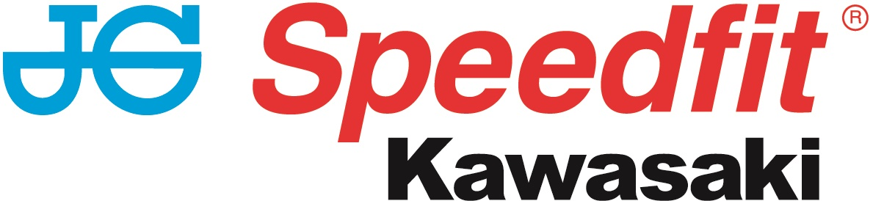

NEWS RELEASE

12th June 2017

JG Speedfit Kawasaki Looks to Continue Winning Streak

Fresh from their successful campaign with James Hillier at the Isle of Man TT road races, the JG Speedfit Kawasaki team now turn their attention back to the 2017 MCE British Superbike Championship.

Knockhill in Scotland is the venue for round four of the championship this weekend and although both riders had mixed fortunes at the recent test at Snetterton, they’re both looking forward to resuming their title challenge with the last round at Oulton Park having taken place some seven weeks ago.

Derbyshire’s Haslam currently leads the championship on 111 points having taken three wins from the six races held so far and that gives him a three-point cushion over team-mate Mossey who took the double back at Brands Hatch in April. The duo have also accrued the most podium credits with 19 and 14 respectively.

At 1.26-miles, and with a lap that takes just 48s, Knockhill is one of the shortest circuits on the calendar but it was kind to both riders 12 months ago with Haslam taking the win in the first race and Cambridgeshire’s Mossey finishing just 0.782s behind him in third. And it’s that kind of form they’ll be looking to repeat this time around.

With five rounds still to go before the crucial showdown gets under way, which will ultimately decide the 2017 champion, they both know the importance of remaining consistent to ensure they keep racking up the all-important credits.

The meeting also sees the third round of the Hyundai Heavy Industries British Sidecar Championship take place with reigning champions Ricky Stevens and Ryan Charlwood looking to build on their solid start to the season. Despite tricky conditions at Oulton Park, the pair secured another podium finish and currently lie 15 points behind double victors Tim and Tristan Reeves.

Maria Costello MBE and her passenger Kirsty Hauxwell will also be looking to improve on their debut sidecar outing at Oulton Park and qualify to compete in all three races.

Haslam said: “I’m really looking forward to Knockhill; it’s been a good seven-week break since Oulton and obviously it didn’t end too well there with the crash behind James. Having said that the season has gone well overall so far and Knockhill last year was a really good weekend in so far as I won race one and was winning race two until I had a visor problem.

“Wet and dry I felt really competitive with the Kawasaki and the JG Speedfit outfit and I’m looking forward to getting back going and continuing the team’s winning ways. Hopefully we can keep pushing on and extend the championship lead.”

Mossey said: “I’ve had a lot of good results so far this season and after the long break I’m raring to go! I’ve been training so hard since the last round at Oulton Park and I’m looking forward to getting back on the bike at Knockhill and bringing some more tropies home!”

Charlwood said: “Knockhill is one of my favourite circuits, but we know it’s going to be a tough round as it’s such a small track, which makes it very difficult to overtake. Also, there are a couple of our competitors who are from the local area so know the circuit like the back of their hand.

“Last our hopes were dashed at Knockhill when I was thrown out of the outfit during practice and dislocated my shoulder. The injury did heal well however, and I have come a long way since then. Nevertheless, I don’t want a repeat performance of last year so I have trained relentlessly in the past few weeks to ensure my core and upper body fitness are on point.

“With potentially two reverse grids to contend with and a lot of points up for grabs we’ll be digging deep in the hope of securing our first win of the season.”

MCE Insurance British Superbike Championship standings:
Leon Haslam (JG Speedfit Kawasaki) 111
Luke Mossey (JG Speedfit Kawasaki) 108
Christian Iddon (Tyco BMW) 86
Josh Brookes (Anvil Hire TAG Yamaha) 67
Glenn Irwin (Be Wiser Ducati) 63
Jason O’Halloran (Honda Racing) 61

To keep up to date with the latest news from JG Speedfit Kawasaki you can follow the team on Facebook @JGSpeedfitBournemouthKawasaki on Twitter @JGSpeedfitKawa or visit the website www.jgspeedfitkawasaki.co.uk

Ends

Notes to Editors

- The line-up for JG Speedfit Kawasaki consists of British Superbike riders Leon Haslam and Luke Mossey, road racing specialist James Hillier and sidecar champions Ricky Stevens and Ryan Charlwood.
- The team is owned by Bournemouth Kawasaki Racing. Title sponsor for 2017 is British plumbing and heating engineering firm JG Speedfit which is a world leader in push-in fittings, as well as plastic plumbing systems and underfloor heating.
- Derbyshire-based Leon Haslam finished runner-up in the 2016 British Superbike Championship while Cambridgeshire-based Luke Mossey secured his highest ever British Superbike Championship season finish last year in sixth place.
- The team’s 2017 International Road racing events at the North West 200 and Isle of Man TT will be contested by James Hillier. Last season, Hillier secured three podiums earning him fourth overall in the 2016 TT riders’ championship.
- 2016 British F1 Sidecar Champions Ricky Stevens and Ryan Charlwood are being retained by Bournemouth Kawasaki Racing for a second year and will be going for their third championship win in a row this year.

For further information about this news release please contact:
Kate Strawson
Director, Shooting Star
kate@weareshootingstar.co.uk
01522 528540
07733 230293
@KateStrawson

