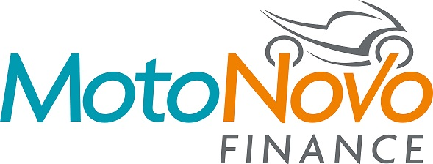

NEWS RELEASE

16th August 2017

MotoNovo Finance Fuels JG Speedfit’s Championship Bid

MotoNovo Finance is delighted to announce it has become an official sponsor of the JG Speedfit Kawasaki British Superbike (BSB) team.

The company, which is a market-leading independent financer, was keen to join forces with the Bournemouth Kawasaki-owned team in recognition of its commitment to the motorcycle industry.

Julian Oliver, MotoNovo's National Motorcycle Manager, said: “We are excited to be uniting with JG Speedfit Kawaski through this partnership and supporting star riders Leon Haslam and Luke Mossey, as well as James Hillier in his TT campaign.

“Our involvement reflects our growing enthusiasm for and commitment to the motorcycle industry as well as our long-term business strategy to invest in the best people, products and services to drive the best results for all our customers.

“We believe that in business the best outcomes always come from great teamwork, and JG Speedfit Kawasaki is the perfect example of where the riders and their exceptional support structure work together to get them on the podium.

“They are proven winners and our coming together is something special due to the natural synergies in our business philosophies and ambitions. We are delighted to be their proud sponsors.”

Owner of the JG Speedfit Kawasaki team Pete Extance said having businesses like MotoNovo Finance on board is crucial to their success in the championship.

“We really value the support of MotoNovo Finance, which is one of the UK’s fastest growing independent finance companies and a leader in its field,” explained Pete.

“To have the backing of such a well-known and respected business demonstrates the preeminence not just of BSB as a sport, but also of the JG Speedfit Kawasaki team and its riders within that sport.

“We’re looking forward to what we hope will be a long and mutually beneficial partnership.”

Ends

About MotoNovo Finance

- MotoNovo Finance, is part of FirstRand Group, and is UK's second largest used car finance lender in the UK offering finance for motorbikes, cars, and vans.
- The company has an established reputation as a leader in digital innovation and won a motorcycle industry Merit Award for Business Support Service of the Year 2017.
- For further information about MotoNovo Finance please visit www.motonovofinance.com

About JG Speedfit Kawasaki

- The line-up for JG Speedfit Kawasaki consists of British Superbike riders Leon Haslam and Luke Mossey, road racing specialist James Hillier, 2015 and 2016 sidecar champions Ricky Stevens and Ryan Charlwood and all female sidecar team Maria Costello and Kirsty Hauxwell.
- The team is owned by Bournemouth Kawasaki Racing. Title sponsor for 2017 is British plumbing and heating engineering firm JG Speedfit which is a world leader in push-in fittings, as well as plastic plumbing systems and underfloor heating.
- For further information about JG Speedfit Kawasaki please visit www.jgspeedfitkawasaki.co.uk

For further information about this news release please contact:

Kate Strawson
Director, Shooting Star
kate@weareshootingstar.co.uk
01522 528540
07733 230293
@KateStrawson

