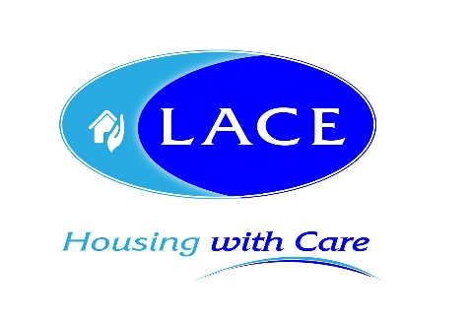
News release

14th March 2017

LACE Housing Tackles Lincoln 10K For Lifeboats

As part of its charity of the year fundraising efforts, 13 representatives of LACE Housing are gearing up to take part in the Asda Foundation City of Lincoln 10K.

The charitable organisation, which provides specialist housing and support services for older and vulnerable people in the county of Lincolnshire and the surrounding area, is championing the RNLI as its charity of the year for 2017.

On Sunday 2nd April, Chief Executive Nick Chambers will be joined by 13 representatives of LACE Housing, plus 12 representatives from the RNLI in Skegness for the 21st annual race.

Nick said: “Building work is currently under way to create even more affordable housing for older people in Skegness and it’s great to be supporting the work of the RNLI, which operates in the area.

“Following last year’s successful sponsored walk along the 110-mile Cleveland Way in aid of the Nicholls Spinal Injury Foundation, we decided to set ourselves a challenge closer to home.

“The team has agreed that we’ll each complete the distance at our own pace, especially as two of the group from RNLI Skegness are taking part in full uniform, which is very heavy!

“The rest of us will be wearing bright orange t-shirts and vests, proudly displaying the RNLI logo, so look out for us if you’re taking part or spectating on the day.”

The RNLI saves lives by providing a 24-hour lifeboat search and rescue service, seasonal lifeguards, water safety education and initiatives and flood rescue response.

The Lincoln 10K is the first planned fundraising activity for LACE Housing and in May, staff will be supporting the RNLI’s month-long Mayday campaign by having a Welly Day.

Nick added: “We’re hoping to raise awareness of as well as money for a fantastic cause and on 4th May the team will don their wellies and take part in various games and activities as a fun way of doing so. That’s if we survive the Lincoln 10K of course!”

To donate please visit: https://www.justgiving.com/fundraising/LACE-Housing

To find out more about LACE Housing please visit: lacehousing.org

Ends

Notes to editors:

- LACE Housing is a voluntary, non-profit making association with charitable status providing specialist housing and support services for older people and vulnerable people in Lincolnshire and the surrounding area.
- LACE Housing provides housing with extra care for older people with high support and personal care needs and sheltered accommodation for those who want to retain more independence.
- It is the leading social housing provider in Lincolnshire specialising in a wide range of housing and support services.
- LACE Housing is a member of the Lincs Independent Living Partnership currently delivering the Lincolnshire Wellbeing Service which includes personal support, simple aids, minor home adaptations, telecare services and rapid response services.
- For more information visit www.lacehousing.org

For media information contact:
Zoe Lamb
Shooting Star
01522 528540
zoe@weareshootingstar.co.uk
[LACE08Lincoln10K]

