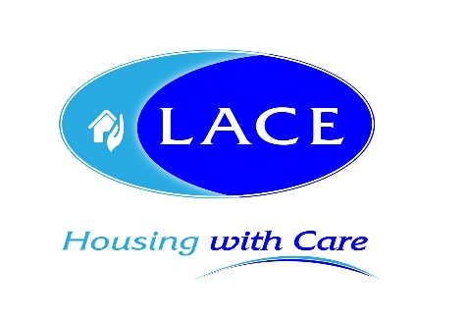
News release

26th November 2019

Brand New Bungalows for Over 55s Open for Viewing

Lincolnshire-based specialist housing provider LACE Housing is inviting prospective residents to view the bungalows available to buy within its newest development for over 55s in Nettleham.

The remaining 11 bungalows, which are available to buy on a shared ownership basis, are being marketed by Mundys Estate Agents, and will be open to view from 10am until 2pm on Wednesday 27th November by appointment only.

Situated on Frith Close and Baker Drive off Deepdale Lane, the two-bedroom bungalows have been designed exclusively for over 55s, who preferably have a connection to the local area to allow people to remain in the community they know and love as they get older.

The bungalows are located next to The Burrows – a new LACE Housing scheme consisting of 22 two-bedroom apartments for rent.

All bungalows include a fully fitted Howdens kitchen, a dedicated car parking space and private garden. Residents can also benefit from the communal lounge and garden to socialise with fellow residents from The Burrows.

The Burrows, which was named by local schoolchildren from Nettleham Infant and Junior schools, is the last of three developments to be completed by LACE Housing this year and is due to be officially opened in February.

Nick Chambers, Chief Executive of LACE Housing, said: “It’s been a very productive year for us as we’ve delivered a total of 82 new homes for older people in Lincolnshire.

“The ageing population in Lincolnshire is increasing and we’re working hard to respond to the needs of older people in the county by designing schemes that mitigate loneliness and isolation and provide a high standard of living.

“The Burrows is no exception and we’re pleased to invite people who are considering their retirement housing options to come and get a flavour of the excellent standards we maintain throughout all of our schemes.”

The Burrows responded to the Nettleham Neighbourhood Plan, which identified potential sites for new homes around the village between 2013 and 2016.

To make an appointment to view one of the bungalows, please contact Mundys directly by calling 01522 510044.

To find out more about the bungalows, visit: lacehousing.org/nettlehambungalows

You can also view them via the Mundys website: mundys.net/property/sales/lincoln/frith-close-lincoln-102125018897

Ends
Notes to editors:
- LACE Housing is a voluntary, non-profit making association with charitable status providing specialist housing and support services for older people and vulnerable people in Lincolnshire and the surrounding area.
- LACE Housing provides housing with extra care for older people with high support and personal care needs and sheltered accommodation for those who want to retain more independence.
- It is the leading social housing provider in Lincolnshire specialising in a wide range of housing and support services.
- LACE Housing is a member of the Lincs Independent Living Partnership currently delivering the Lincolnshire Wellbeing Service which includes personal support, simple aids, minor home adaptations, telecare services and rapid response services.
- For more information visit www.lacehousing.org

For media information contact:
Zoe Lamb
Account Manager
Shooting Star
01522 528540
zoe@weareshootingstar.co.uk
[LACE36NettlehamOpenDay]

