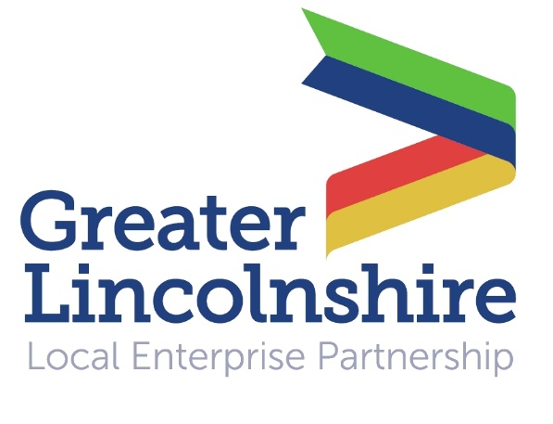

News release

3rd December 2015

Shoppers Urged to Support Small Businesses

The third annual Small Business Saturday event takes place on 5th December and organisers are hoping it will be the best yet.

In 2014 a total of 16.5 million people spent £550 million on Small Business Saturday, which emphasises and celebrates the fundamental contribution of small independent businesses on both a local and national scale.

David Dexter is Deputy Chair of the Greater Lincolnshire LEP and Lincoln Branch Chairman of the Federation of Small Businesses (FSB), a UK-wide organisation which promotes and protects the interests of those who are self-employed and own small businesses.

“Small Business Saturday aims to highlight the success of small businesses and encourage consumers to ‘shop local’ with them, as opposed to larger competitors,” said David.

“When consumers decide to source their goods locally, they are making an active decision which offers invaluable support to businesses that contribute massively to the economy.”

David is hoping that this year’s Small Business Saturday event will be just as successful. He said: “It’s easy for consumers to get into the habit of purchasing from larger high street stores, especially because of their high-profile marketing activity. However we must not forget about those excellent businesses which operate on a much smaller scale and provide real personal service.

“Without the success of the types of businesses we aim to highlight during Small Business Saturday, we would all suffer as a result; they are the very building blocks and backbone of a booming economy.”

Organisers are encouraging all kinds of small businesses to get involved, from family-run businesses, to local shops, online businesses, and more.

By taking part, any type of small business will be able to increase their profile locally. To find out more visit www.smallbusinesssaturdayuk.com/

To keep up to date, follow @SmallBizSatUK on Twitter and get involved in the conversation using #SmallBizSatUK and #SmallBizSat.

Notes to Editors:
- The Greater Lincolnshire Local Enterprise Partnership is a private and public sector partnership led by the private sector which aims to improve conditions for infrastructure and doing business in the Greater Lincolnshire area.
- One of the first LEPs to be established in the UK, the Greater Lincolnshire LEP covers a large geographical area with a population of over one million and a diverse range of industries, from ports and logistics to farming, tourism and engineering.
- It includes North and North-East Lincolnshire and the administrative county of Lincolnshire and is controlled by a LEP board made up of leading figures in the public and private sector.
- Visit www.greaterlincolnshirelep.co.uk for more information.
- Small Business Saturday UK is a grassroots, non-commercial campaign which highlights small business success and encourages consumers to ‘shop local’ and support small businesses in their communities.
- As of 2012, Small Business Saturday takes place on the first shopping Saturday in December each year and the campaign aims to have a lasting impact on small businesses.
- Visit www.smallbusinesssaturdayuk.com for more information.

For media information please contact:
Jez Ashberry
Shooting Star
01522 528540
07780 735071
jez@weareshootingstar.co.uk
[LEP109SmallBusinessSaturday]

For all press and media enquiries regarding Small Business Saturday please email:
media@smallbusinesssaturdayuk.com

