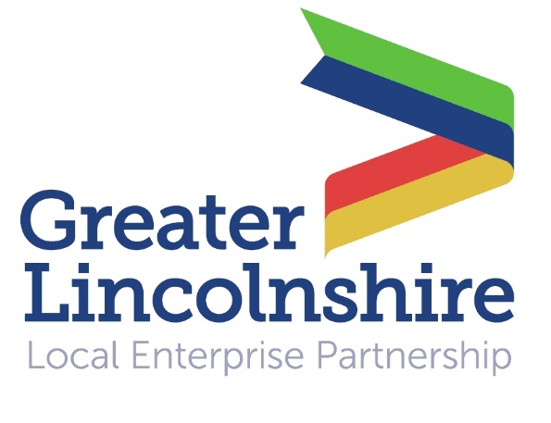
News release

18th October 2016

London Dinner Offers Chance to Bang the Drum for Lincolnshire

Greater Lincolnshire will be promoted as an attractive place to work, live, visit and invest at a special Team Lincolnshire dinner during MIPIM UK on Thursday (20th October).

The aim of the dinner at the prestigious Lansdowne Club in Mayfair will be to promote Greater Lincolnshire and to engage with investors and developers from outside the region – many of whom will be in London this week for MIPIM UK.

MIPIM UK at Olympia in London from 19th to 21st October is the UK’s largest exhibition and conference for property professionals. It provides a marketplace for industry players and international investors to meet, discuss projects and opportunities and do business.

The dinner will be hosted by Cllr Colin Davie, Executive Councillor for Economic Development at Lincolnshire County Council and a board director at the Greater Lincolnshire Local Enterprise Partnership, and the guest speaker will be Ian Harrison, Acting Director Exports and Investment at the Department for International Trade (formerly UKTI).

Among the opportunities that the Greater Lincolnshire LEP will be outlining at MIPIM UK and at MIPIM in Cannes in March 2017 will be:

- places to stay - infrastructure to support the visitor economy
- places to live - 100,000 new homes to be built in Greater Lincolnshire by 2030
- Food Enterprise Zones - Holbeach, Hemswell, and Europarc, Grimsby

Councillor Colin Davie said: "This dinner offers a perfect opportunity to showcase Greater Lincolnshire as the ideal place for companies to invest in. Greater Lincolnshire is one of the most buoyant areas in the UK and we continue to see significant growth and development in the region.

"For example, there are major RAF plans to expand improvements to its bases in Lincolnshire which will mean further housing, new schools, community facilities and infrastructure. Huge opportunities in our growing Food Enterprise Zones in Grimsby, Holbeach and central Lincolnshire will increase the demand for technology specialists. These are just two examples of the many projects we are supporting which will attract future investment into the region.

"With the support of our property companies, we are looking forward to meeting future as well as current clients. We will certainly be banging the drum about the Greater Lincolnshire region as it continues to thrive as a dynamic and buoyant place to live, work and invest."

Team Lincolnshire is a group of public and private sector ambassadors for Greater Lincolnshire, one of whom - Paul Bennett, Unit Director at environmental consultants Delta-Simons - commented: "Delta-Simons is happy to support the MIPIM UK dinner for the second year running. It provides us with the perfect platform to engage with key contacts in the London region, as well as flying the flag for Team Lincolnshire."

Greater Lincolnshire LEP Director Ruth Carver added; “There’s a lot to shout about across Greater Lincolnshire so it’s important that we take the opportunity to let people know why it’s such an attractive place for investors and developers to base their projects.

“Inward investment both from the UK and overseas plays an important role in supporting the growth of our economy. MIPIM offers an unrivalled opportunity to get in front of leading investors and developers and highlight what we have to offer. We have a strong tradition within Team Lincolnshire of public and private sector collaboration and it’s good to that we are all focused on the same end goal of more economic growth.”

Last year's Team Lincolnshire dinner at MIPIM UK attracted around 100 guests and the organisers are hoping that this year's event will be just as successful.

Notes to Editors:

- The Greater Lincolnshire Local Enterprise Partnership is a private and public sector partnership led by the private sector which aims to improve conditions for infrastructure and doing business in the Greater Lincolnshire area.
- One of the first LEPs to be established in the UK, the Greater Lincolnshire LEP covers a large geographical area with a population of over one million and a diverse range of industries, from ports and logistics to farming, tourism and engineering.
- It includes North and North-East Lincolnshire and the administrative county of Lincolnshire and is controlled by a LEP board made up of leading figures in the public and private sector.
- Visit www.greaterlincolnshirelep.co.uk for more information.
- To find out more about MIPIM UK and MIPIM visit www.mipimuk.co.uk and www.mipim.com

For media information please contact:
Jez Ashberry
Shooting Star
01522 528540
07780 735071
jez@weareshootingstar.co.uk
[LEP129MIPIMUK]

