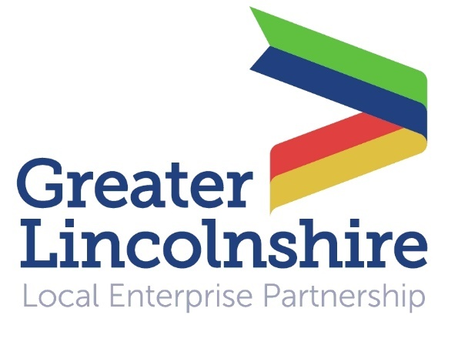
News release

24th October 2016

LEP Business Live Raises the Bar

Inspiring talks by the Chairman of the Midlands Engine and an Olympic medallist were the highlights of LEP Business Live at the Lincolnshire Showground today (Friday).

Sir John Peace made a passionate case for the Midlands economy and placed the Midlands Engine in a global context, while Steve Smith drew on his experience as a sporting champion to explain how businesses can achieve success.

Over 300 business people attended the Greater Lincolnshire Local Enterprise Partnership’s annual summit, which combined talks by business leaders with networking opportunities and a trade exhibition.

Lincolnshire Media Editor Charles Walker opened the event by telling delegates of the need for Greater Lincolnshire to embrace place making and place marketing.

He cited the example of Birmingham, which deliberately transformed itself into an international centre for conferences and events, and urged Greater Lincolnshire to use events and conferences to promote its food sector.

Ursula Lidbetter MBE, Chair of the Greater Lincolnshire LEP, rounded up a year of success for the LEP, highlighting the major infrastructure projects which are moving forward thanks to Growth Deal funding.

She also looked forward to an exciting 2017 with continued partnership and collaboration across all of Greater Lincolnshire’s councils.

Sir John Peace told his audience that globalisation means that the Midlands is now competing not with Yorkshire or the south-east but with Frankfurt, New York and Shanghai.

“To be successful the UK must focus more on the regions and reduce its reliance on London and the south-east,” he said.

“We have to equip our regions to make sure we can be competitive on the global stage. The Midlands must seize the opportunity to turn itself into a national powerhouse strategically located in the heart of the country.

“It’s time for the Midlands to speak with one loud voice on key issues. One load roar is more likely to be heard than 1,000 whispers.”

The theme of the event was ‘raising the bar’, and British high jumper Steve Smith rounded off a morning of stimulating talks with an entertaining account of how he won an Olympic bronze medal in Atlanta in 1996.

He cited the example of US athlete Dick Fosbury, who invented a new high jump technique in 1968 and revolutionised the event, and said companies like AirBnB and Uber are doing the same in the business arena.

“Today it was fantastic to see so many business people coming together and creating a real buzz at our annual summit,” said Ursula Lidbetter.

“Our speakers were all inspiring in their different ways and our priority sectors were all well represented in our exhibitor zones.

“The emphasis this year was on how Greater Lincolnshire can raise the bar, and we certainly achieved this by staging an event that was bigger and better than ever before!”

Other attractions included a full-size combine harvester simulator demonstrated by Bishop Burton's Riseholme College Showground Campus, two FreshLinc produce trucks decorated with local landscapes as part of the Transported community arts project, the UKTI Export Hub truck and the Visit Lincoln tour bus.

Notes to Editors:

- The Greater Lincolnshire Local Enterprise Partnership is a private and public sector partnership led by the private sector which aims to improve conditions for infrastructure and doing business in the Greater Lincolnshire area.
- One of the first LEPs to be established in the UK, the Greater Lincolnshire LEP covers a large geographical area with a population of over one million and a diverse range of industries, from ports and logistics to farming, tourism and engineering.
- It includes North and North-East Lincolnshire and the administrative county of Lincolnshire and is controlled by a LEP board made up of leading figures in the public and private sector.
- Visit www.greaterlincolnshirelep.co.uk for more information.
- Business Live was staged for the first time by the Greater Lincolnshire LEP and Lincolnshire Media in October 2013.
- The first annual Greater Lincolnshire LEP business summit took place in October 2012.

For media information please contact:
Jez Ashberry
Shooting Star
01522 528540
07780 735071
jez@weareshootingstar.co.uk
[LEP130businesslive]

