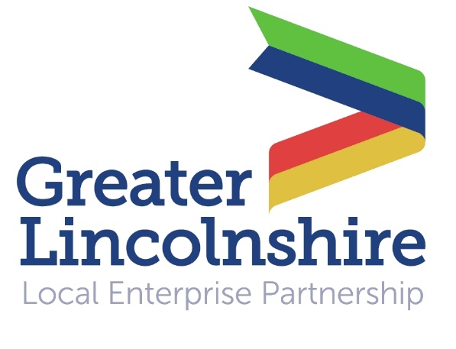
News release

[date]

Securing Water Supplies and Reducing Future Flood Risk

A plan which sets out how to ensure a sustainable water supply in Greater Lincolnshire while protecting homes, farms and businesses from flooding will be launched in Louth later this month.

The Greater Lincolnshire Water Management Plan was given a seal of approval by the Environment Secretary, the Rt Hon Andrea Leadsom MP, when it was launched in the House of Commons in September last year.

She praised the Greater Lincolnshire Local Enterprise Partnership for being “ahead of the game” when it comes to planning for future water supplies and reducing flood risk.

Now the plan is being given a Lincolnshire launch to allow more interested parties to hear about it and contribute their views.

The launch will take place at the Best Western Kenwick Park Hotel near Louth from 9.45am until 12 noon on Friday 24th February 2017. There will then be an opportunity to tour the Louth Flood Alleviation Scheme from 12 noon until 2pm.

“Greater Lincolnshire is a growth area which is planning to create 100,000 new homes and 29,000 new jobs and grow its economy by £8 billion by 2030,” said Mark Tinsley, a Board Member of the Greater Lincolnshire Local Enterprise Partnership and Chair of the Greater Lincolnshire Water Management Board.

“The area also has a long coastline and a great deal of low-lying land – 45% of Greater Lincolnshire is in the flood plain – so flood management is critical to facilitating growth. In a low-lying area more storms and sea level rise increase the risk of flooding from the sea.
“Our Water Management Plan is vital as it sets out how we ensure a sustainable water supply in the future while protecting our homes, farms and businesses from flooding.”

The Water Management Plan aims to increase investment in three linked areas: water supply, flood risk reduction and innovative ways of managing water – for example, through schemes which both reduce flood risk whilst securing the water resources needed for growth.

To attend the launch please send an email to enquiries@greaterlincolnshirelep.co.uk by Friday 10th February. You can also request a hard copy of the plan or download a digital version by visiting http://www.greaterlincolnshirelep.co.uk/assets/downloads/Water_Management_Plan.pdf

Notes to Editors:

- The Greater Lincolnshire Local Enterprise Partnership is a private and public sector partnership led by the private sector which aims to improve conditions for infrastructure and doing business in the Greater Lincolnshire area.
- One of the first LEPs to be established in the UK, the Greater Lincolnshire LEP covers a large geographical area with a population of over one million and a diverse range of industries, from ports and logistics to farming, tourism and engineering.
- It includes North and North-East Lincolnshire and the administrative county of Lincolnshire and is controlled by a LEP board made up of leading figures in the public and private sector.
- Visit www.greaterlincolnshirelep.co.uk for more information.
- Greater Lincolnshire has been affected by a number of significant coastal and inland floods, most notably in 1953, 2007, 2012 and 2013.
- The Greater Lincolnshire LEP has developed the Water Management Plan in partnership with a wide range of stakeholders and partner organisations, shaping and refining it through workshops.

For media information please contact:
Jez Ashberry
Shooting Star
01522 528540
07780 735071
jez@weareshootingstar.co.uk
[LEP137waterplanlaunch]

