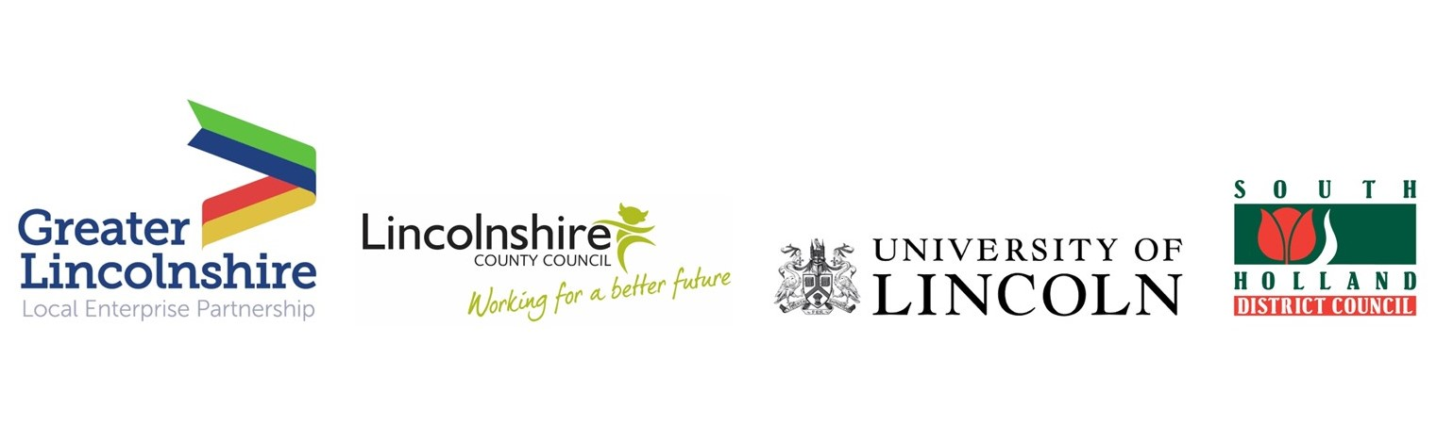
News release

9th October 2020

Global Spotlight on Greater Lincolnshire
Food Automation and Robotics Research

Automation and robotics in the food sector in Greater Lincolnshire has been chosen as one of the Government’s 19 new investment opportunities across the UK.

The announcement means our area will now work with the Department for International Trade (DIT) to attract overseas investment into agrifood automation and robotics projects and businesses in Greater Lincolnshire.

The High Potential Opportunities (HPO) scheme aims to increase inward investment into the UK and help the country build back better.

Last night (Thursday) the Investment Minister Gerry Grimstone MP announced that the bid submitted by the Greater Lincolnshire Local Enterprise Partnership in the second round has been successful.

DIT’s global network based in 177 cities around the world will now provide support to our agrifood automation and robotics cluster by showcasing opportunities internationally and contacting investors to promote the opportunities.

Next month partners from DIT, the Greater Lincolnshire LEP, Lincolnshire County Council, district councils, universities and industry will meet to start work on Greater Lincolnshire’s HPO in food processing, automation and robotics.

DIT will then use the resulting commercial proposition to put Greater Lincolnshire on an international stage through its sector teams and network of posts across the globe.

The expectation is that the HPO will attract more inward investment to the area and create more high-quality jobs in the agrifood sector.

Pat Doody, Chair of the Greater Lincolnshire Local Enterprise Partnership, said: "Food production is a cornerstone of the Greater Lincolnshire economy and indeed the UK. It has created more growth and high-value jobs in the last five years than any other sector so we are delighted this is recognised nationally, and we will work with the Department for International Trade to develop our pitch for additional investment opportunities to bring automation and robotics companies to Lincolnshire.

“Partners locally are working together to develop Greater Lincolnshire into the ‘UK Food Valley’ which will compete globally. In the last five years we have seen a real upturn in this sector, with at least £500 million being invested locally, including £90 million on research and development and innovation. Key schemes such as the development of the South Lincolnshire Food Enterprise Zone and the growth of the agri-robotics research hub have been influential in growing the cluster.

“However, I am really clear that there are significant opportunities for growth, particularly around food production and logistics in Boston, automation and robotics, AI, and nutrition. These are exciting times for Greater Lincolnshire food production.”

Karen Seal, Principal Officer for Place and Investment at Lincolnshire County Council, said: "The HPO will give us a fantastic opportunity to showcase our region on an international platform, promoting our assets, attracting new inward investments and creating highly skilled jobs.

“We need investors to know that Greater Lincolnshire is the UK and European leader for agri-robotics and automation, and to be based here opens up a wealth of opportunities for their business."

Professor Simon Pearson, Professor of Agri-Food Technology at the Lincoln Institute for Agri-Food Technology, said: "We’re delighted to be engaged in this opportunity. Clearly agrifood technology is a significant strength of the University of Lincoln and we’re looking forward to collaborating with the Greater Lincolnshire LEP and the Department for International Trade to support inward investment into the area.

"It’s a wonderful way to exploit the research capacity at the university which now includes the largest group of agri-roboticists in the EU.”

Councillor Nick Worth, Lincolnshire County Councillor for Holbeach and Deputy Leader of South Holland District Council, welcomed the announcement, saying: “This is really positive news for the area, and the additional support, promotion and resource will be invaluable as the district and wider county continues to promote itself to investors as the home of the largest cluster of agri-food businesses anywhere in the country.

“With the Department for International Trade’s assistance we can begin to build new global connections and highlight some of the fantastic projects taking place in the area, such as the Food Enterprise Zone in Holbeach. Working with our partners I am excited to help put Lincolnshire on the map worldwide and encourage new investment, businesses and jobs into the county.”

The Minister for Investment Gerry Grimstone MP said: “The UK has so much to offer international investors across a variety of key sectors and regions. Our HPO programme looks at some of the sectors and sites across the UK where we see some of the world’s greatest challenges being solved.

“Inward investment will help the UK build back better while levelling up all parts of the UK. This is just the start of the steps we are taking to increase inward investment and drive economic recovery.”

Notes to Editors

About the Greater Lincolnshire LEP:

- The Greater Lincolnshire LEP was set up in 2010 and works with businesses and local authorities to develop and grow Greater Lincolnshire’s diverse economy.
- It is a public / private partnership led by the private sector.
- It works with central Government and the private sector to invest in infrastructure, skills, innovation and productivity.
- More than 100 businesses are involved in its strategies, and 80 business people sit on its boards.
- The LEP has an ambitious and balanced strategic economic growth plan for Greater Lincolnshire.
- The LEP’s six priority sectors are agri-food, the visitor economy, manufacturing, logistics, health and care and low-carbon energy.
- The LEP has invested £307 million in local economic growth schemes in Greater Lincolnshire since 2014.
- The Greater Lincolnshire LEP covers an area including North Lincolnshire, North East Lincolnshire, Rutland and the administrative county of Lincolnshire and is led by a LEP board made up of leading figures in the public and private sector.
- To find out more visit http://www.greaterlincolnshirelep.co.uk or follow the LEP on Twitter @greaterlincslep, Facebook or LinkedIn.

About DIT and inward investment:

- The UK continues to be the top destination in Europe for attracting foreign direct investment. Results published by UNCTAD (United Nations Conference on Trade and Development) show that by the end of 2019 the UK’s inward FDI stock levels reached USD2.1 trillion, second only to the United States.
- The Financial Times FDI Report 2020 highlights that the UK remains top in Europe on attracting FDI projects and on green field capital expenditure. This demonstrates that the UK continued to attract FDI throughout 2019 at an unbeaten rate in Europe.
- The most recent FDI figures show 1,852 projects were recorded, 56,117 new jobs were created and 9.021 were safeguarded in 2019/20 thanks to FDI. [Source: DIT Figures July 2020].
- Regionally, FDI contributes to around 12% to 17% of employment in every region of the UK and contributes to more than a quarter of the business turnover in every region of the UK, with the exception of London, where the share of employment and business turnover is 24% and 52% respectively.
- It is observed that businesses that receive inward FDI were 74% more productive than non-FDI firms.
- There is high productivity disparity within the UK regions, with relatively higher productivity in London and the south-east (where the presence of foreign-owned firms is more than proportional to other regions). Thus, attracting additional FDI can be a part of the solution to the UK’s long-standing productivity challenge and particularly for the levelling up agenda.

For media information contact:
Jez Ashberry
Director
Shooting Star
01522 528540
jez@weareshootingstar.co.uk
[LEP250HPO]

