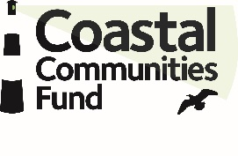
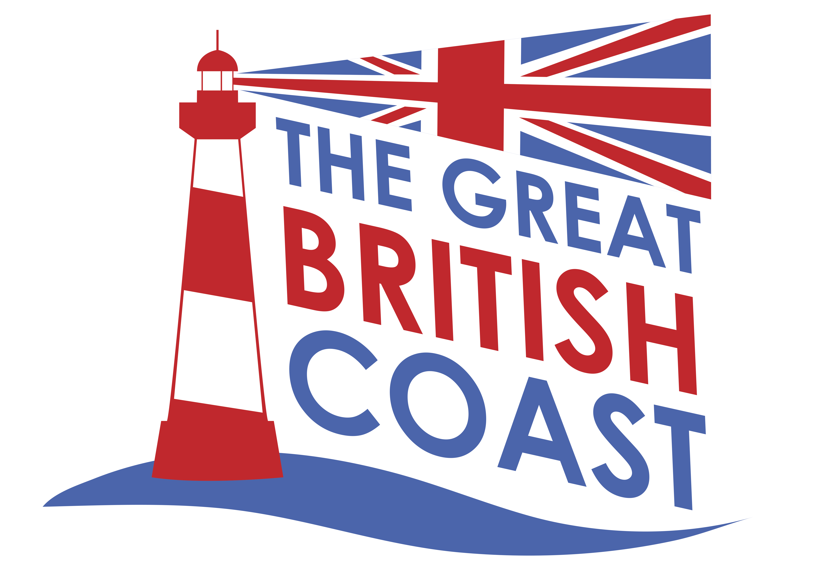

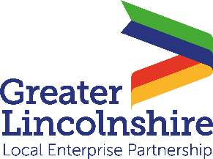

News release

21st January 2022

Skills Courses to Boost Lincolnshire’s Coastal Communities

Are you located on the Lincolnshire coast and seeking a brand new career path or looking to upskill your staff in the visitor economy, tourism or hospitality industries?

The Coastal Communities programme is offering fully funded courses for individuals or businesses to help advance and upskill Greater Lincolnshire’s coastal workforce.

The Coastal Communities project, spearheaded by the Greater Lincolnshire LEP and delivered by Lincolnshire County Council, aims to enhance the thriving Lincolnshire coastline with a developing visitor economy founded on business growth and career opportunities for local people.

The fully funded courses cover a range of topics, from excellence in customer service, to hospitality and kitchen management, the sunflower lanyard scheme and caravan siting development.

The visitor economy sector is worth over £1.9bn per annum to Greater Lincolnshire’s economy and there is a vast choice of rewarding career opportunities on offer on the Lincolnshire coast.

Nicola Radford, Senior Commissioning Officer at Lincolnshire County Council, said: “What we have access to here is something that will undoubtedly benefit existing businesses and job seekers alike.

“So far, we have engaged with 370 learners in 75 qualifications through 50 different businesses. From coastal businesses such as Batemans Brewery and Butlins to Magna Vitae leisure hubs and Stagecoach transport, this funding is here to help you.

“We strongly encourage those wanting to advance their knowledge in visitor economy industries to take advantage of these courses as they provide integral transferrable skills and will allow businesses to benefit from free funding to support their recovery and growth.”

Clare Hughes, Employment and Skills Executive Manager at the Greater Lincolnshire LEP, said: “Coastal employers previously told us that they could not access information about the training available in their area so we have secured funding for the training courses and the skills portal to help employers see everything in one place.”

Full details of the courses on offer and how to enroll are available on the Visit Lincs skills portal.

To watch video case studies about Lincolnshire’s Coastal Champions, click here.

For further information visit the Coastal Communities Alliance.

Notes to Editors:

- The Greater Lincolnshire LEP was set up in 2010 and works with businesses and local authorities to develop and grow Greater Lincolnshire’s diverse economy.
- It is a public / private partnership led by the private sector.
- It works with central Government and the private sector to invest in infrastructure, skills, innovation and productivity.
- More than 100 businesses are involved in its strategies, and 80 business people sit on its boards.
- The LEP has an ambitious and balanced strategic economic growth plan for Greater Lincolnshire.
- The LEP’s six priority sectors are agri-food, the visitor economy, manufacturing, logistics, health and care and low-carbon energy.
- The LEP has invested £307 million in local economic growth schemes in Greater Lincolnshire since 2014.
- The Greater Lincolnshire LEP covers an area including North Lincolnshire, North East Lincolnshire, Rutland and the administrative county of Lincolnshire and is led by a LEP board made up of leading figures in the public and private sector.
- To find out more visit http://www.greaterlincolnshirelep.co.uk or follow the LEP on Twitter @greaterlincslep, Facebook or Linkedin.

For media information, contact:

Molly Hare
Account Executive
Shooting Star
01522 528540 / 07767 266914
molly@weareshootingstar.co.uk
[LEP290CoastalCommunitiesFund]

