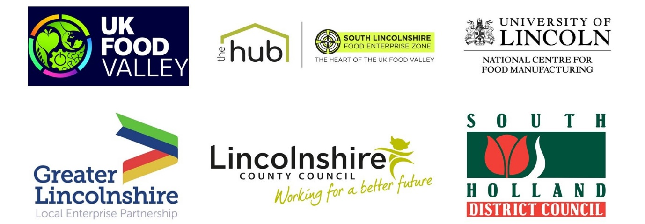

News release

23rd September 2022

UK Food Manufacturers to Benefit from the Opening of the
South Lincolnshire Food Enterprise Zone

The future of food production in the UK has taken a step forward this week, after the official opening of the South Lincolnshire Food Enterprise Zone (FEZ).

The event, which marks the completion of the first phase of the FEZ, took place at the recently opened site just outside Holbeach on Thursday 22nd September. This first phase of the FEZ includes two new facilities for the University of Lincoln’s National Centre for Food Manufacturing (NCFM) along with a Hub for agri-food businesses sponsored by Lincolnshire County Council.

Pat Doody, Chair of the Greater Lincolnshire Local Enterprise Partnership, said:
“The opening this week of the South Lincolnshire FEZ is a perfect example of how determined partners sharing a common vision – in this case the ambitious goal of creating the UK Food Valley, a top 10 global food cluster – can achieve so much, so quickly. We are very proud to have contributed £16 million from the LEP to help make this development happen.”

Leading food industry representatives spoke of the unprecedented challenge faced by the industry and the importance of investing in skills and research to build the sector’s resilience and exploit growth opportunities.

Representatives from Bakkavor and OAL, as joint sponsors, opened The Institute of Technology – Digital Food Manufacturing Technologies Centre.

Donna-Maria Lee, Chief People Officer at Bakkavor, said:

“As a leading UK fresh prepared food producer and an anchor partner of the Lincolnshire Institute of Technology, we passionately believe that our future growth depends on the young talent we attract, train and support. This new facility provides a great opportunity for us to continue to drive and shape the skills we need by helping develop a future workforce that has expertise in food manufacturing and engineering.”

Harry Norman, CEO of OAL, said:

“As a growing technology business, we are pleased to have helped secure investment in food engineering and digital skills, which are essential both to the industry and to businesses like ours, where we need ongoing investment in food automation, robotics and processing research.”

Opening the Centre of Excellence in Agri-food Technologies, Research and Innovation facility, Jayne Almond, Director of Policy and Corporate Affairs at the Food and Drink Federation, said:

“It was an honour to open the first phase of the Food Enterprise Zone here in Holbeach, South Lincolnshire. I’m excited to see how local and national food and drink companies use the expertise in cutting edge, pioneering technology and innovation on offer to grow their business and increase their productivity.

“The local area will also hugely benefit from the skills and business support the zone has to offer and I’m looking forward to returning to the Food Enterprise Zone in the coming months to see the growth of the project.”

Professor Val Braybrooks, Dean at the NCFM, said:
“We are delighted for the opportunity to build on the outstanding success of the NCFM. We are indebted to our key partners, the hundreds of food manufacturing businesses that continue to support the NCFM, and to the Greater Lincolnshire LEP and the Food and Drink Federation who work tirelessly at the regional and national level to influence policy and help the sector’s cause.”

For media information please contact:

Jez Ashberry
Director
Shooting Star
jez@weareshootingstar.co.uk
01522 528540
07780 735071
[LEP304FEZlaunchmanufacturing]

